

**User Guide 1.5**

MODTRACKER_WK_DOC004



**Table of Contents**

1 General Information 5

1.1 Overview 5

1.2 Objective 5

1.3 Scope 5

1.4 Purpose of the document 6

2 Getting Started 7

2.1 Logging in 7

2.1.1 Login 7

2.1.2 Validations 8

2.2 Logging out 9

2.3 Quick Reference Guide 10

2.4 Create New Account 10

2.5 Steps to Create New Account 11

3 Welcome to ModTracker 13

3.1 My Account 13

3.1.1 User Details 13

3.1.2 Notification Settings 14

3.1.3 View all alerts 15

3.1.4 Pagination Limit Setting 15

3.1.5 My Activities, All Activities, My Franchise(s) and My Team screen -Columns to display 17

3.1.6 Query Panel - Fields to display 18

3.2 Roles in ModTracker 20

3.2.1 Roles and Responsibilities of users in ModTracker 23

3.3 Activity 23

3.4 Creation of Modeling Activity 23

3.4.1 Steps to create a new activity 23

3.4.2 Mandatory Fields 24

3.4.3 Tool Tips 25

3.4.4 Field Border Colors 25

3.4.5 Auto Expanding Fields 26

3.4.6 Multiple Selection 27

3.4.7 Collapse and Expand mode 32

3.4.8 Associated Activities 32

3.4.9 Team 33

3.4.10 Validation Status 36

3.5 Creation of Data Request Activity 36

3.5.1 Associated Activities 37

3.5.2 Team 38

3.5.3 Activity Files 38

3.5.4 Deliverables 40

3.5.5 Source Data 40

3.5.6 Specifications 45

3.5.7 General Considerations 48

3.6 Creation of Module Activity 53

3.6.1 Source Data 55

3.6.2 Specifications 56

3.6.3 General Considerations 56

3.6.4 Reset Activity 58

3.7 Creation of Platform Request Activity 60

3.8 Creation of Summary Activity 63

3.9 Validations to create the new activity 64

4 My Activities 65

4.1 Types of Activity Status(M&S Status) 65

4.1.1 Active 65

4.1.2 Planned 65

4.1.3 On hold 66

4.1.4 Completed 66

4.1.5 Cancelled 67

4.1.6 Stopped 68

5 All Activities 69

5.1 Sort/Filter All Activities 70

6 View Activity 72

6.1 Update/edit the activity 73

6.1.1 Updating Completed Activity 76

6.1.2 Request Updates 79

6.1.3 Clone Activity 81

6.1.4 Save As New Version 82

6.1.5 View Revisions 84

6.1.6 Save Activity - Alerts 87

6.2 My Franchise(s) 90

6.3 My Line Function Team 90

6.3.1 My team 90

6.3.2 Go Back functionality 91

7 Search 93

7.1 Global Search 93

8 Advanced Search 94

9 Resource Management 96

9.1 Resource View 98

9.1.1 Overlap information 99

9.2 Activity View 101

10 Reports 102

11 Dashboard 102

# General Information

## Overview

In the existing system **Modeling and Simulation** provide model based quantitative insights to clinical teams and other groups within Novartis that inform in a meaningful way business decisions made in support of Novartis business objectives.

Modeling and Simulation must prioritize, plan, manage and report the different activities that it undertakes for the organization as well as demonstrates optimized productivity in the context of environment in which Novartis operate.

Existing Lotus Notes database system is not addressing many of the requirements like - Tracking, Reporting, Search capabilities and Portfolio Management.

ModTracker is intended to address the above mentioned gaps and also facilitates a fine solution to perform actions like Reporting, Portfolio management, Tracking and searching in an effort less manner. It improvises the user satisfaction and compliance regarding reporting activity and demonstrating value.

Integrated with M&S core process and principles, ModTracker provides a reliable record of M&S activities. This application also acts as the central hub to incorporate the full palette of M&S technology systems (MODESIM, MODSPACE, DRT, and Push2Doc).

## Objective

The main objective of the **MODTRACKER** is to build an integrated tracking tool to track the activities and data requests. A legacy **Lotus Notes** application captures the details of the individual activities. But its structure is not facilitating reports and Dashboard generation. To enhance the application usability **MODTRACKER** is accommodating the following benefits to the users

* Increasing Resource efficiency to trim down the re-work
* Planning the limited resources in order to meet the short/critical submission time-lines
* Focus resources on critical activities.
* Track resources gaps to pro-actively manage road blocks to deliver

## Scope

ModTracker is the specific system that supports the end user to focus and to make the usability easy and straight forward. Its wider context facilitates centralized and integrated work environment for the tracker system and acts as a central hub to the entire system of tracking and management.

Scope includes

* Access control to the System
* Provision of the necessary metadata
* Activity Lifecycle Management
* Portfolio management and prioritization
* Reporting
* Advanced Search

## Purpose of the document

User Guide gives assistance on the complete usability of the application and also helps in providing all the information that is required for the end user to work on the system. This document describes the complete end – end flow of the Activity process in an elaborated manner, thereby enabling the user to access and manage the system easily.

# Getting Started

ModTracker provides a user-friendly interface to get all the related details regarding an Activity. Relevant user credentials are required to login to the application

## Logging in

Open ModTracker application in an IE browser and

1. Enter the valid user credentials in the Login page
2. Click “Login” button as shown in below screenshown in below screen.

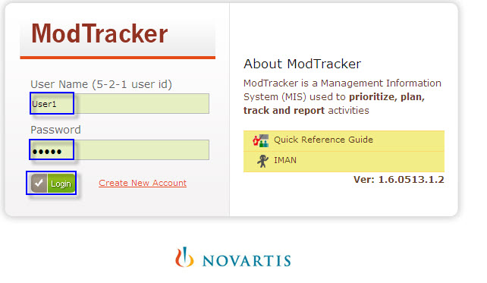

Screen

### Login

1. My Activities page appears as shown in below screenshown in below screen.

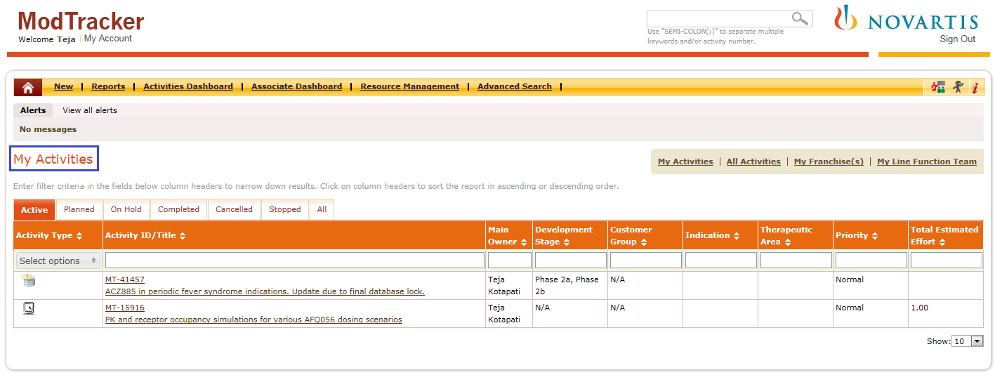

Screen

### Validations

1. Click login without specifying “Password”, an alert message appears as shown in below screenshown in below screen.

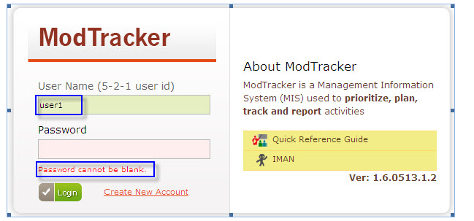

Screen

1. Enter invalid username or password to login to the application, an alert message appears indicating the “Username or Password are incorrect” as shown in below screenshown in below screen.

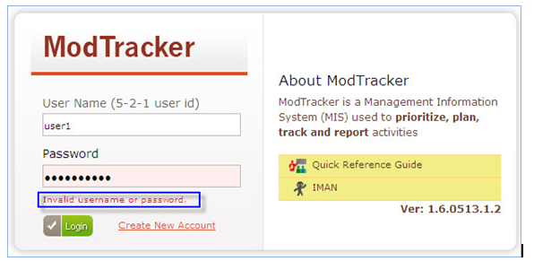

Screen

## Logging out

Click “Sign out” link from any page of the application to logout from the application as shown in below screen.



Screen

Application navigates to Login page as shown in below screenshown in below screen.

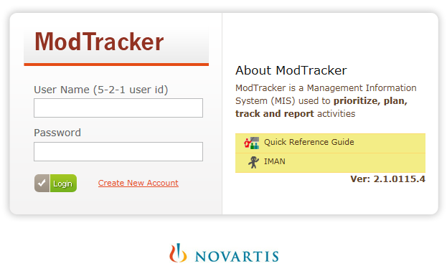

Screen

## Quick Reference Guide

ModTracker application facilitates a brief information document for the end users about the application flow and its behavior, under the “Quick Reference Guide” link in the application.

Click “” Quick Reference Guide link from the login page or from the main menu bar of the application as shown in below figures.

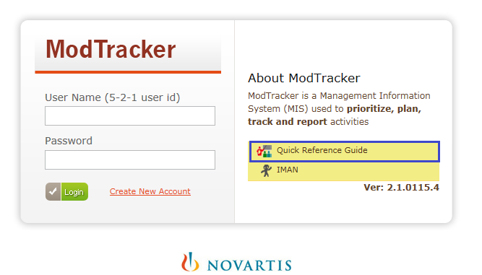

Screen



Screen

Quick Reference Guide appears in a new window as shown in below screen.

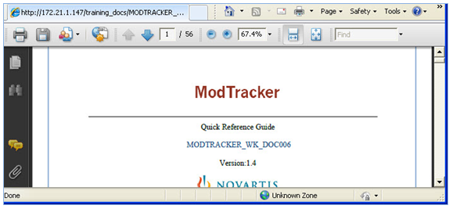

Screen

## Create New Account

Create New Account allows new userto create new account for users to access the ModTracker Application.

**Steps to Create New Account**

## Steps to Create New Account

**Step 1:**Click “Create New Account” link as shown in below screenshown in below screen.

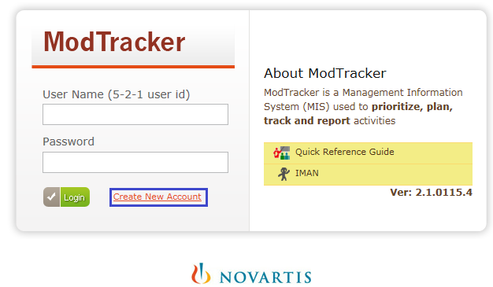

Screen

**Step 2**: “Create New Account” page appears as shown in below screenshown in below screen.

**Step 3:** Enter the user name (5-2-1 User Id) as configured in LDAP server in the “User Name” text field and press Enter or Tab key.

**Note:** For the creation of new account the user should be configured in LDAP.

**Step 4:** Application retrieves the user information from LDAP server and auto completes the data in the “Novartis Email, Full Name and Title” fields as shown in below screenshown in below screen.

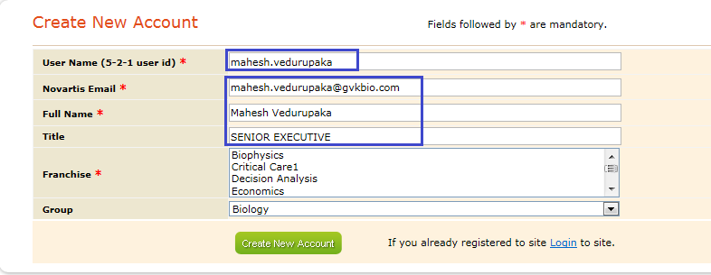

Screen

**Step 5:** Select Franchise from the “Franchise” list and click “Create New account” button as shown in below screenshown in below screen.

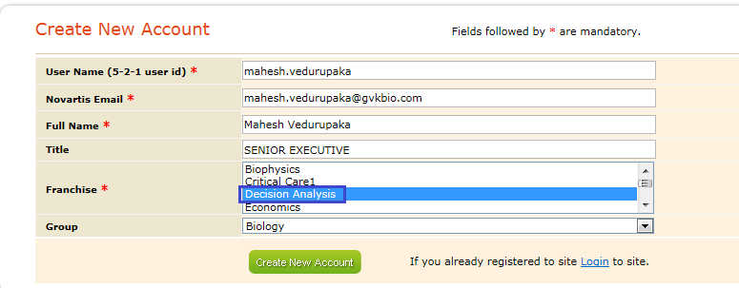

Screen

**Step 6:**Application creates user account and an acknowledgement appears on login page as shown in below screenshown in below screen.

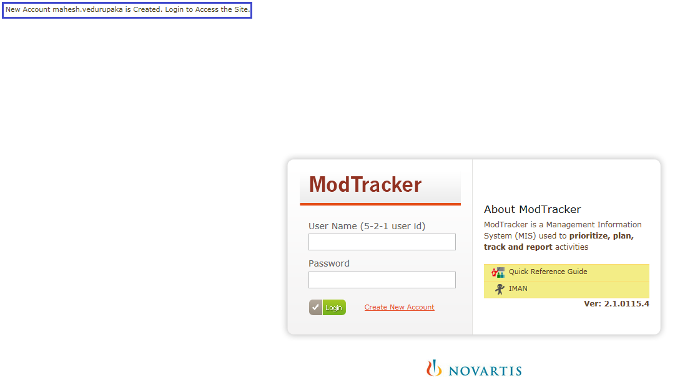

Screen

**Note:**Initially newly created account status will be inactive, Admin need to activate the user account using “Manage Users” from “Metadata Management”. Then corresponding user can login to the application.

# Welcome to ModTracker

## My Account

My Account allows users to configure their own settings regarding “User Details, Notifications, Pagination Limit Setting, My Activities and All Activities screen - Columns to display, Query Panel - Fields to display”.

1. Click “My Account” link from the application as shown in below screenshown in below screen.



Screen

1. My Account” page appears as shown in below screen.

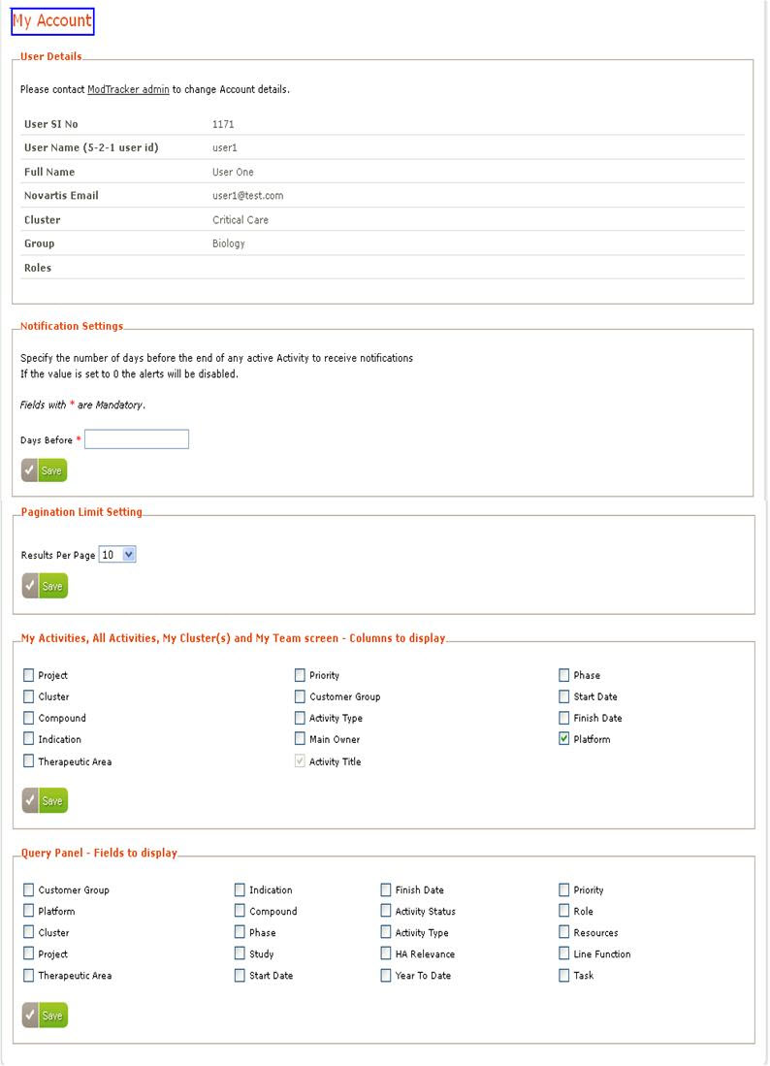

Screen

### User Details

User Details section provides complete details of the logged in user and also allows user to contact “ModTracker Admin” regarding the changes in the user account using “ModTracker admin” link as shown in below screen.

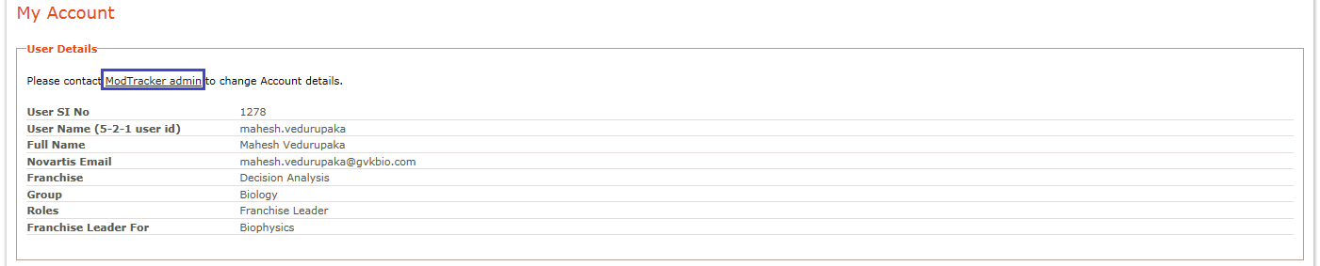

Screen

### Notification Settings

Notification Settings allows user to specify the “Days Before” the end of any active activity to receive notifications in the form of emails.

1. Enter value in the “Days Before” field and click “Save” button.
2. A message appears indicating the “Notifications are updated” as shown in below screen.

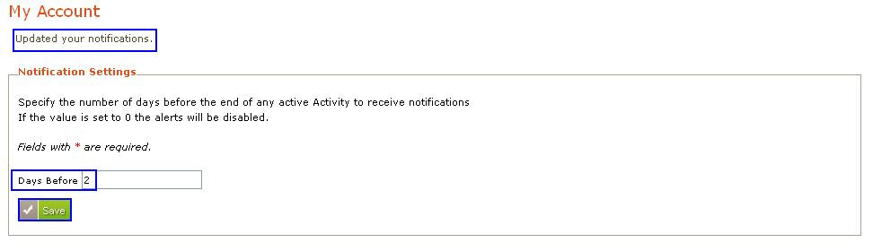

Screen

#### Alerts

Application considers the specified number of days entered in the “Days Before” field and notifications appears in the form of Alerts and My Alerts in the “My Activities” page as shown in below screen.

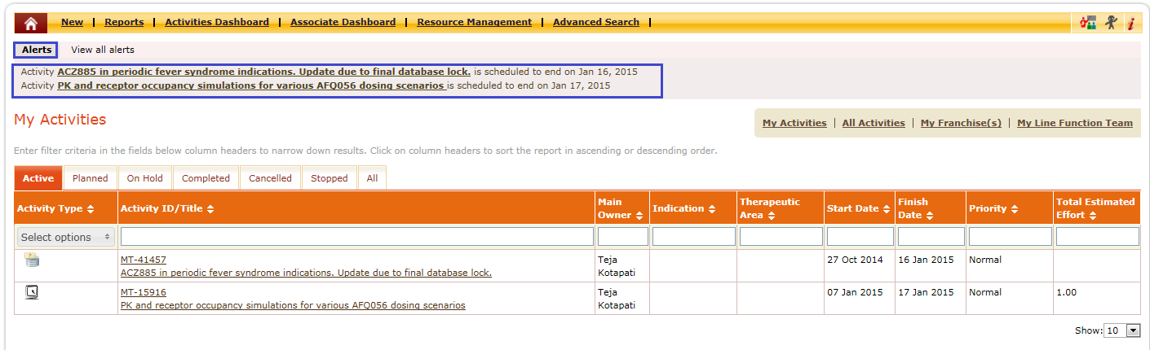

Screen

### View all alerts

By default maximum 3 alerts appears under “Alerts”. Click “View All Alerts” to view all the alerts as shown in below screen.

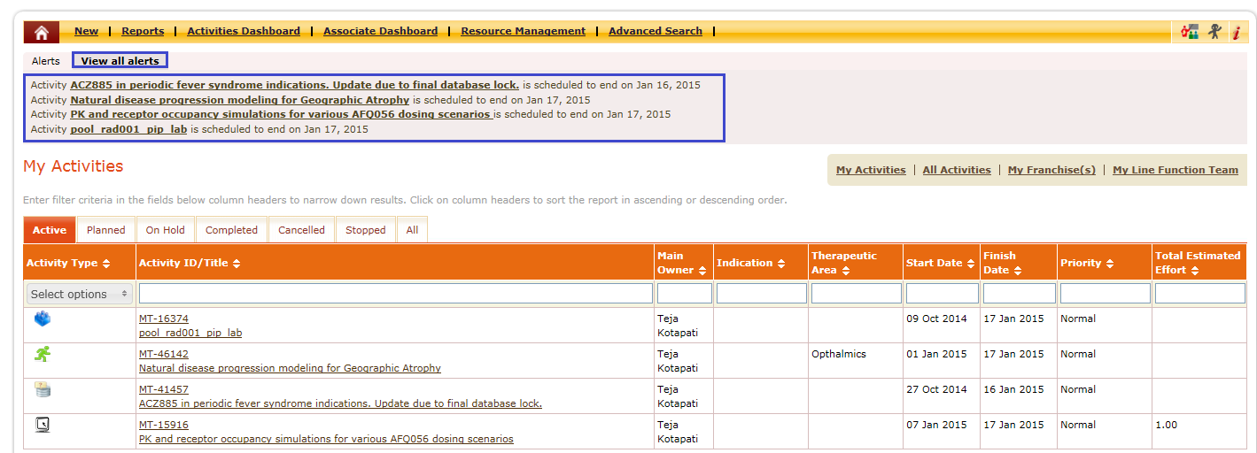

Screen

Email notifications will be sent to the corresponding “Activity Owner” regarding the approach of their schedule end dates of only the active “activities” in the below sample Emailformat.

Activity Title is hyperlinked click “Activity Title” to access the activity.

Dear Joseph Kahn,

The following activities are about to end:

[**Trial Forecasting Tool (for Oncology)**](http://172.21.0.74/index.php/activities/9281) is scheduled to end on 30 May 2013

Please review these activities and make sure that the Finish Date as well as all other relevant information is up-to-date.

Thank you,

ModTracker Application

### Pagination Limit Setting

User is allowed to set the number of results that can be displayed per page throughout the ModTracker application using “Pagination Limit Setting”.

* Select the “Results per Page” value from the drop down as shown in below screen.

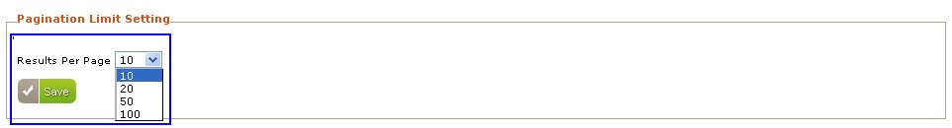

Screen

* Click “Save” button as shown in below screen.

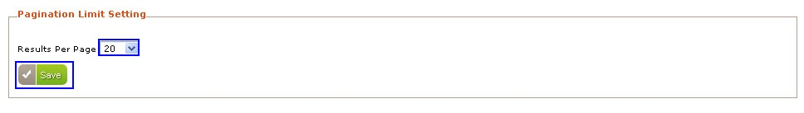

Screen

* “Updated your Pagination Limit” message appears as shown in below screen.

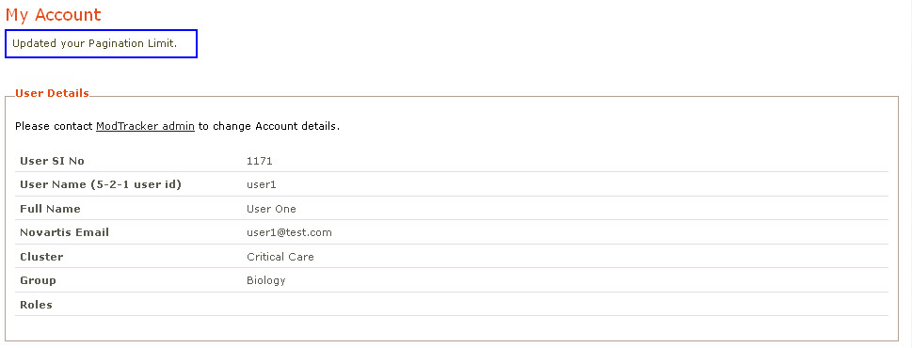

Screen

Navigate through the application then the customized “Results Per Page” value appears in the “Show” drop down with that specified value as the default value as shown in below screens.

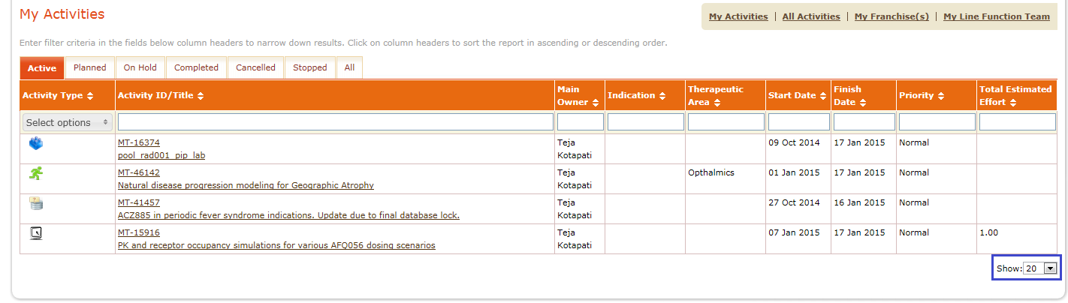

Screen

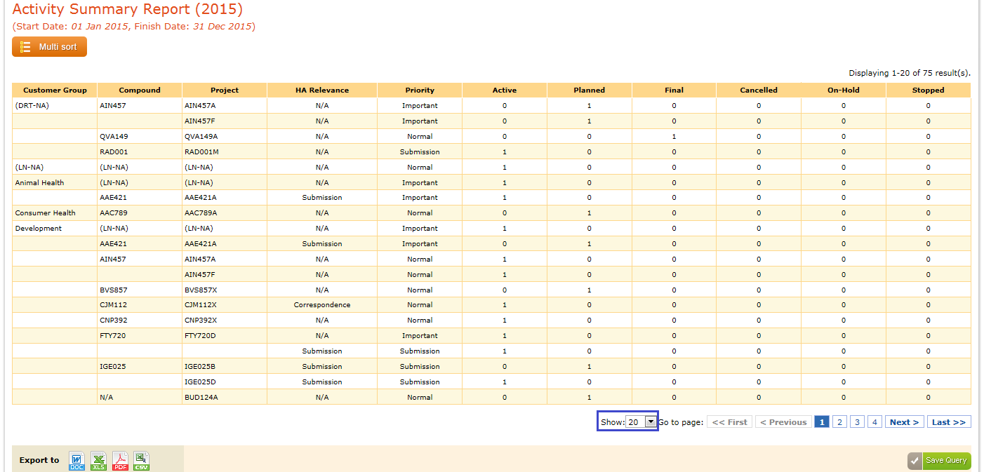

Screen

### My Activities, All Activities, My Franchise(s) and My Team screen -Columns to display

“My Activities, All Activities, My Franchise(s) and My Team screen -Columns to display” section enables users to select required columns that need to be displayed in the “My Activities, All Activities, My Franchise(s) and My Team” screens.

1. Select the required columns using check boxes and then click “Save” button as shown in below screen.

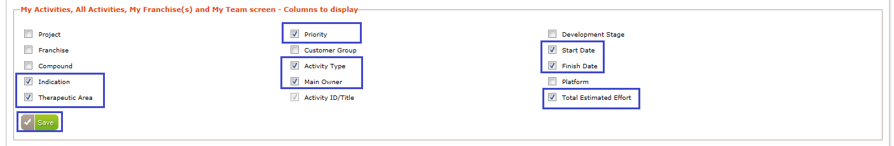

Screen

1. “Updated your selection of fields for My Activities and All Activities page” message appears as shown in below screen.

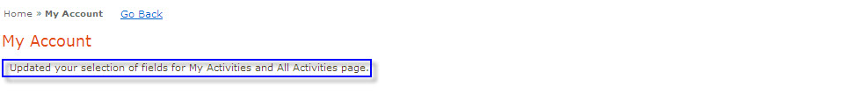

Screen

1. Selected columns appears in the “My Activities, All Activities, My Franchise(s) and My Team screens” as shown in the below screens.

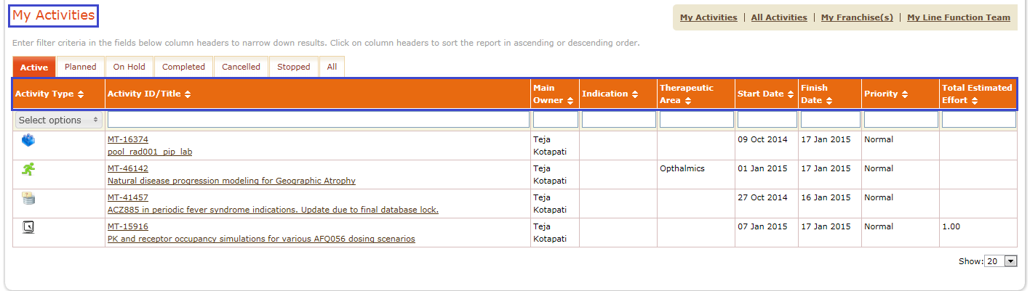

Screen

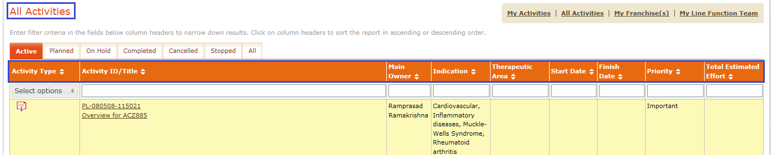

Screen

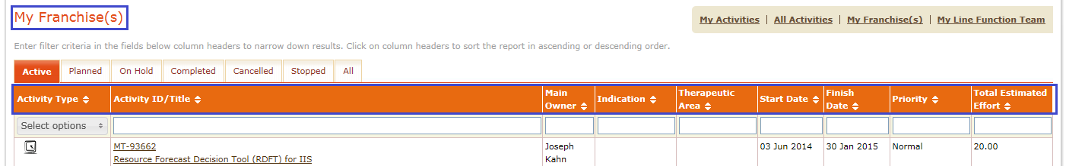

Screen

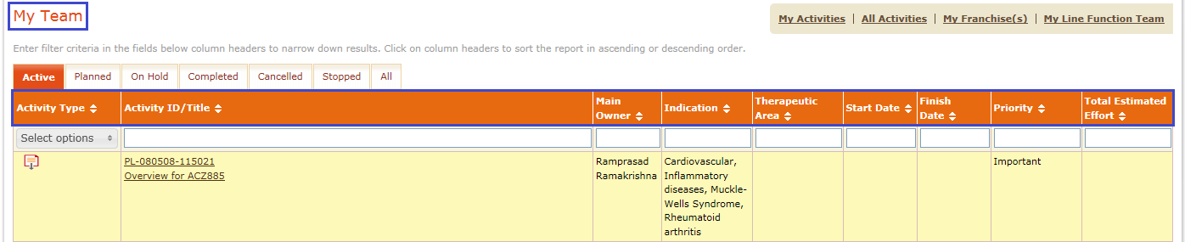

Screen

### Query Panel - Fields to display

“Query Panel-Fields to display” allows users to select the required fields that need to be displayed in the “Query Panel”.

1. Select the required fields using checkboxes.
2. Click “Save” button as shown in below screen.

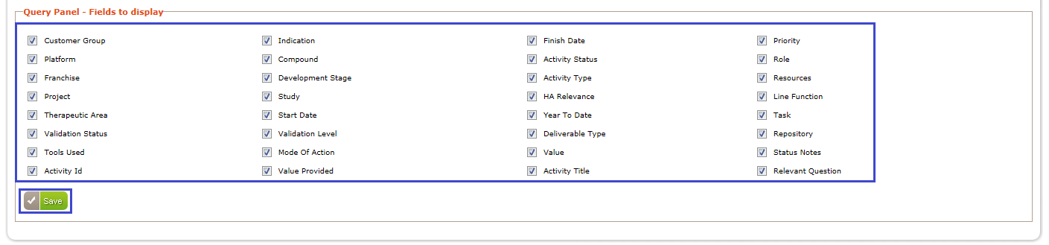

Screen

1. “Updated your Query Panel options” message appears as shown in below screen.

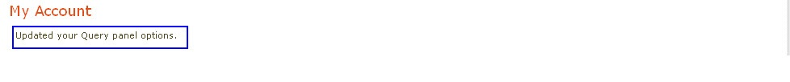

Screen

1. Only the selected fields appear in the Query Panel as shown in below screen.

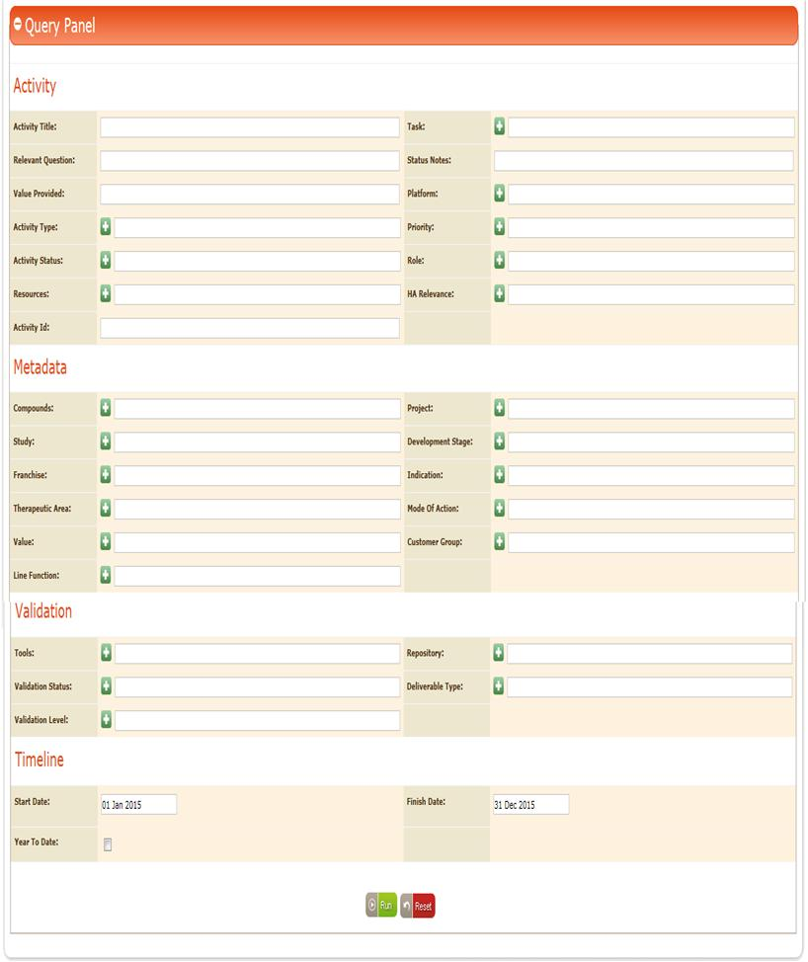

Screen

## Roles in ModTracker

Different roles are involved in the ModTracker application as listed below with their individual responsibilities. Depending on the permissions granted to a specific role by the Administrator corresponding access privileges will be facilitated.

* Associate
* FranchiseLeader
* Project Manager
* Line Function Head
* Senior Mentor
* Programmer
* Assistant
* Reviewer

1. Any role can be assigned to any of the users, but all those users should be configured in LDAP.
2. User account cannot be created for other users (non configured LDAP users).
3. For all the users configured in LDAP all the permissions will be provided by default except “Access Portfolio Metrics Report” and “Access Site wide Configuration Settings” as shown in below screen.

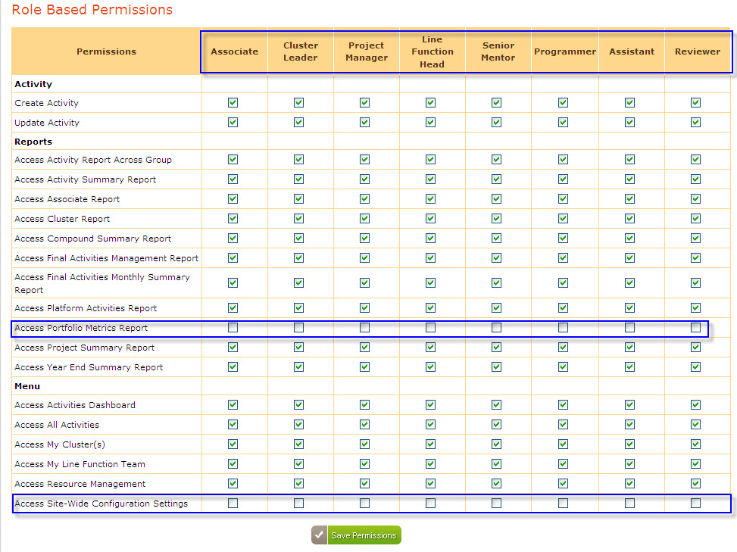

Screen

1. If permissions to a particular Role are saved by admin then all those permissions reflects to all the users assigned with that particular role.
2. If required admin can change the permissions for a particular user using “User Based Permissions” wherein all the assigned “Permissions” gets overridden to that particular user as shown in below screen.

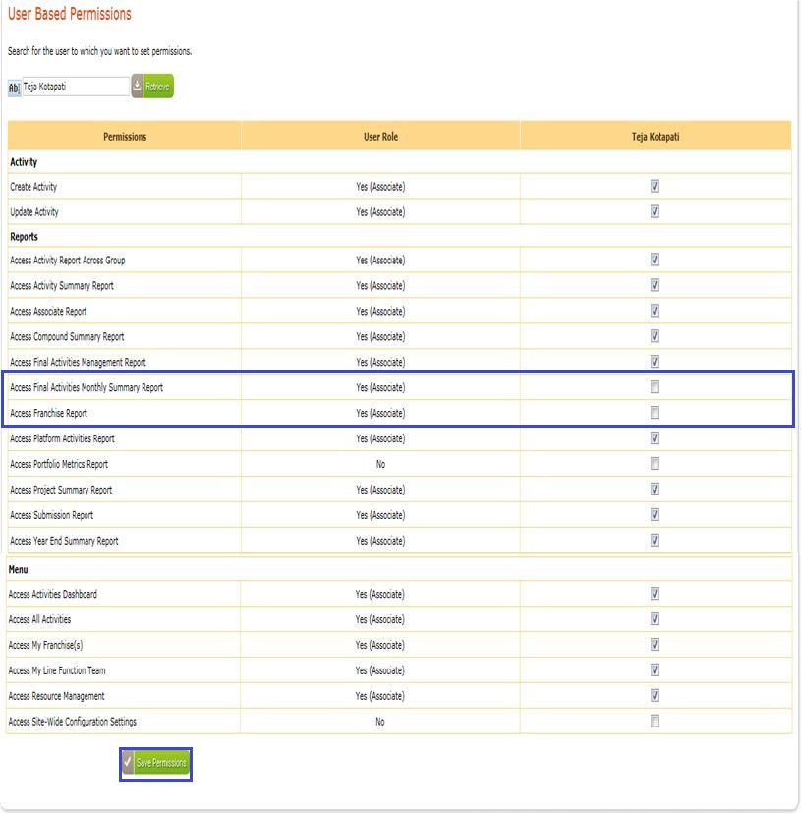

Screen

**Note:**

1. Only Administrator has the right to change or assign the role of any user and can also grant permissions to the roles and users.
2. Based on the permissions granted to a user, only relevant links appear for that user after logging in to the application

### 

### Roles and Responsibilities of users in ModTracker

In ModTracker admin can assign any role to any user using “Manage Users” option in the “Administer” page.

Refer “**Manage Users” section** in the Admin Guide document for details.

## Activity

Depending upon the Activity usage and functionality, activities are classified into different types as listed below

* Modeling
  + Platform
  + Modeling activity
* Programming
  + Data request
  + Module
* Summary
  + Summary Activity
* Technology & Infrastructure
  + IT Work
  + Tools/Macros
  + Literature Search

## Creation of Modeling Activity

Activity Creation is the significant process in which user has to enter/select the required data in the “Create New Activity” page. Based on the selected “Activity Type” only relevant tabs appear in the “Create New Activity” page.

### Steps to create a new activity

1. Log in to the application with valid credentials
2. “My Activities” page appears in that click “New” link as shown in below screen***.***

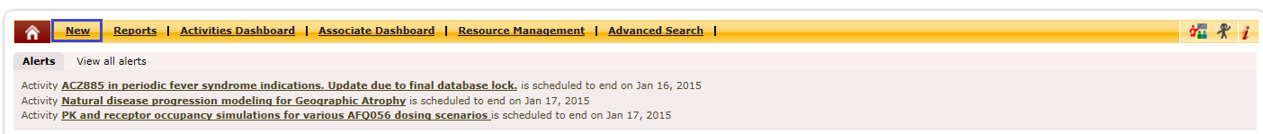

Screen

1. “Create New Activity” page appears with a Unique ID at the top of the “Create New Activity” page as shown in below screen.

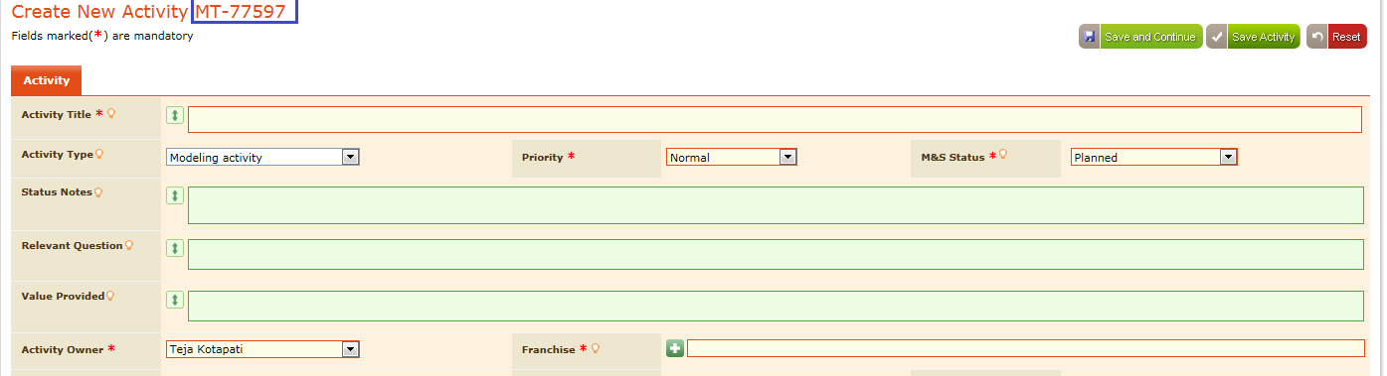

Screen

1. By Default, application displays the below specified selected data

* “Activity Type “ as “Modeling Activity”
* M&S status as “Planned”
* Priority as “Normal”
* Logged in user as “Activity Owner” as shown in below screen.

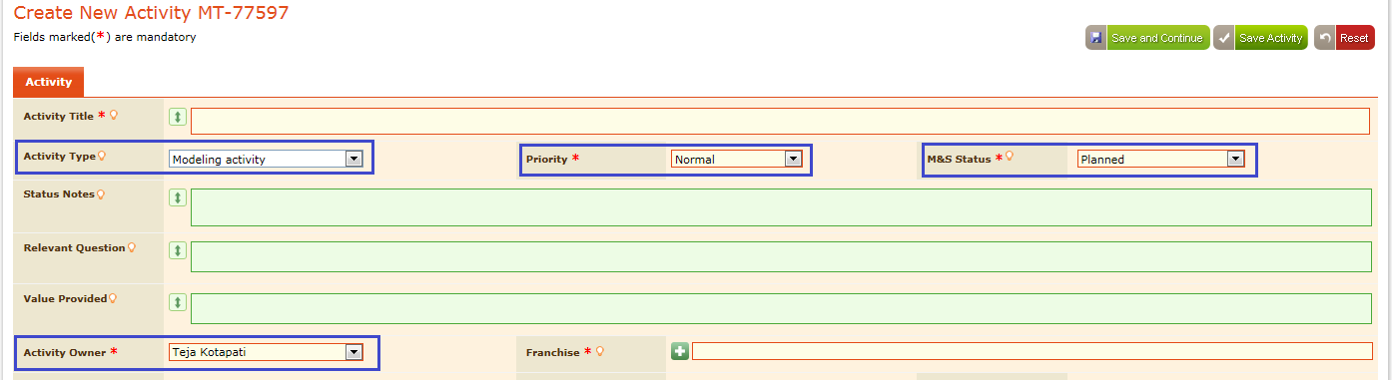

Screen

### Mandatory Fields

In the ModTracker application all the mandatory fields in the “Create New Activity” are represented by “*” symbol besides the label name, user should enter/select data for all the mandatory fields as shown in below screen.

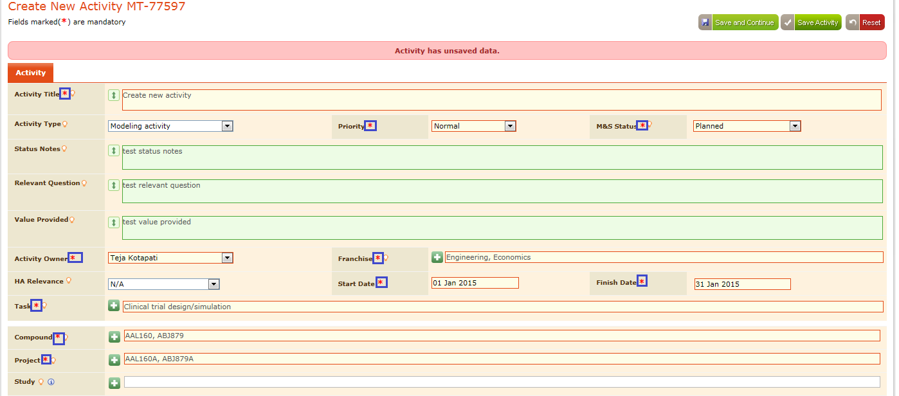

Screen

### Tool Tips

Tool Tips are provided in the “Create New Activity” page for the end user to understand the significance of the field.

Mouse hover on the “” icon, corresponding field information appears as a tool tip, shown in below screen.



Screen

### Field Border Colors

ModTracker application also facilitates clear information about the significance of field borders which are being used in the application. They are specified as shown in below screen in the legend information

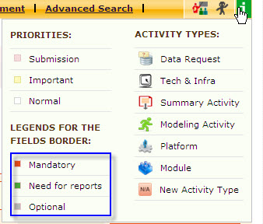

Screen

* Field borders with “Red” color are mandatory
* Field borders with “Green” color are required for reports generation
* Field borders with “Grey” color are optional

And the field borders appear in the application as shown in below screen.

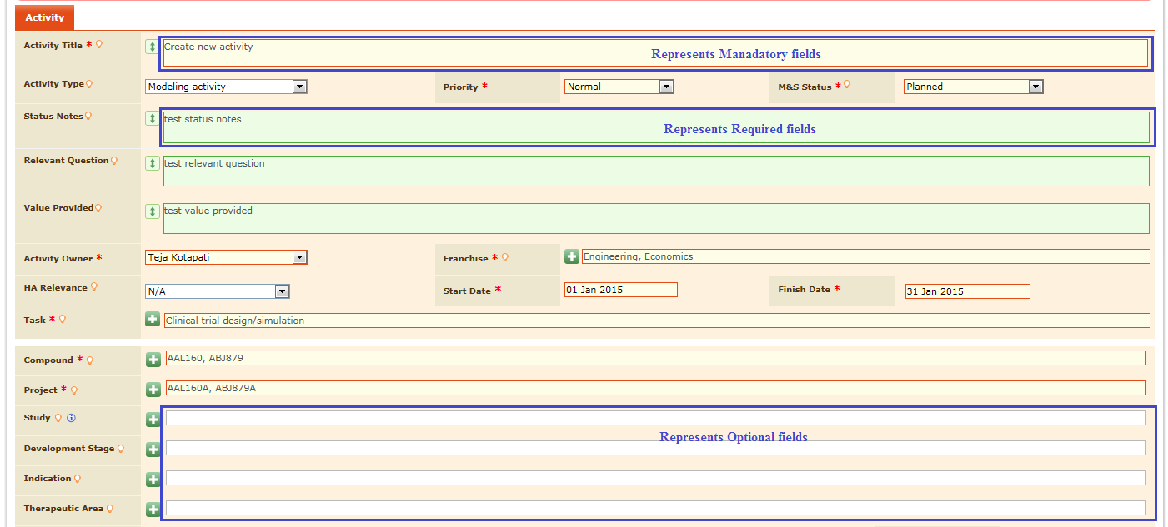

Screen

### Auto Expanding Fields

In the “Create New Activity” page Auto Expansion Fields are provided for the end user to enter large amount of the data separated by new lines, specified with “” symbol besides the label name as shown in below screen.

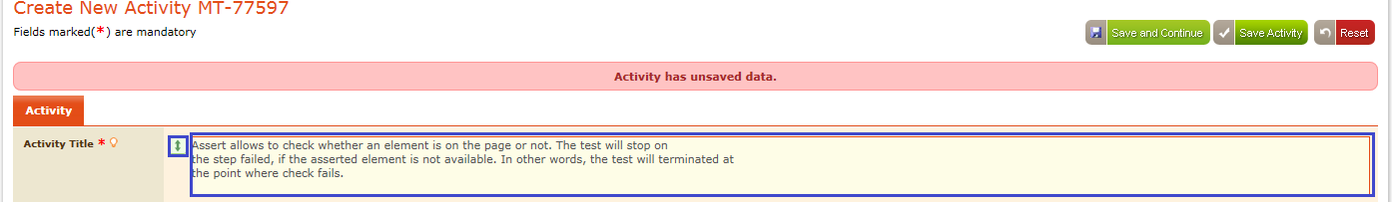

Screen

### MultipleSelection

In Create New Activity page auto selection fields are indicated with “”symbol besides label name are provided for the end user to select the values from the list as shown in below screen.

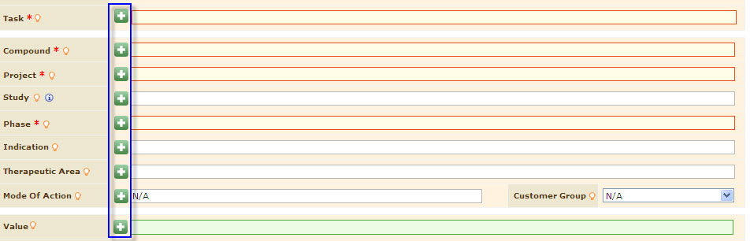

Screen

1. Click “” symbol besides the required fields then “Choose Values” pop up window appears with the corresponding data as shown in below screen.

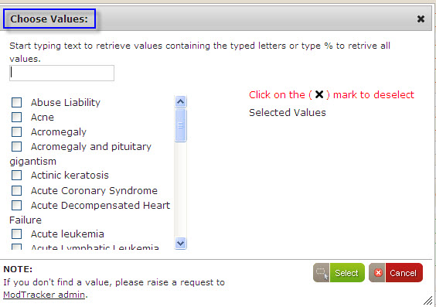

Screen

1. Select the required values using the check boxes from the “Choose Values” pop up window
2. The selected values appear under “Selected Values” as shown in below screen.

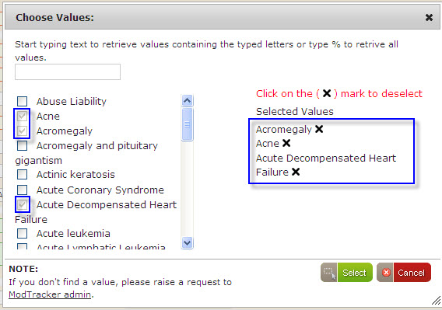

Screen

1. Enter the search term in the “Choose Values” popup then corresponding values appears as shown in below screen.

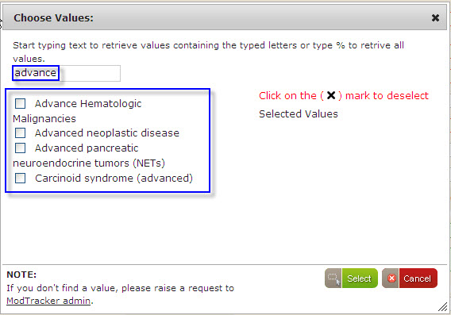

Screen

1. Select required values using “Checkboxes” and click “Select” button as shown in below screen.

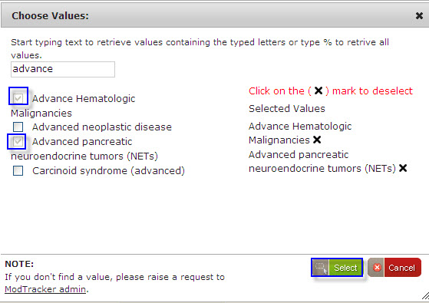

Screen

1. Selected values appear in the corresponding field in the “Create New Activity” page as shown in below screen.



Screen

1. Delete the values using “X” button besides the selected values in the “Choose Values” pop up as shown in below screen.

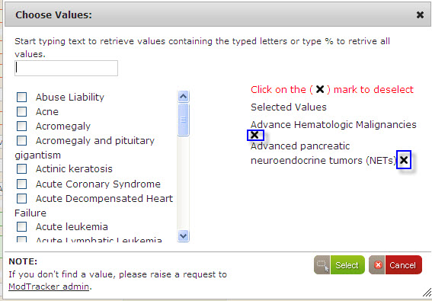

Screen

1. Selected values get deselected and the checkboxes also appears in unchecked state as shown in below screen.

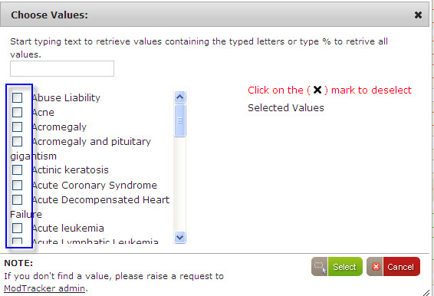

Screen

1. Click “ModTracker admin” link in the “Choose Values” pop up as shown in below screen to raise the request to find new value.

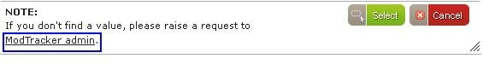

Screen

**Compound-Porject-Study Mapping:**

* Compound, Project, Study fields display the mapped values and un-mapped values in choose values window for the user to select desired value as mentioned below.
* Click on Compound field and select values from the choose values window as shown inbelow screen

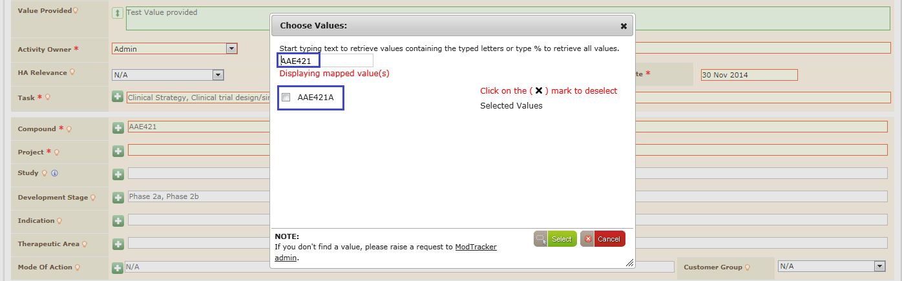

Screen

* Click on ‘Project’ field and, see that mapped project values are displayed for the selected compound in choose values window
* User can search for the desired value by providing the text in search box to get the list of mapped and unmapped project values
* On user selection, selected values are displayed in project field.
* Click on Study field and see that mapped study values for the selected project(s) are displayed in choose values window as shown inbelow screen

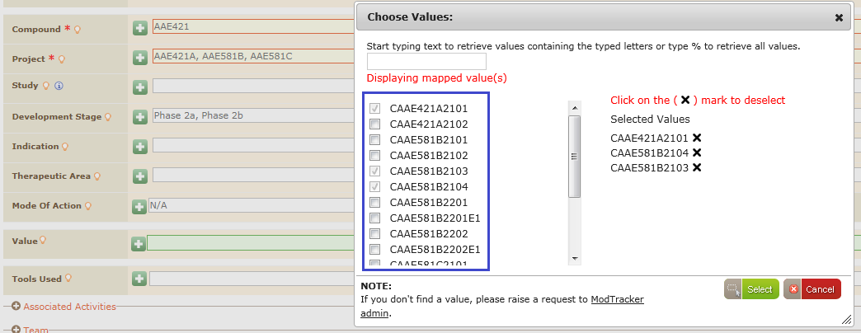

Screen

Note: When User selects more than one value from compound/project then choose values search box doesn’t display the values default but display the mapped values below the search box

### Collapse and Expand mode

In the Create New Activity Page “Associated Types, Team,” section appears in collapsed mode by default.

1. Click symbol (+ Sign) besides the section label then the corresponding section appears in expanded mode with all the relevant fields and the (+ Sign) appears as (- Sign) as shown in below screen.

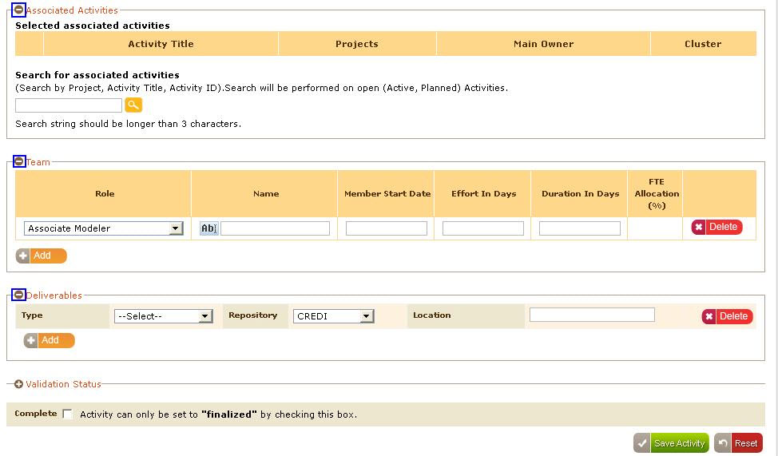

Screen

### Associated Activities

In the “Associated Activities”, search for any activities based on “Project/Activity Title/Activity ID” 1. Enter search value in the search field and click “” button

1. Corresponding activities appears as shown in below screen.

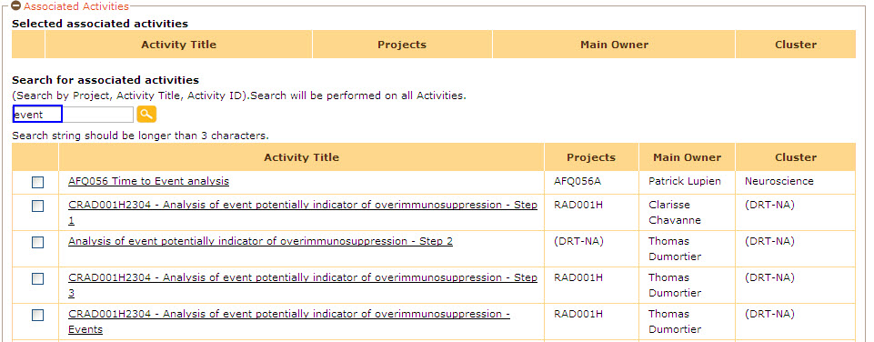

Screen

1. Select any activity as associated activity to the current activity using checkboxes
2. The selected activity is moves to the table of selected activities above as shown in below screen.

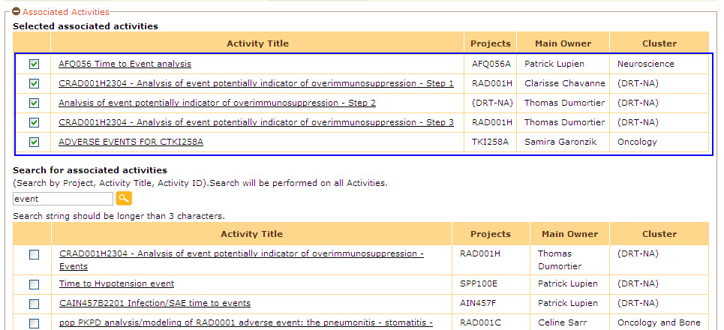

Screen

Now the selected activities are considered as “Associated Activities” for the current activity.

### Team

In the “Team” section, user is allowed to add new team member by selecting the role from “Role” dropdown.

1. Enter the Name, Member Start Date, Effort in Days, Duration in Days, FTE Allocation.
2. Click “Add” button to add a new team member as shown in below screen

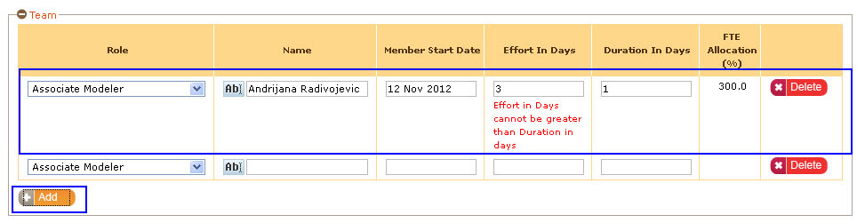

Screen

#### FTE Allocation

FTE Allocations are used to identify the % of task allocated for a particular role regarding the current activity. User can add roles in the team section and can also provide data for the task allocation in the form of effort in days and duration in days.

The below are various roles and their order that need to be considered in the Team section

* Primary Modeler
* Associate Modeler
* Translation Modeler
* Programmer
* Reviewer
* Partner
* External Partner

1. FTE allocation (%) appears considering the “Effort in Days” and “Duration in Days”.
2. If the Effort in Days is more than the Duration in Days then the FTE Allocation (%) will be higher than 100%.
3. If the Effort in Days is less than the Duration in Days then the FTE Allocation (%) will be less than 100% as shown in below screen.

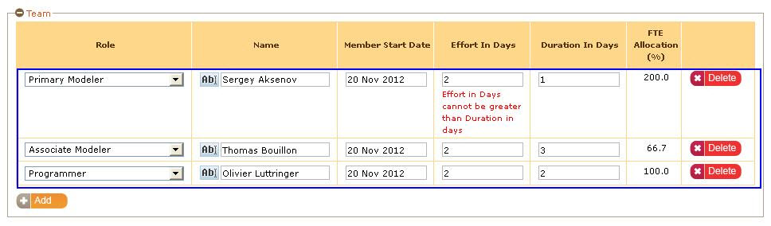

Screen

1. Auto generated email will be sent to the corresponding “FranchiseLeader” of the selected associate name in the team considering the time period and FTE allocation % values for the activities that are associated to the selected associate name.
2. A user can be associated to more than one activity also.
3. Based on the FTE allocation percentage if the percentage is >100 then an automatic email will be sent to the corresponding “FranchiseLeader” of the selected associate name in the Team.
4. Click “Delete” button to delete team member as shown in below screen.

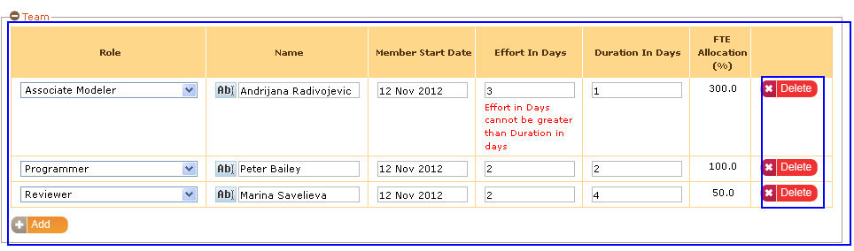

Screen

Then mail will be sent to the corresponding Franchiseleader regarding the FTE allocation in the below sample Emailformat.

Activity Title is hyperlinked click “Activity Title” to access the activity.

|  |
| --- |
| Dear Ramprasad Ramakrishna,  The following resources will be over-allocated within the next 5 days:   * Phil Lowe   is allocated 114.1% during the period of 29 May 2013 to 31 May 2013 in the following activities:   * 1. [**Xolair in urticaria. Input to submission documents on posology via population PK, IgE and urticaria symptoms model**](http://172.21.1.147/index.php/activities/7799)*(Translational Modeler)* - allocated 30.77% from 06 Dec 2012 to 22 May 2013   2. [**Tesr Data request**](http://172.21.1.147/index.php/activities/9531)*(Translational Modeler)* - allocated 83.33% from 24 May 2013 to 31 May 2013   Please review these activities and work with the affected resources and their cluster leaders to resolve the over-allocation conflicts.  Thank you,  ModTracker Application |

Total estimated effort of the activity is calculated from the Total team members effort in days and this will be displayed in the home page as shown in below screen

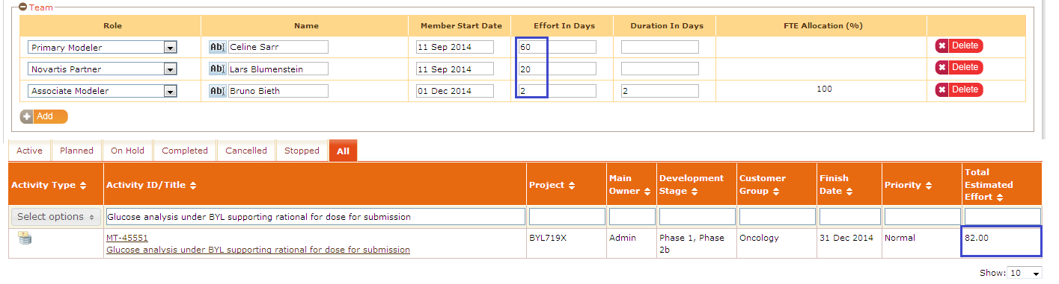

Screen

#### Deliverables

In deliverables section, by default ‘Program Outputs’ and ‘Data’ records displayed with out delete option for the records, deliverable type change is not allowed to the user for default deliverable records. For adding deliverable records user can click ‘Add’ button as shown in below screen



Screen

Deliverables section enables user to selectrequired deliverables from the list given in “Type” dropdown and select corresponding repository from the “Repository” dropdown as shown in below screen.

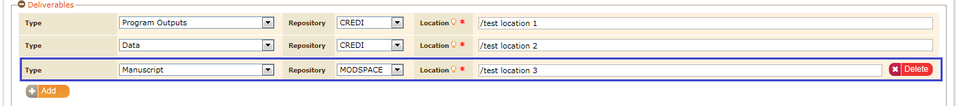

Screen

Click “Delete” button to delete the required deliverable type as shown in below screen.

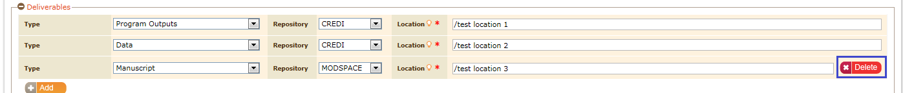

Screen

### Validation Status

Select the validation level and validation status from the “Validation Level” and “Validation status” drop downsrespectively as shown in below screen.



Screen

**Note:**But among the validation status options, when user completes the activity then the “Validation Status” as “Final” appears in the selected mode automatically as shown in below screen.

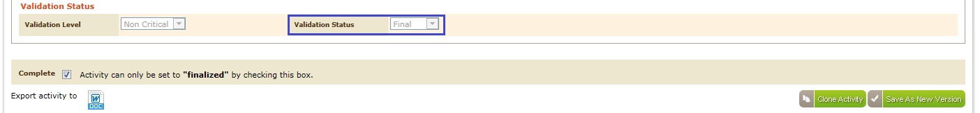

## Creation of Data Request Activity

Data Request is one of the activity types wherein user is allowed to provide all the needed information regarding the activity creation, along with that specifies the data required for “Source data”, “Specifications” and “General Considerations”.

1. Select the activity type as “Data Request or Module” then the “Source Data, Specifications, General Considerations” tabs appears besides the “Data Request” tab as shown in below screen.

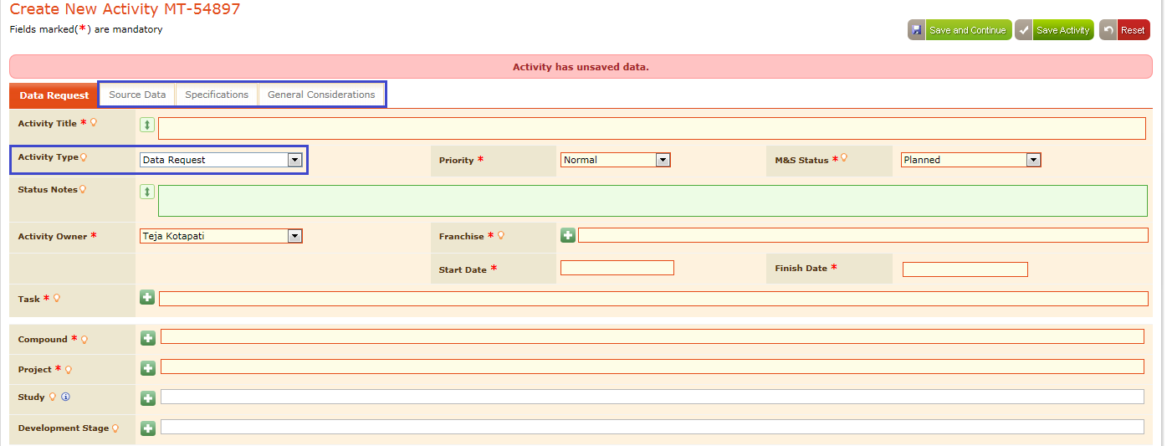

Screen

In the “Create New Activity” page fill the required data as shown in below screen.

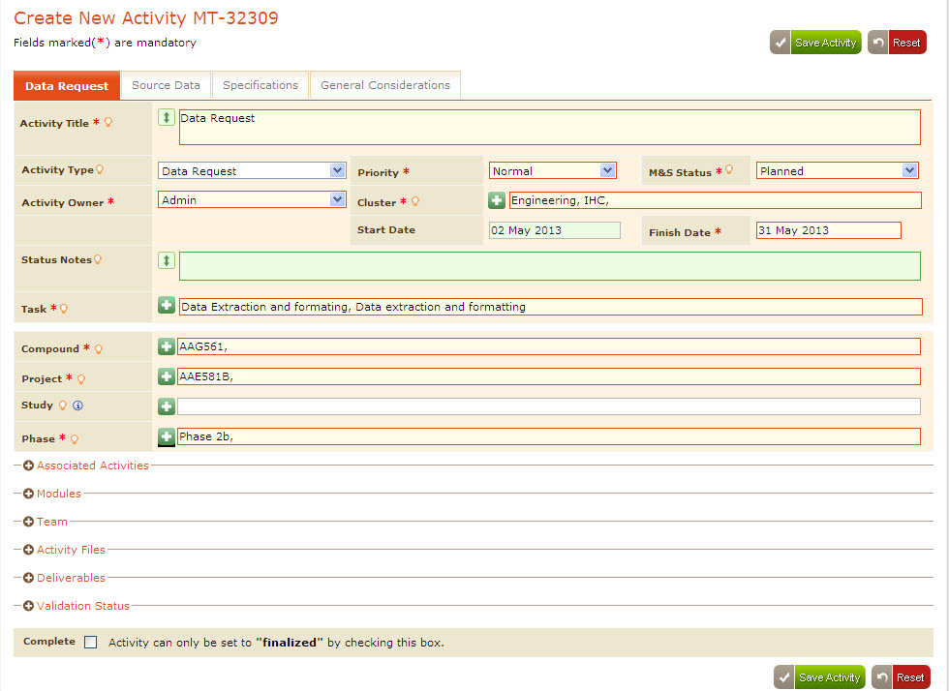

Screen

### Associated Activities

In the “Create New Activity” page user can create “Associated Activities” in similar way user has created for “Modeling Activity” as shown in below screen. For details ***Refer Section 3.4.8***

shown in below screen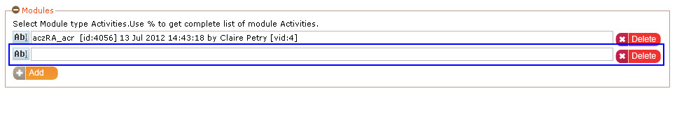

Screen

### Team

In “Data Request Activity” also user can add team members in the similar way user has created for “Modeling Activity” for details ***Refer Section 3.4.9.***

### Activity Files

Activity Files in the “Data Request” are used to attach required files for an activity, for this user can attach activity files in the specified format, size and count limit provided by the administrator. For more details ***refer section 4.3 Manage File Uploads*** in the Admin Guide.

1. Admin configureddetails appear by default in the “Activity Files” section as shown in below screen.

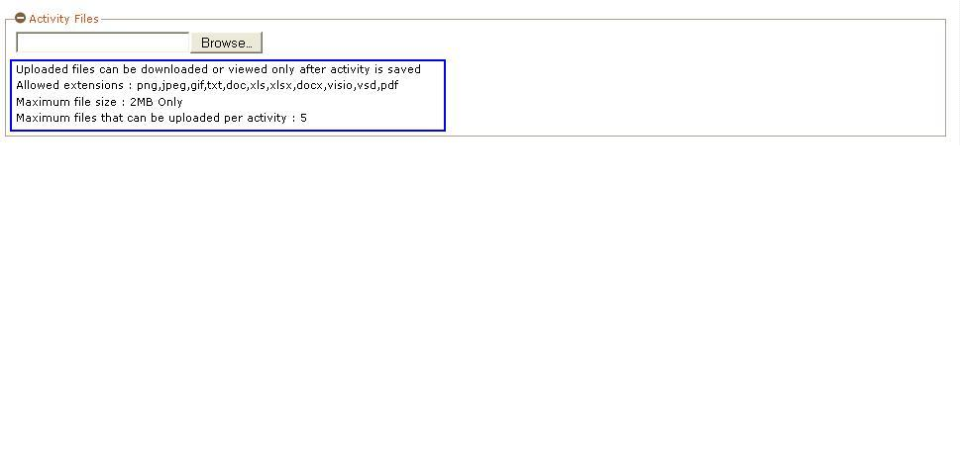

Screen

1. Attach the activity file considering the specification provided in the “Activity Files” section.
2. If user failed to consider the details given and tries to attach any activity file that is not in the specified size, format, exceeds the maximum file count then alert messages appears while saving the activity in the below formats
3. If the file size exceeds the maximum file size limit an alert appears as shown in below screen.

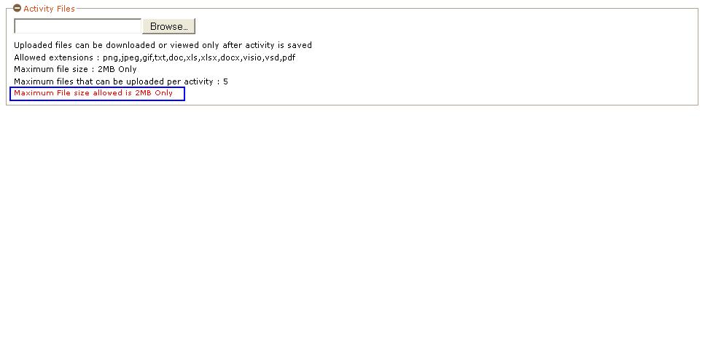

Screen

If the extension is not in the allowed extensions an alert message appears as shown in below screen.

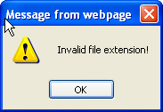

Screen

If the number of files uploaded exceeds maximum files that can be uploaded per activity then the “Browse” button appears in disabled state as shown in below screen.

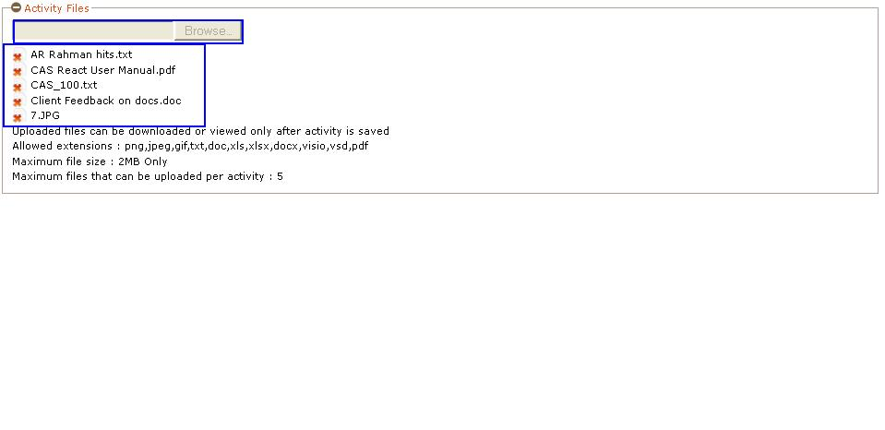

Screen

When user tries to upload any file more than once then an alert appears as shown in below screen.

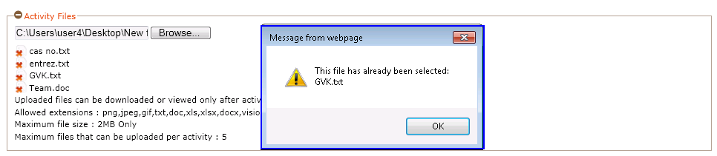

Screen

Considering the specifications facilitated in the “Activity Files” user is allowed to attach activity file using “Browse” button then the file gets uploaded and appears as shown in below screen.

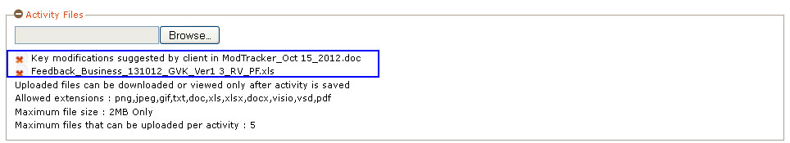

Screen

Click “” button besides the uploaded activity file to delete the attached file as shown in below screen.

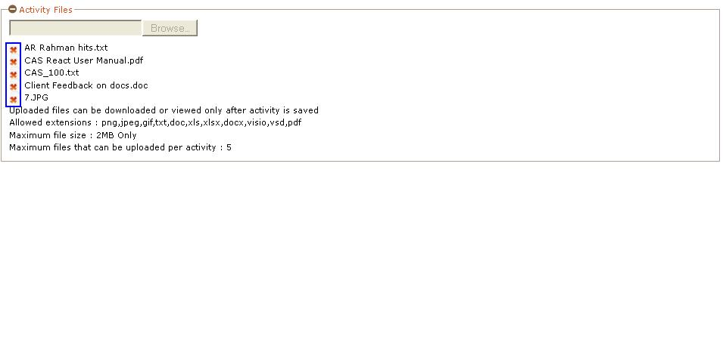

Screen

Corresponding activity file gets deleted and the page appears as shown in below screen.

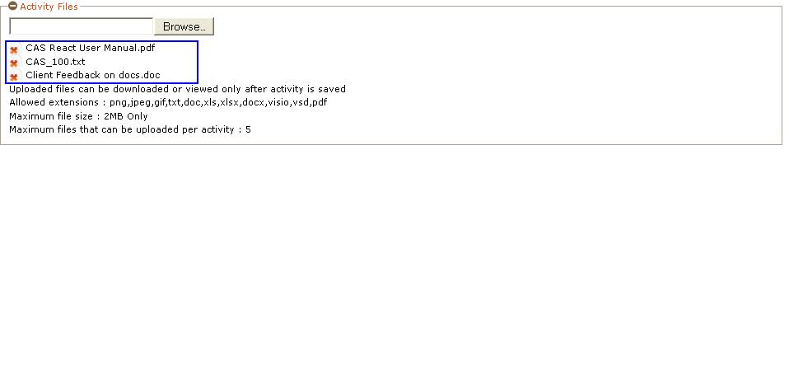

Screen

### Deliverables

In the “Data Request” user is allowed to add deliverables in the similar way user has added for “Modeling Activity” ***Refer section3.4.9.2*** for details.

### Source Data

Data Request Activity provides user to include “Source Data” regarding the study Data and Module data in “Source Data” tab.

1. Click “Source Data” tab then the application appears as shown in below screen.



Screen

1. Select the Study information from the study field.
2. Enter data in Study field the application provides the list of studies related to the entered study as shown in below screen.

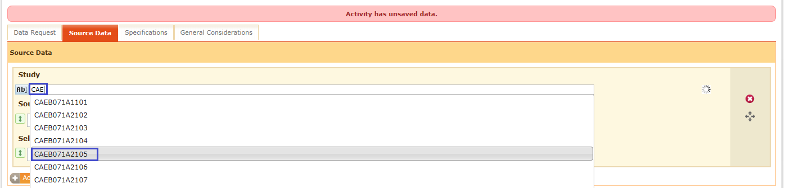

Screen

1. Enter data about Source Data Location and Selection Criteria in the corresponding fields as shown in below screen

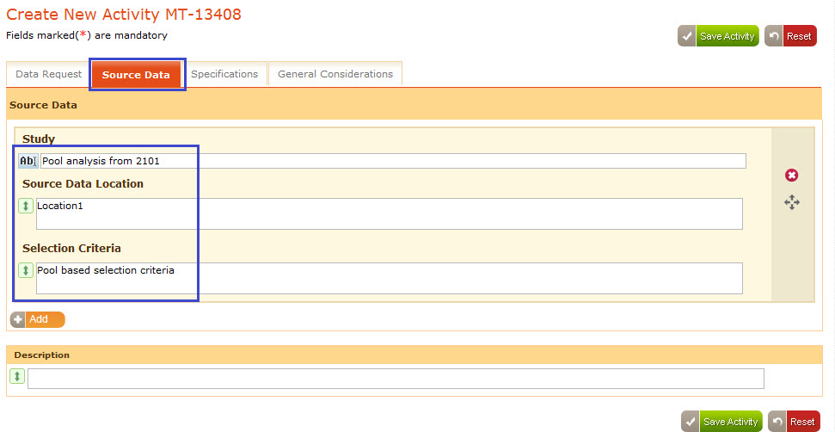

Screen

1. Click “Add” button to add multiple studies as shown in below screen.

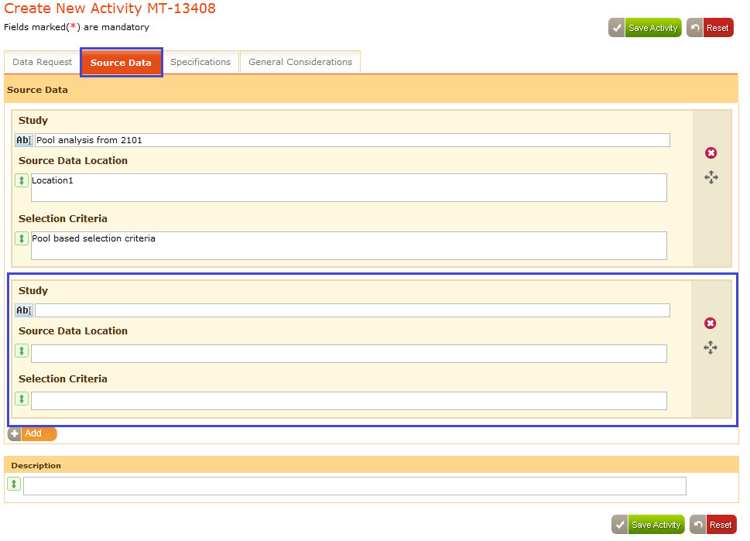

Screen

1. Enter the data for the other study as shown in below screen.

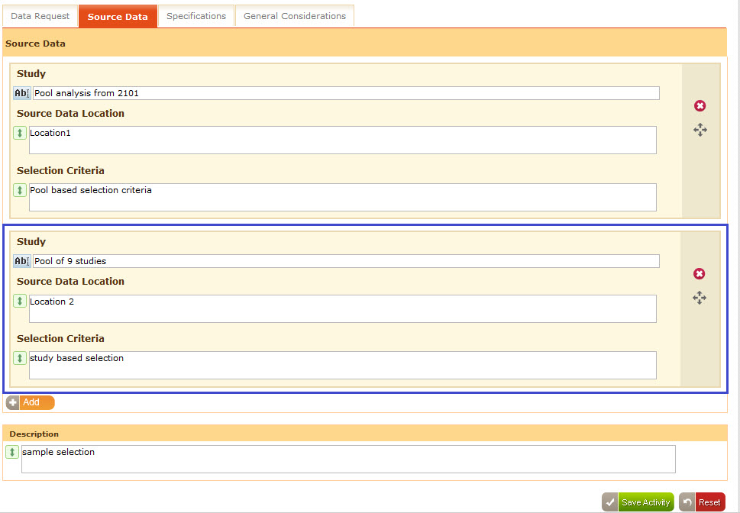

Screen

1. Click “” icon to drag and drop to change the order of the studies as shown in below screen.

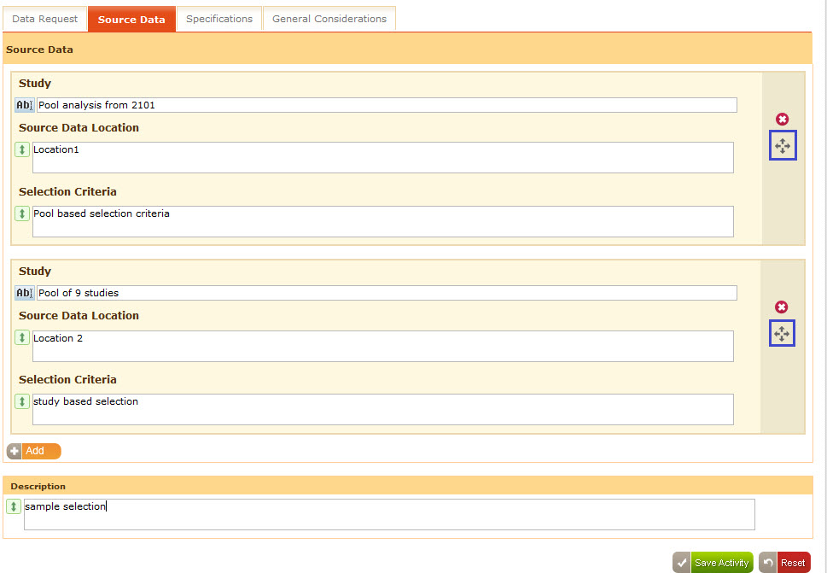

Screen

1. Order of the studies changes and appears as shown in below screen.

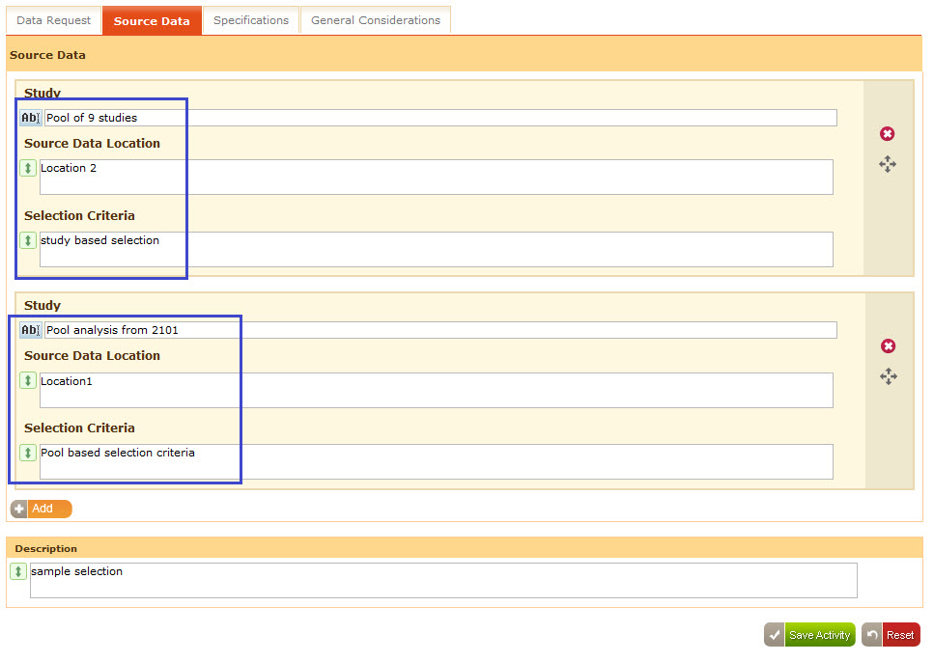

Screen

* 1. Click“” button to delete the study information as shown in below screen.

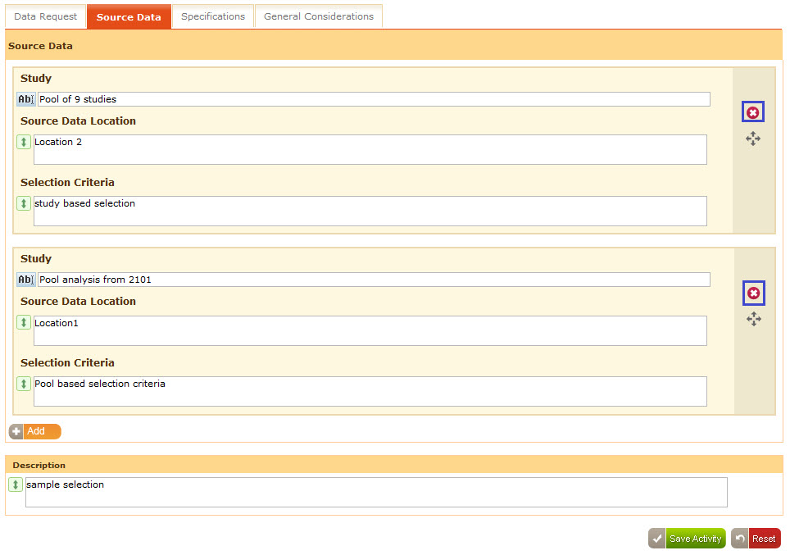

Screen

* 1. Deletion confirmation message box appears as shown in below screen.

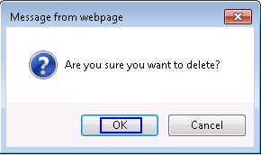

Screen

* 1. Click “Ok” then that study information gets deleted from the “Source Data” page and it appears as shown in below screen.

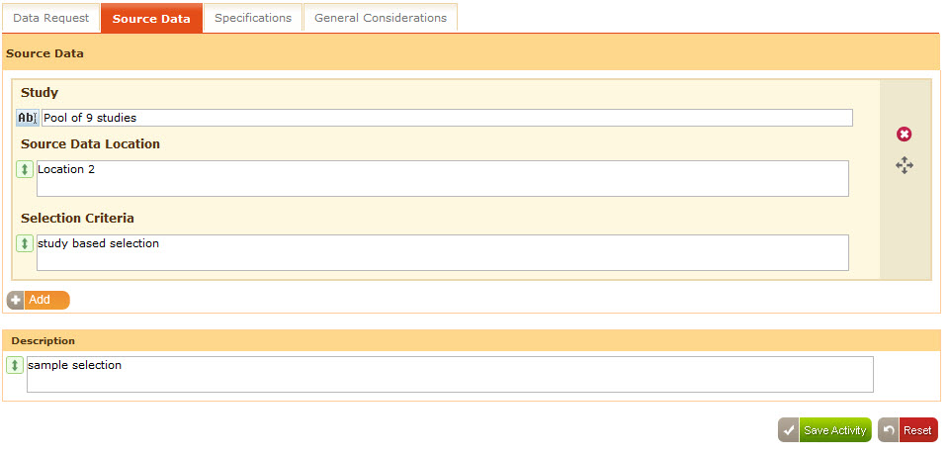

Screen

### Specifications

Data Request activity permits user to provide data related to specifications for the “Data Request Activity” using “Specifications” page.

1. Click “Specifications” tab then the specifications page provides information of the existing “Table of Variables” and “Table of Events” as shown in below screen.

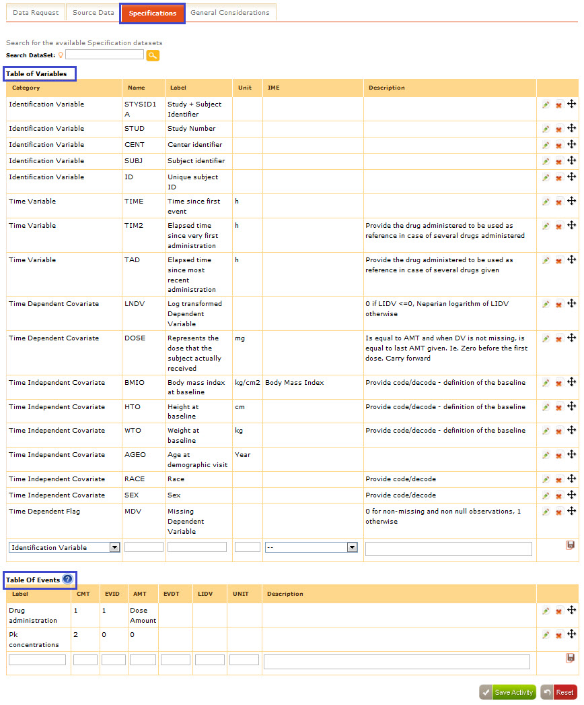

Screen

1. Search for any specification using “Search Dataset” field,
2. Enter any specification in the “Search Dataset” field and click “” button
3. Corresponding dataset information appears as shown in below screen.

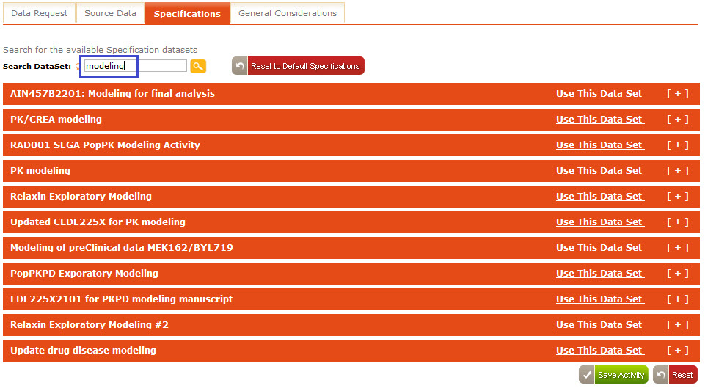

Screen

1. xpand the dataset information using “[+]” button, the data appears in the expanded mode and the [+] button appears as [-]
2. Click [-] button to collapse the expanded mode as shown in below screen.

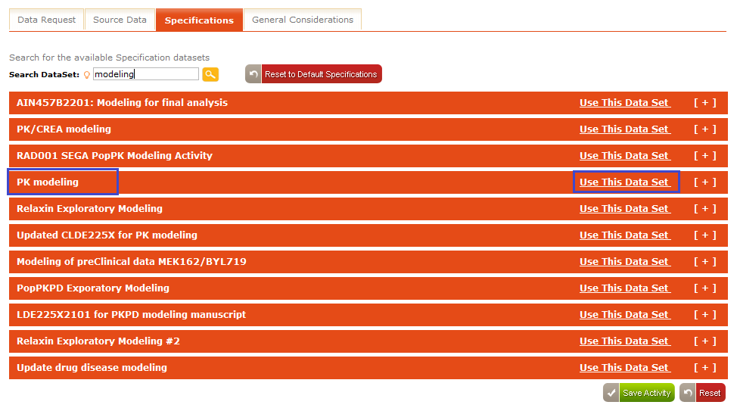

Screen

1. Click “Use This Data Set” as shown in below screen.

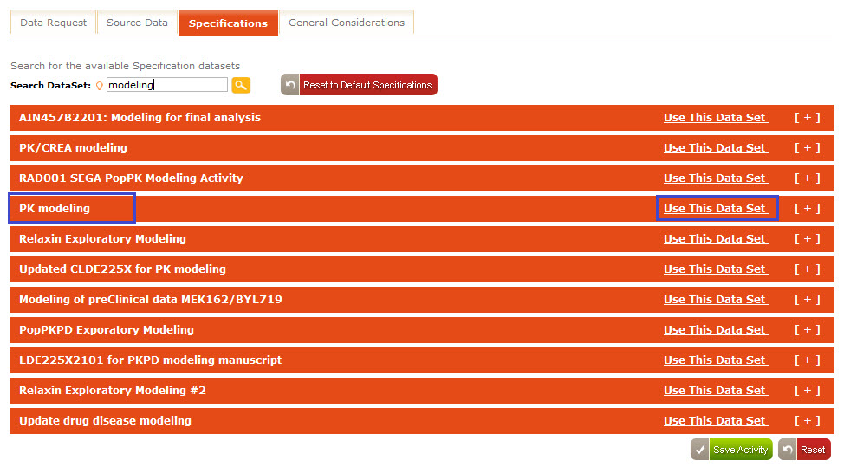

Screen

1. Corresponding specifications information gets loaded in the “Specifications” page and the page appears as shown in below screen***.***

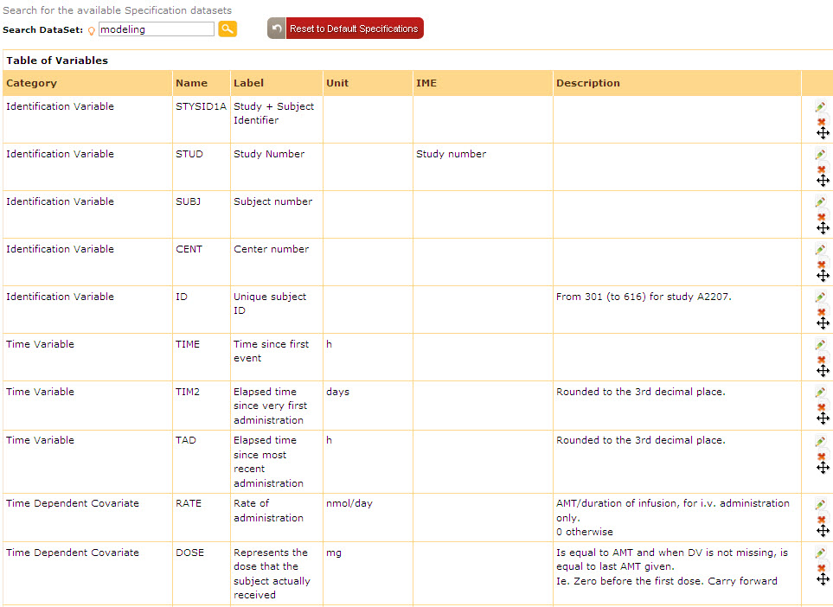

Screen

### General Considerations

Data Request activity also facilitates users to provide the information about the study files that are affected in this activity using “General Considerations” tab.

1. Click “General Considerations” then the page appears as shown in below screen.

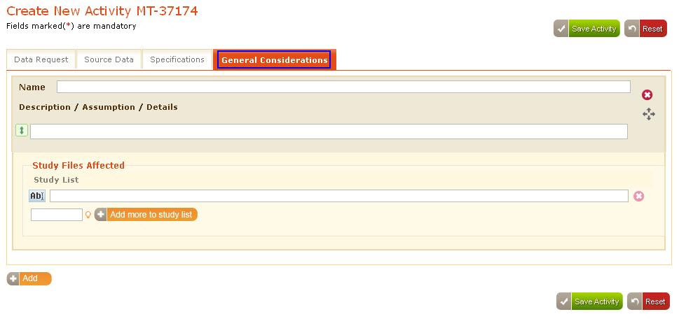

Screen

1. Enter data in the “General Considerations” page
2. Select the affected study list files from the “Study Files Affected” section under Study list, auto select field as shown in below screen.

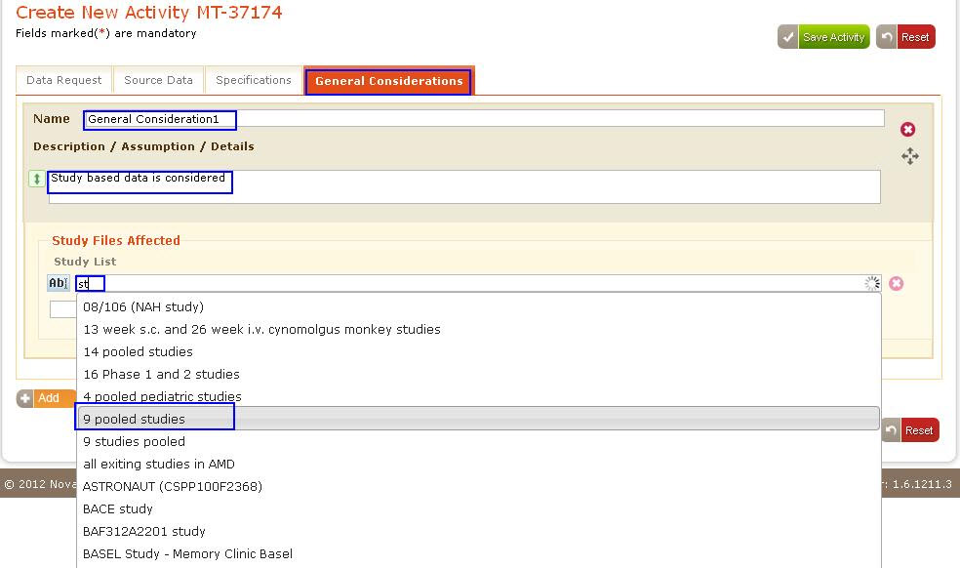

Screen

1. Specify the number of study lists value and click “Add more to Study List” button to add multiple study lists as shown in below screen.

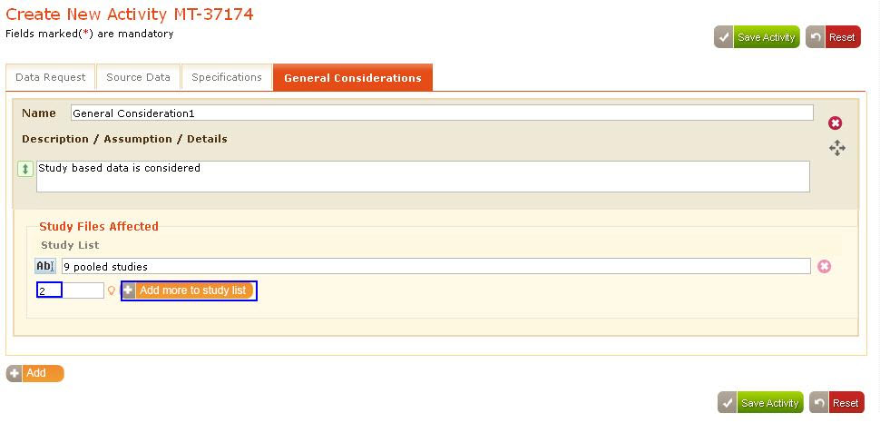

Screen

1. Based on that the specified number of study list fields get added and appears as shown in below screen.

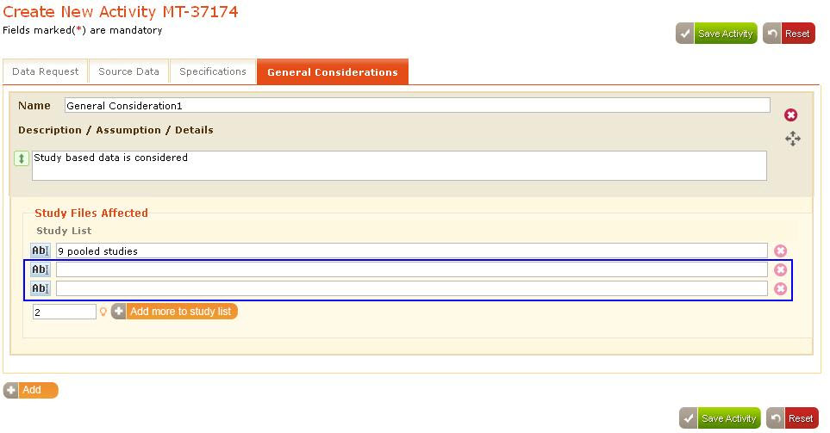

Screen

1. Click “” button besides the required study list that to delete the study list as shown in below screen.

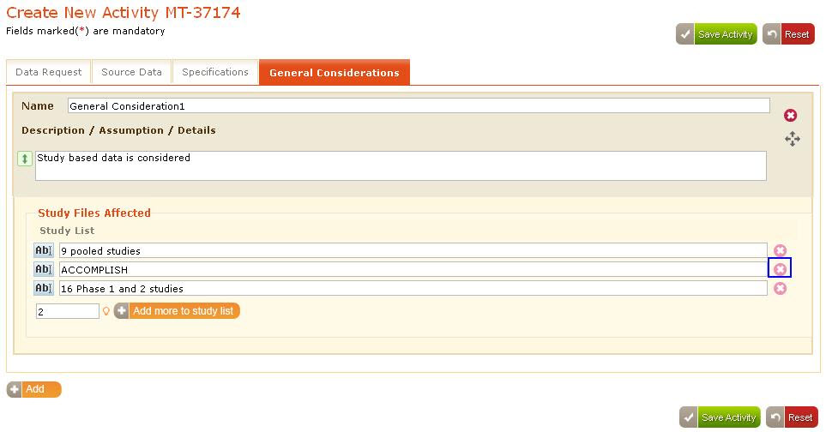

Screen

1. Deletion confirmation message box appears as shown in below screen.

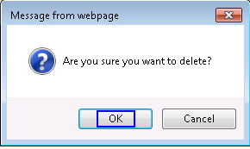

Screen

1. Click “Ok” button on the message box then the corresponding study list gets deleted as shown in below screen.

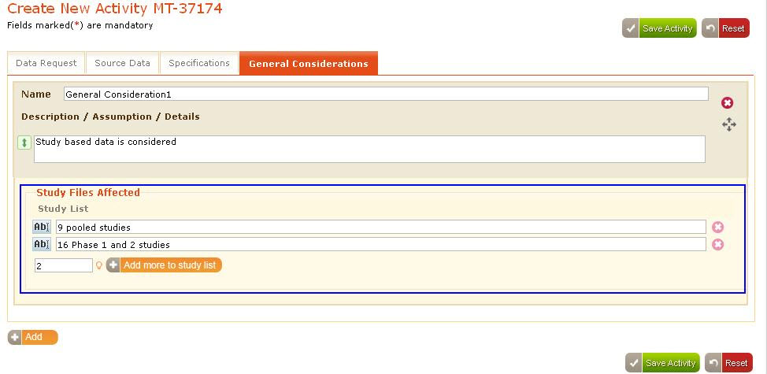

Screen

1. Click “Add” button to add multiple study lists as shown in below screen.

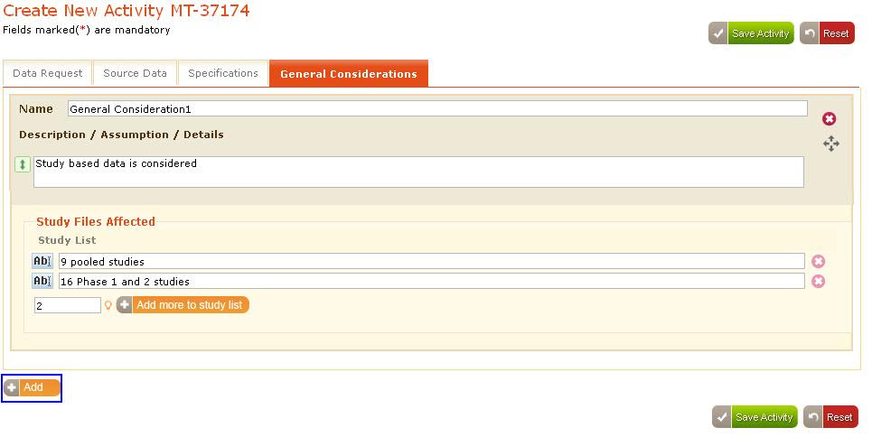

Screen

1. General consideration sections get added and appear as shown in below screen.

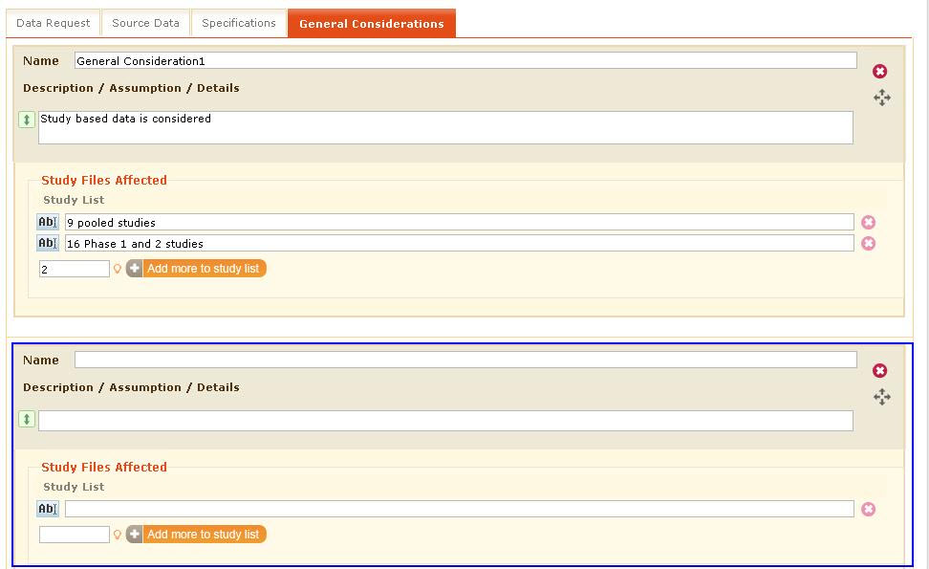

Screen

1. Click “” button besides the name field to delete the study lists as shown in below screen.

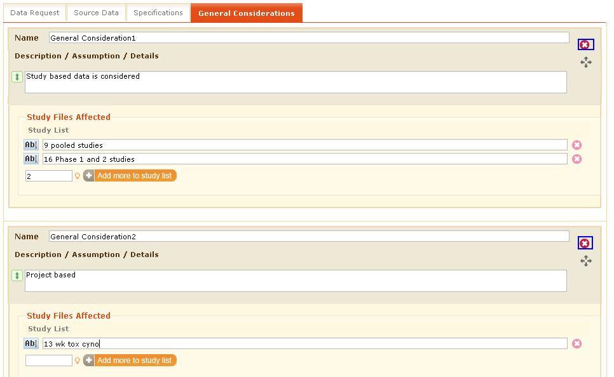

Screen

1. Deletion confirmation message box appears as shown in below screen.



Screen

1. Click “Ok” on the message box, the corresponding General Consideration information gets deleted as shown in below screen.

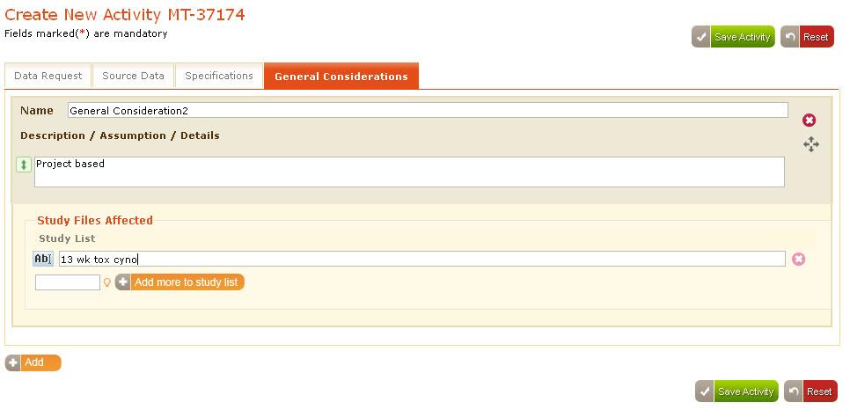

Screen

1. Click “Save Activity” button, the activity gets saved and an acknowledgement appears indicating the activity is saved successfully in the “My Activities” page.

## Creation of Module Activity

Module Activity is similar to “Data Request Activity “except adding module in which user is allowed to fill data in the below specified sections similar that the user has filled in “Data Request Activity”

* **Mandatory fields :** User need to fill all the mandatory fields in the “Create New Activity” page for the “Module” activity
* When user selects “Module” as activity type then “Source Data, Specifications, General Considerations” tabs appears besides the “Module” tab similar to the “Data Request Activity” as shown in below screen.

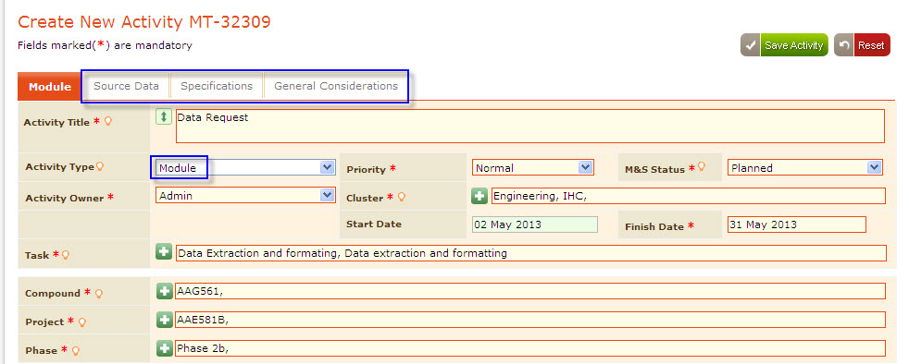

Screen

* **Associated Activities:**Add associated activities to the Module activity following the same process that the user has followed for “Modeling Activity” for details ***Refer section 3.4.8***
* **Team:**Add Team roles to the Module activity following the same process that user has followed for “Modeling Activity” for details ***Refer section3.4.9***
* **Activity Files:** Attach activity files to the Module activity following the same process that user has followed for “Data Request Activity” for details ***Refer section3.5.3***
* **Deliverables:** Add deliverables to the Module activity following the same process that user has followed for “Modeling Activity” for details ***Refer section3.4.9.2***
* **Validation Status:**Select the required validation level and validation status following the same process that user has followed for “Modeling Activity” for details ***Refer section3.4.10***

All the above selected/entered data appears as shown in below screen.

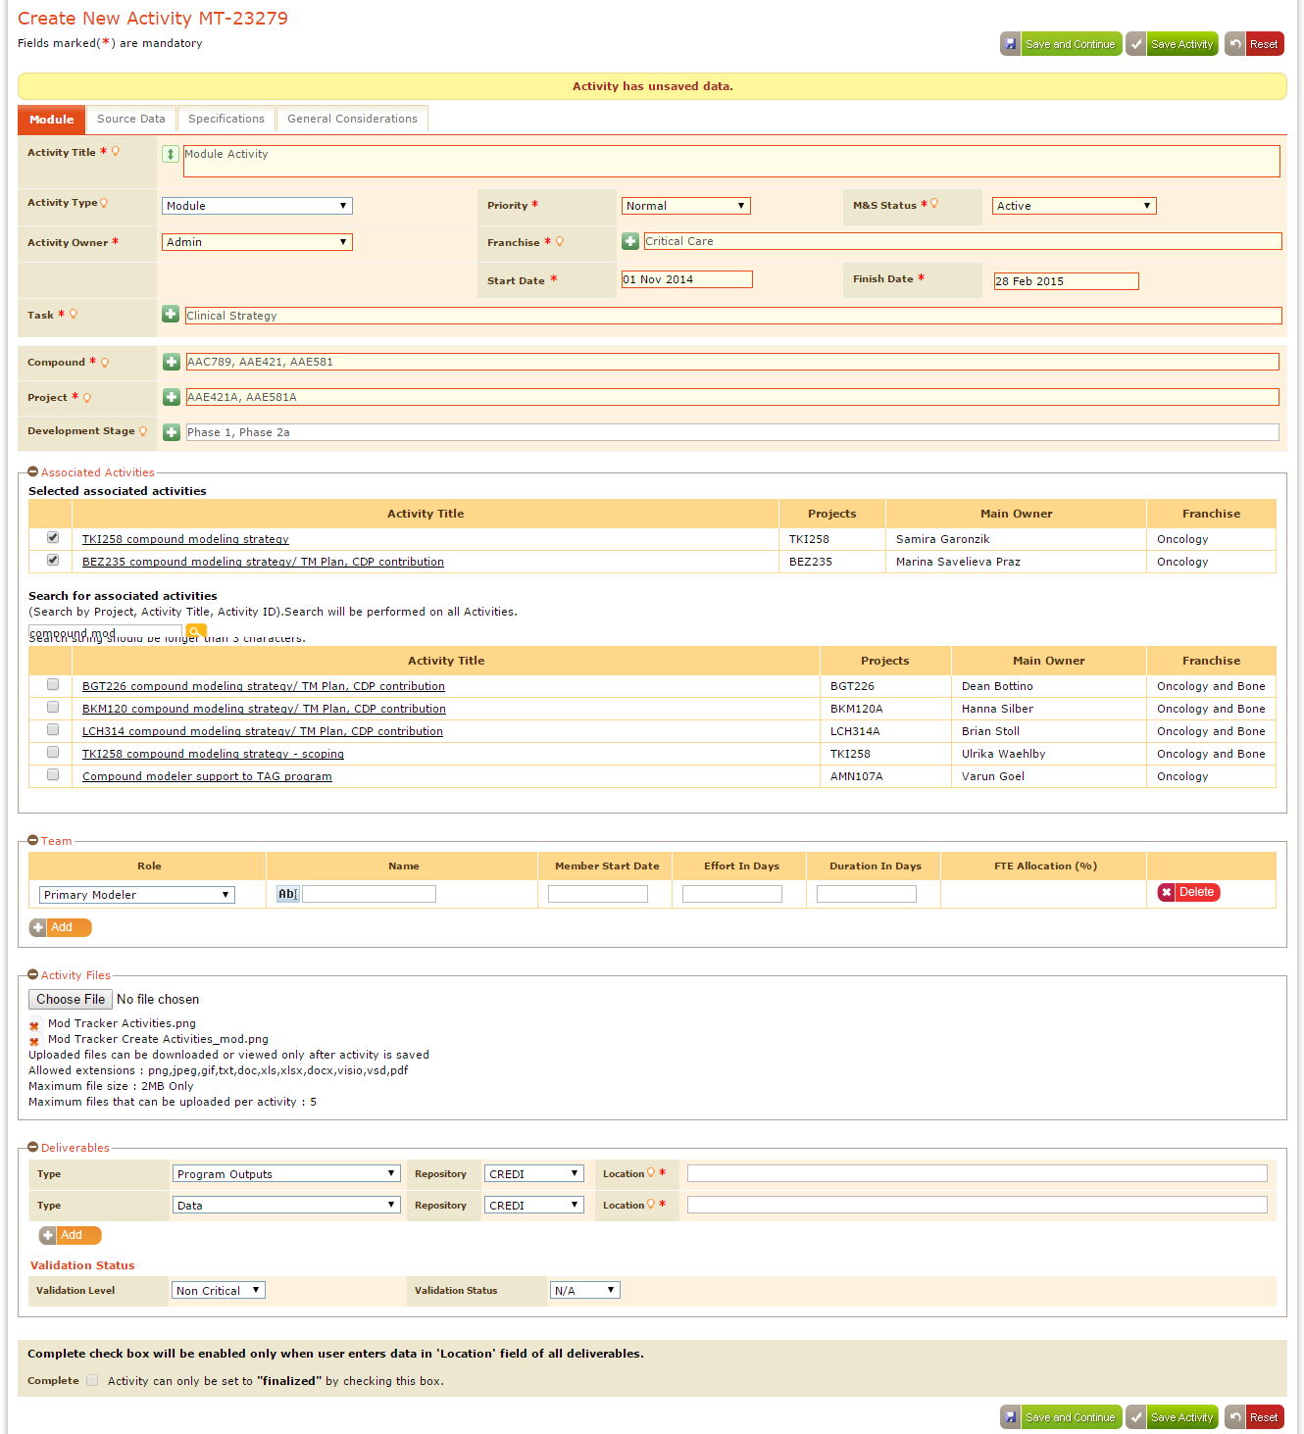

Screen

### Source Data

User can provide needed details in the “Source Data” following the process that user has followed for “Data Request” and the page appears as shown in below screen***.***

For details ***Refer Section3.5.5***

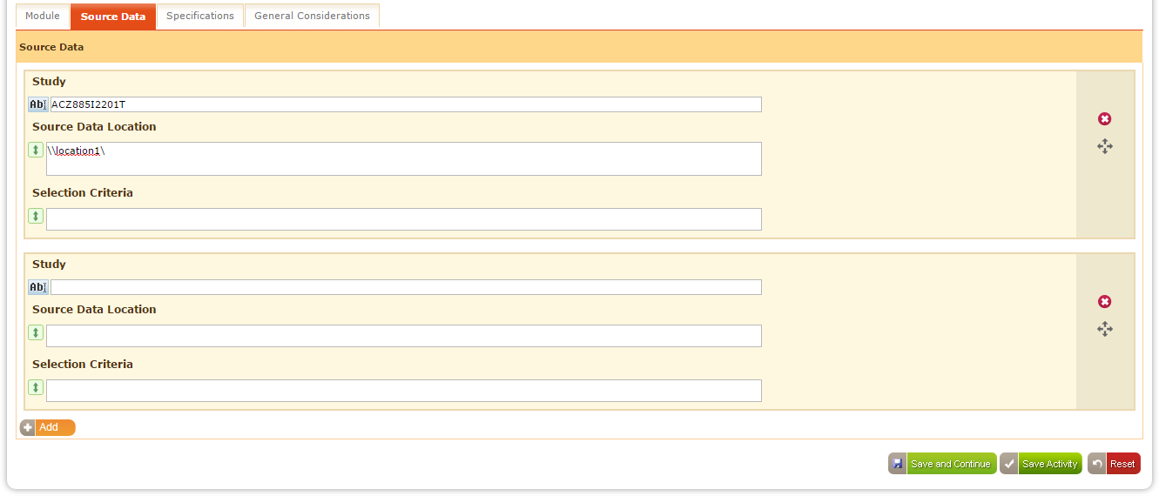

Screen

### Specifications

User can provide needed details in the “Specifications” following the process that user has followed for “Data Request” and the page appears as shown in below screen.

For details ***Refer Section3.5.6***

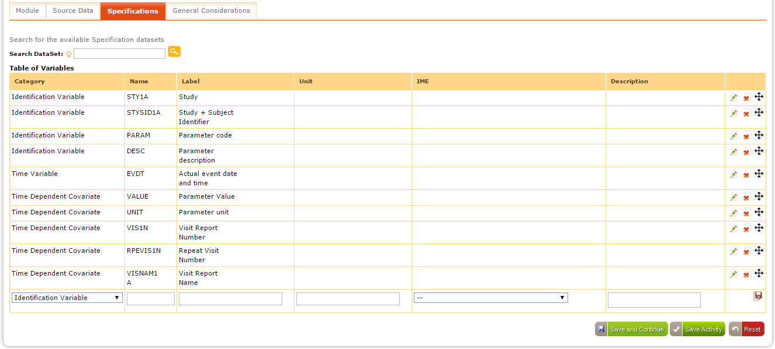

Screen

### General Considerations

1. Provide the required details in the “Specifications” following the same process that user has followed for “Data Request” and the page appears as shown in below screen.

For details ***Refer Section3.5.7***

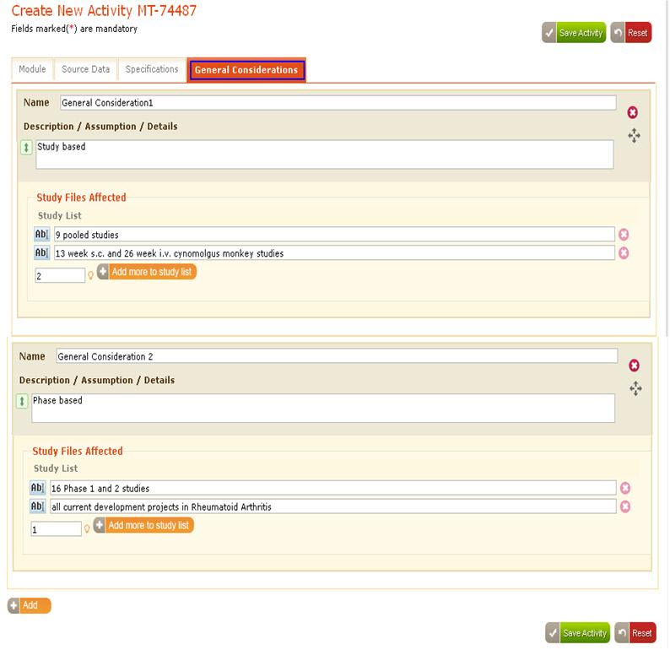

Screen

1. Click “Save Activity” button as shown in below screen.

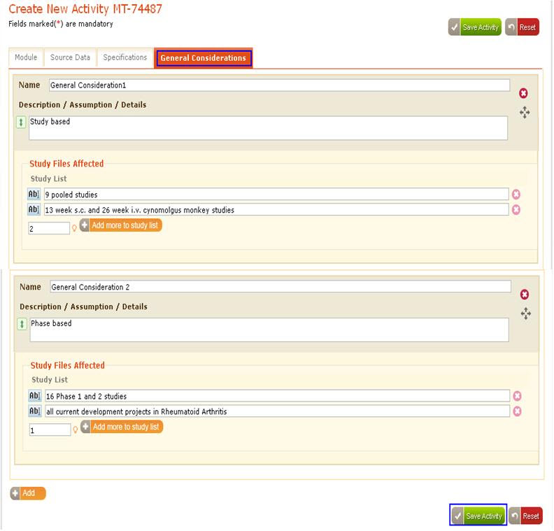

Screen

1. Activity gets saved and application navigates to “My Activities Page”
2. Saved activity appear under the corresponding “M&S Status” tab considering the “M&S Status” value selected while creating the activity as shown in below screen.

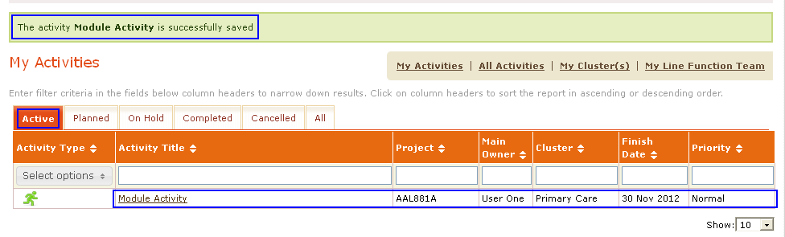

Screen

### Reset Activity

Click “Reset” button to reset all the data given in the “Create New Activity” page as shown in below screen.

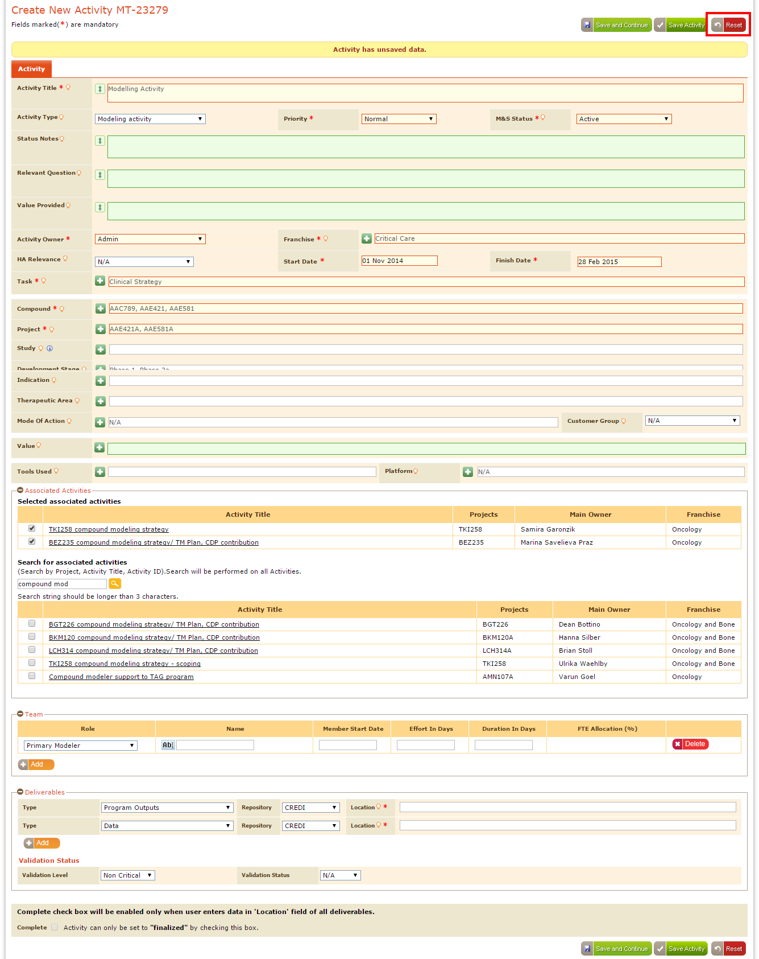

Screen

The page gets refreshed and only displays the default selected data as shown in below screen.

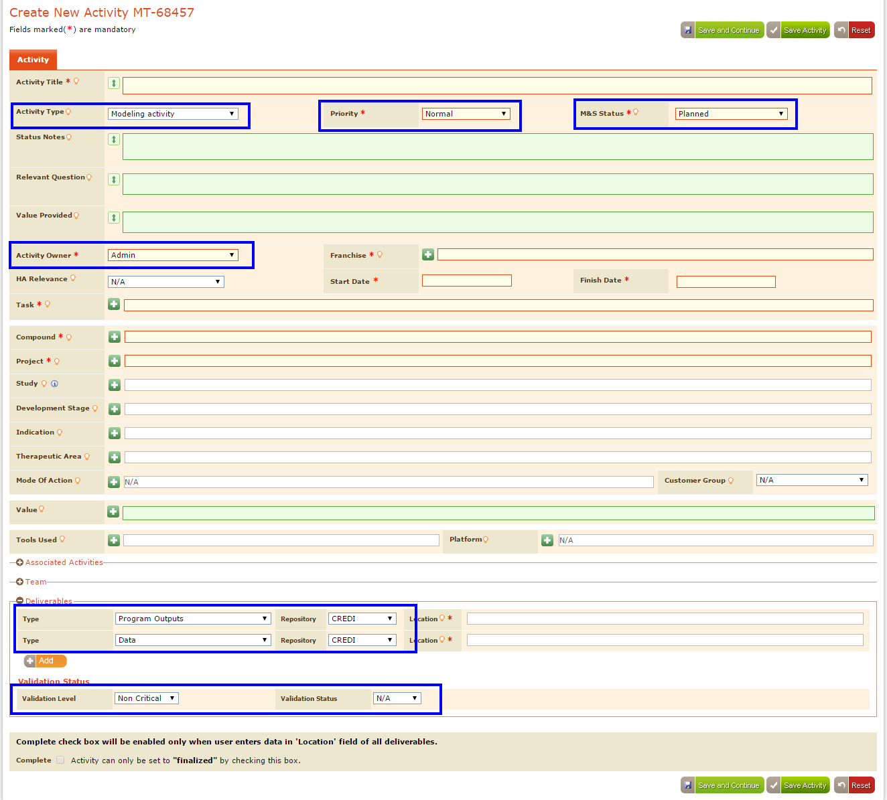

Screen

## Creation of Platform Request Activity

Platform Request Activity is similar to the Modeling Activity. In the new activity page select “Activity Type” as “Platform Request” and

* Select/enter the data similar to that user has selected for “Modeling Activity” for details ***Refer Section3.4***.
* Enter“Dev FTE Saving” information in the section below the “Tools Used”,
* Enter/select the data required for “Dev FTE Saving, QC FTE Saving, Speedup (%), Cost, Quality Enhancement, and Enabling of Project”.
* Click “Save Activity” to save the “Platform Request Activity” as shown in below screen.

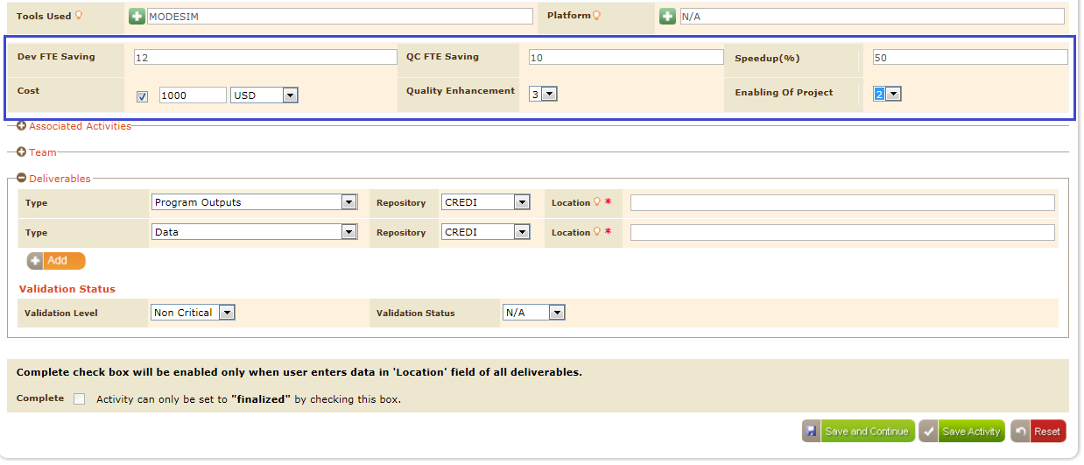

Screen

* Activity saved message appears in the “My Activities” page, and the platform request gets saved under the corresponding “M&S Status” tab in the “My Activities” page and as shown in the below screen.

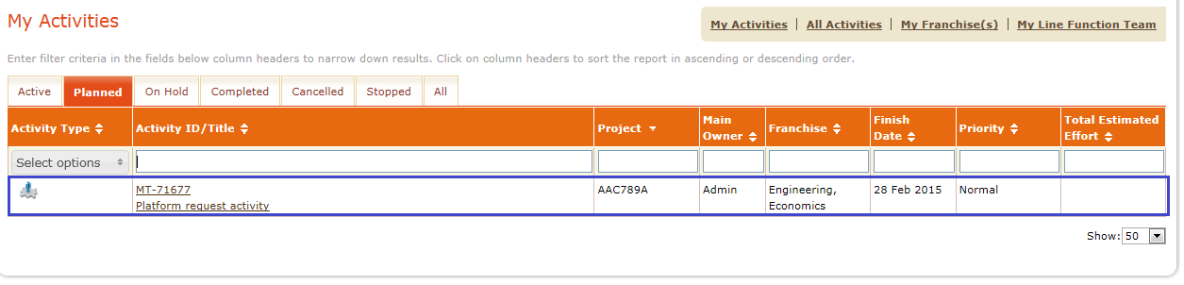

Screen

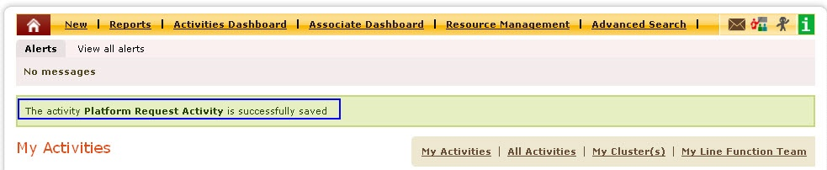

Screen

* Run Platform Activities” report to view the platform request activities as shown in below screen.

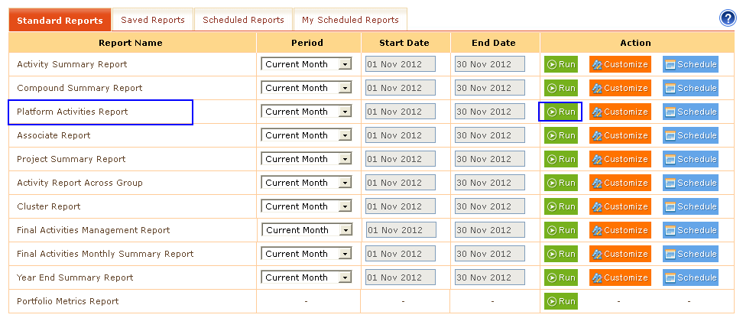

Screen

* All the platform request activities information appears as shown in below screen.

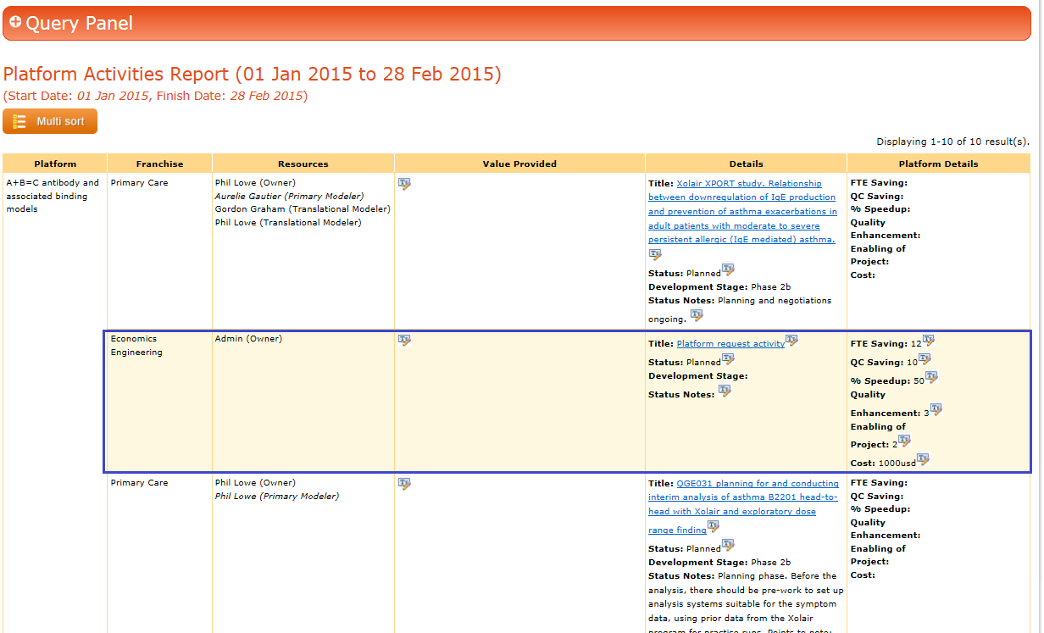

Screen

**Note:** When user selects “Platform” value as “N/A” then those activities doesn’t appears in the reports.

## 

## Creation of Summary Activity

1. Select “Summary Activity” from the activity type drop down in the “Create New Activity” page,
2. Fill the mandatory fields in the similar way as that of the other activities
3. For summary activities there will be no start and finish dates.
4. Hence “Start Date and Finish Date” fields don’t appear in the “Create New Activity” page.
5. For “Summary Activities” there is no need to add “Teams, Modules, Deliverables and Validation Status” so these sections will not appear for Summary Activity.
6. Add associate activities for the summary activity using “Associated Activities” as shown in below screen.

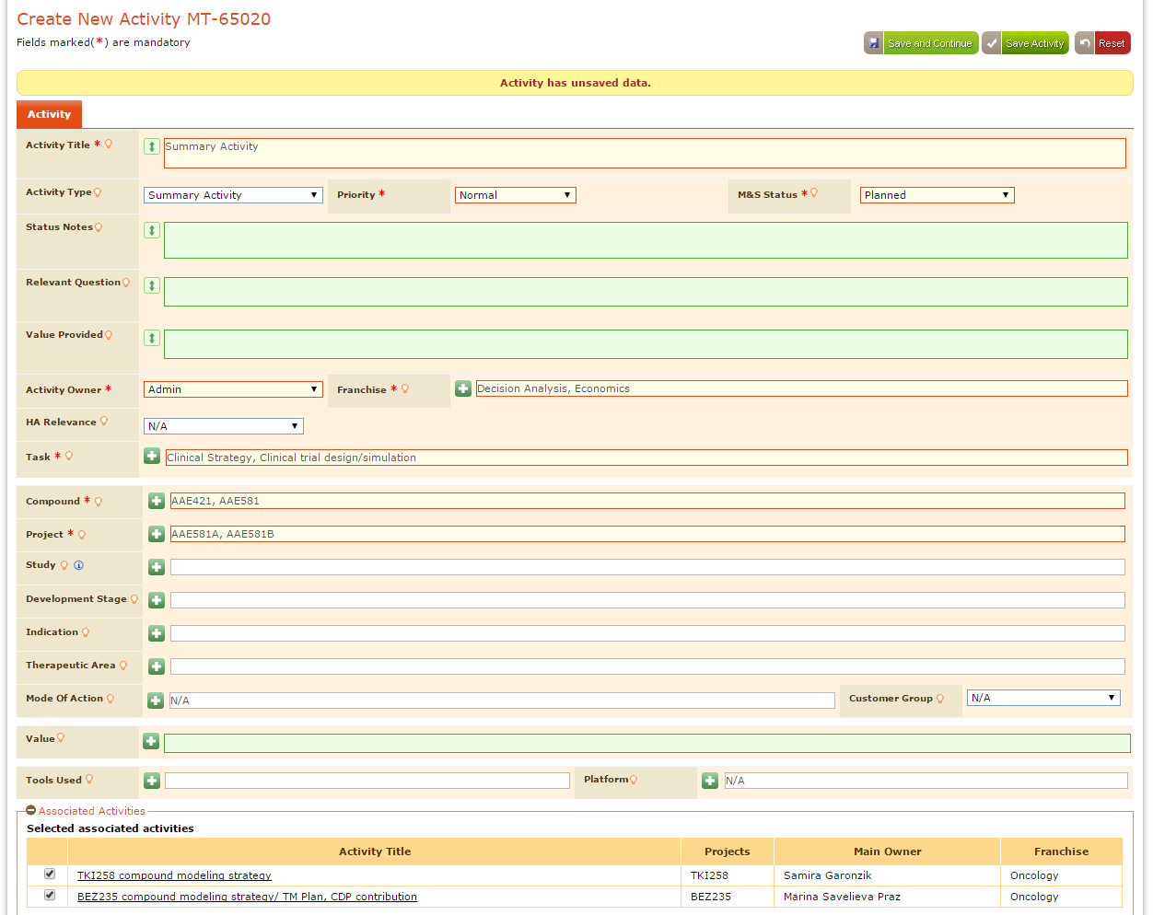

Screen

**Note:**

As summary activities do not contain start and finish dates, so while generating the report application considers earlier start date and last finish dates of its associated activities.

The report displays with summary activities and their associated activities at the top of the report as shown in below screen.

This functionality is not applicable for the “Activity Summary Report, Associate Report, and Year End Summary Reports.

As “Summary Activities” considers the Start and Finish dates of its associated activities, if user doesn’t select any associated activities for Summary Activity then those summary activities information doesn’t appear in the report

## Validations to create the new activity

1. All the mandatory fields should be filled.
2. Start Date should be earlier date than the Finish Date.
3. Under “Activity Files” the chosen files should be of the specified format, file size should be less than the maximum file size and the number of files that can be uploaded should be within the limit mentioned in “Maximum Files that can be uploaded per activity”, these “Activity Files” section appears only for the activity type “Data Request and Module.
4. If the selected activity is “Data Request or Module” then the “Source Data, Specifications, General Considerations” appears.
5. When user clicks “Add” button under “Team” then new team appears
6. When user clicks “Add” button under “Deliverable Types” then new deliverable types appears
7. User also can select the required validation status using “Validation Status” shown in below screen drop downFields in the “Create New Activity” page varies depending upon the type of activity selected
8. If user want to reset the data entered in the “Create New Activity” page use “Reset” button
9. For Summary Activity “Start Date and Finish Date” fields don’t appear because summary activities doesn't consists start and finish dates.

# My Activities

My Activities displays the activities created by the logged in user. By default “Active” activities appear. User is allowed to view the other activities in their respective M&S Status tabs in “My Activities” page.

## Types of ActivityStatus(M&S Status)

All Activities are classified into 4 types considering the selected “M&S Status” while creating the activity.

### Active

Click “Active” tab then the activities that are created with “M&S Status” as “Active” appears as shown in below screen. When user clicks “My Activities/All Activities” Active tab appears by default.

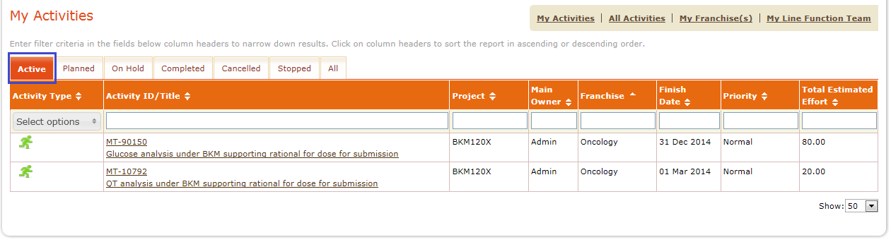

Screen

### Planned

Click “Planned” tab then the activities that are created with “M&S Status” as “Planned” appears as shown in below screen.

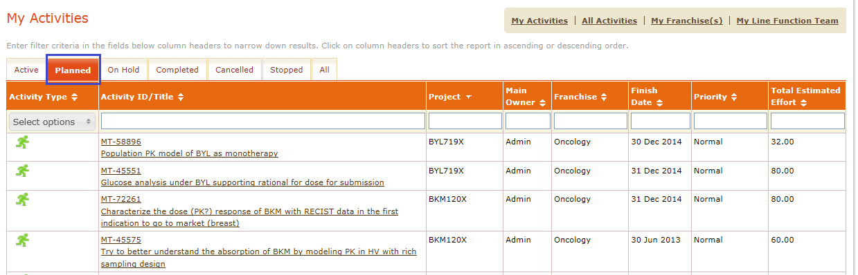

Screen

### On hold

Click “On hold” tab then the activities that are created with “M&S Status” as “On hold” appears as shown in below screen.

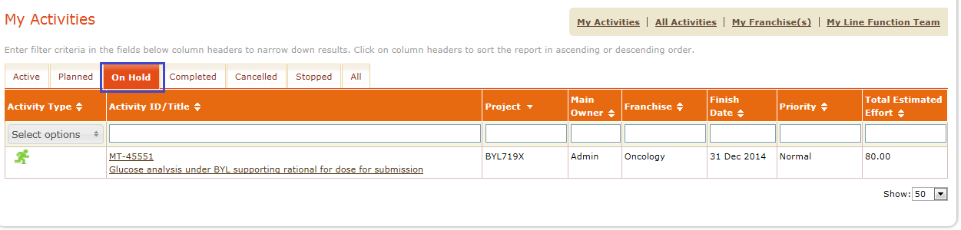

Screen

**Note:** All the “On Hold” activities gets excluded from the Reports and from Search Results unless until user selects them deliberately from “Query Panel” and “Advanced Search” options respectively.

### Completed

Completed tab in the landing page provides the list of activities that are marked completed. When an Activity is created user can set M&S Status to Active, Planned, On Hold, Stopped or Cancelled.

For completing the activity, user has to provide below mandatory fields

* Value provided must be filled
* Relevant question must be filled
* Program Outputs and Data Deliverable records must contain data in location field

Once user provides data in required deliverables, only then Complete check box is enabled for the user selection.

While completing the activity, if user doesn’t fill any mandatory field, then pop up with missing fields is displayed as shown in below screen

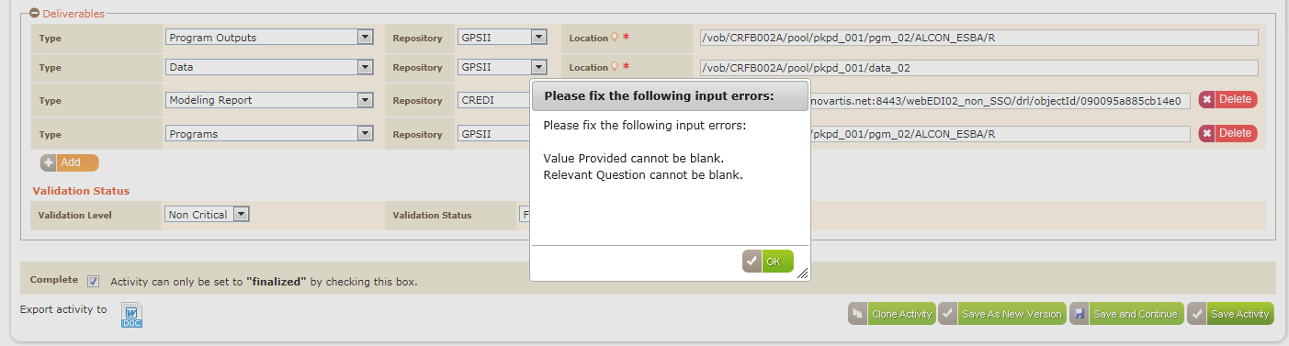

Screen

When user selects check box acknowledgement is displayed as shown in below screen

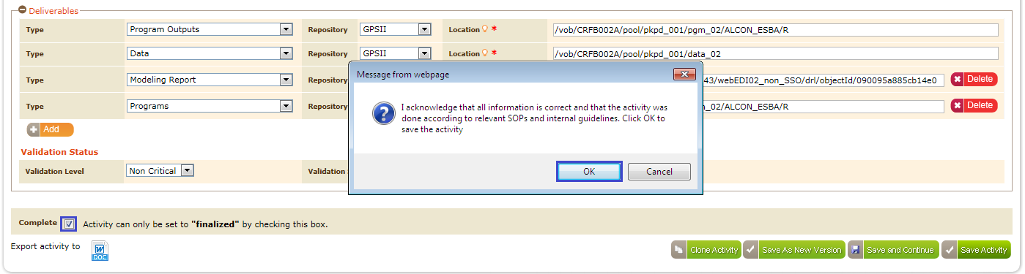

Screen

On clicking “OK” button activity gets saved with M&S status set to “Final” and stays on the same page with disabled fields.

Note:

* By default completed activities appears in all the reports along with other corresponding activities.
* “Final Activities Management Report” and “Final Activities Monthly Summary Report” displays only completed activities which have“M&S Status” as “Final.”
* Audit log records all the updated fields of the Activity.

### Cancelled

Cancelled M&S Status is used to cancel the existing activities. Below are the steps to cancel the activity.

1. Select “Cancelled” in“M&S Status” field.
2. Cancel Reason text field appears
3. Enter the reason for cancellation in the “Cancel Reason” text box as shown in below screen.

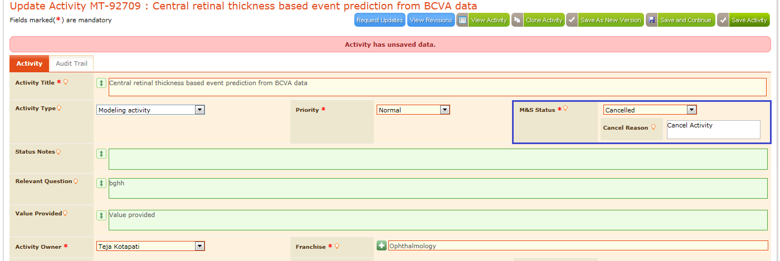

Screen

1. Click “Save Activity” button so that the cancelled activity gets saved and appears under “Cancelled” tab in the “My Activities” page as shown in below screen.

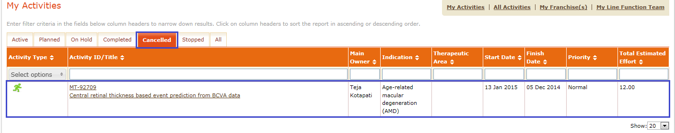

Screen

Note: All the “Cancelled” activities gets excluded from the Reports until user selects them deliberately from “Query Panel” options

### Stopped

Stopped M&S Status is used to Stop the existing activities. Below are steps to stop the activity

1. Select “Stopped” in “M&S Status” field
2. Stopped Reason text field appears
3. Enter the reason for stoping an activity in the “Stopped Reason” text box as shown in below screen.

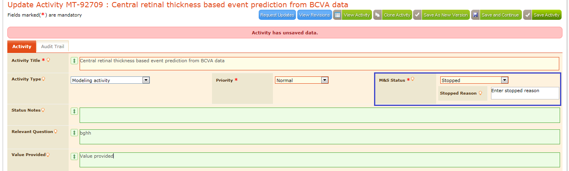

Screen

1. Click “Save Activity” button so that the stopped activity gets saved and appears under “Stopped” tab in the “My Activities” page as shown in below screen.

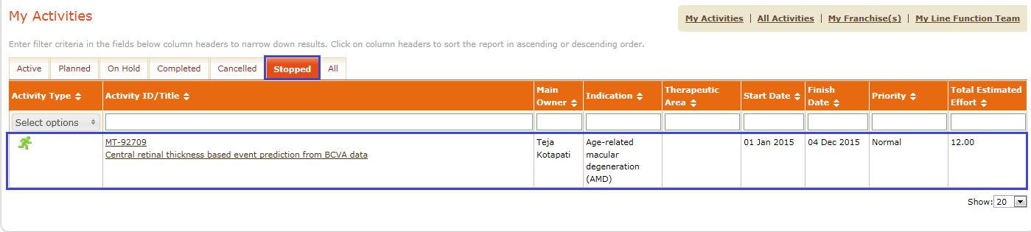

Screen

Note: All the “Stopped” activities gets excluded from the Reports until user selects them deliberately from “Query Panel” options

# All Activities

All Activities page provides the complete activities information created by all the users considering the columns to display that are selected by the user in the “My Account” page. Under “My Activities and All Activities screen - Columns to display” section as shown in below screen.

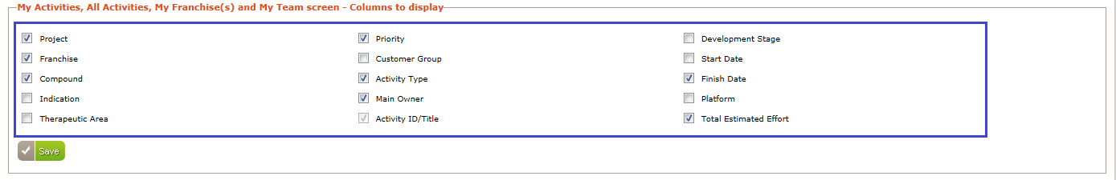

Screen

1. Modify these columns display whenever it’s required using checkboxes.
2. Click “Save” button to save the modified columns to display
3. User is allowed to select maximum of 9columns only for the display in the “All Activities” page. All Activities page displays all the activities irrespective of the user logged in as shown in below screen***.***

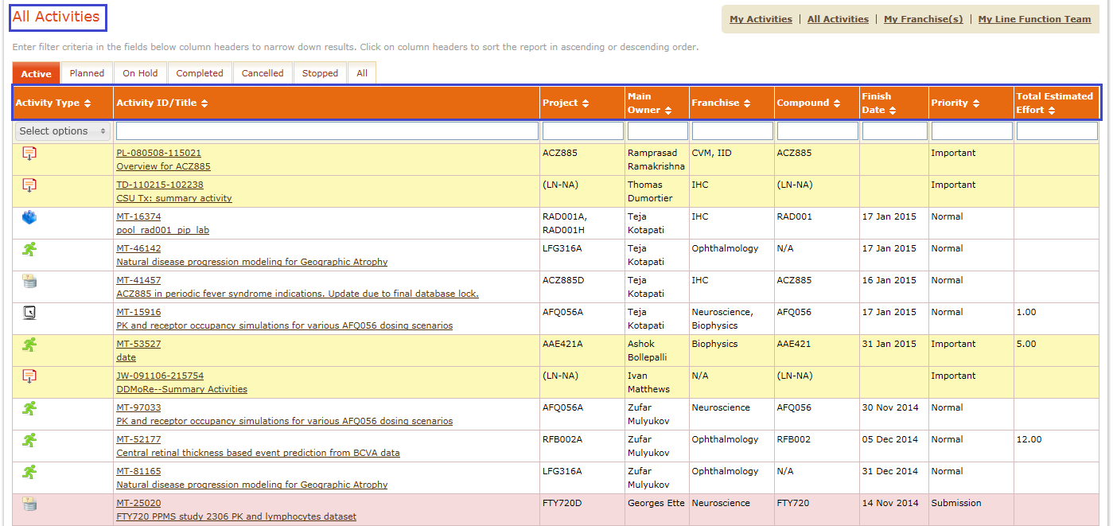

Screen

Clickon“M&S Status” tabs to view the activities related to selectedM&S Status as shown in below screen.

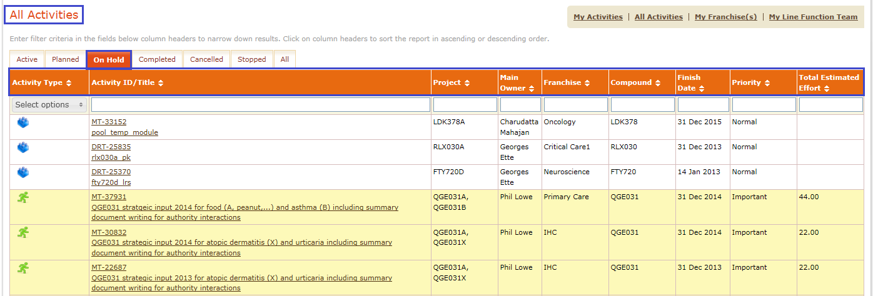

Screen

All the functionalities of the Active, Planned, On Hold , Completed, Cancelled, Stopped and All are same as that are in the “My Activities” page. This tab displays the activities of all the users appears in all those "M&S Status” tabs irrespective of the logged in user. For details refer***Section 4 My Activities.***

## Sort/Filter All Activities

ModTracker application allows users to sort the data using “” sort symbol. Filtering of the data is allowed by entering the values in the text field and click “Tab” button from the keyboard then the corresponding data appears in the application.

Application remembers the Sorted/Filtered data until/unless user logouts from the application.

Example:

1. Click “All Activities” from the home page
2. Enter the required activity name in the “All Activities” page
3. Click “Tab” button from the keyboardshown in below screen.
4. Application filters the data and corresponding values appears as shown in below screen.

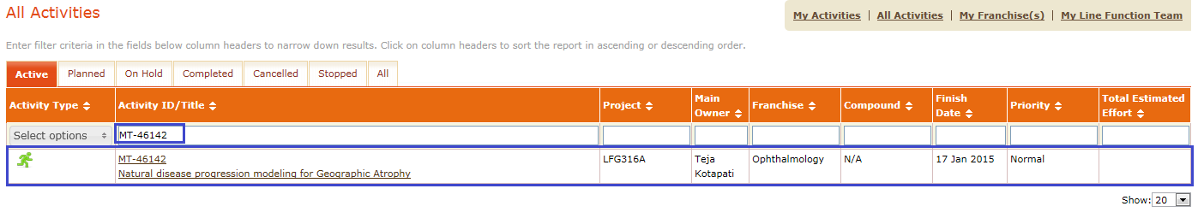

Screen

1. To navigate to another page, click “Resource Management” link from the main menu bar as shown in below screen.

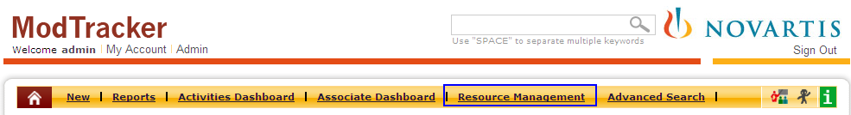

Screen

1. Resource Management page appears as shown in below screen.

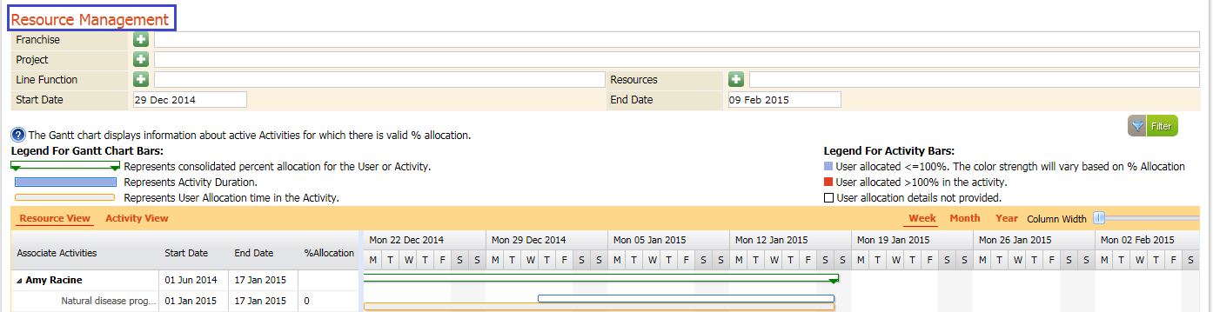

Screen

1. Click “” link from the main menu bar, “My Activities Page” appears shown in below screen
2. Click “All Activities” from “My Activities” page
3. Application remembers the previously applied filter and displays the filtered data as shown in below screen.

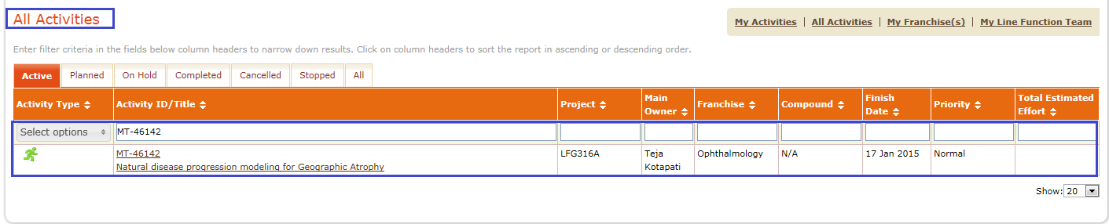

Screen

**Note:** Sort/Filter functionality is applicable to “My Activities, All Activities, My Franchise(s), and My Line Functional Team

# View Activity

Click the “Activity Title”/”Activity ID” in the “My Activities/All Activities” pages as shown in below screen to view the activity as shown in below screen.

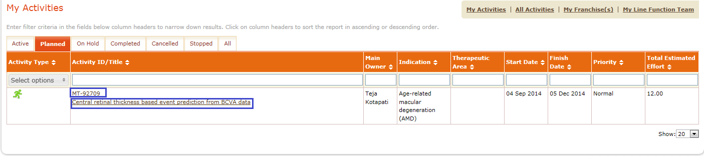

Screen

Then “View Activity” page appears with the complete activity information in non editable mode. Along with “Activity” tab user can view Audit trail tabwhich displays the audit trail records of that activity. Also “Request Update, Clone Activity and Edit Activity” buttons displayed as shown in below screen.

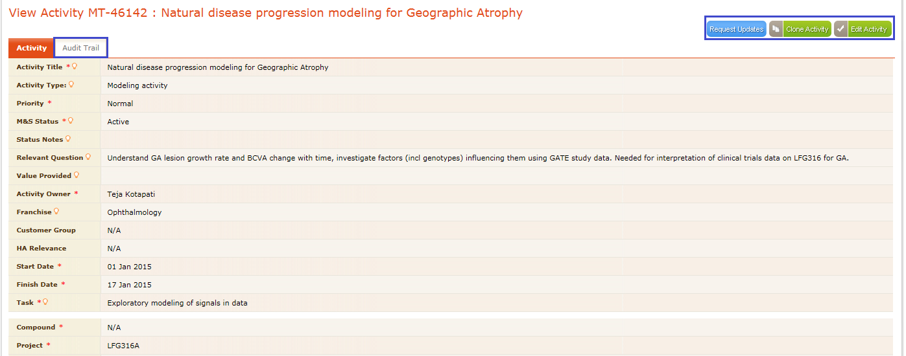

Screen

## Update/edit the activity

In the “ModTracker” application user is allowed to edit any activity using “Edit Activity” button, if the logged in user is the either “Activity Owner or Team Member” of that activity.

1. Click “Edit Activity” button in the “View Activity” page shown in below screen

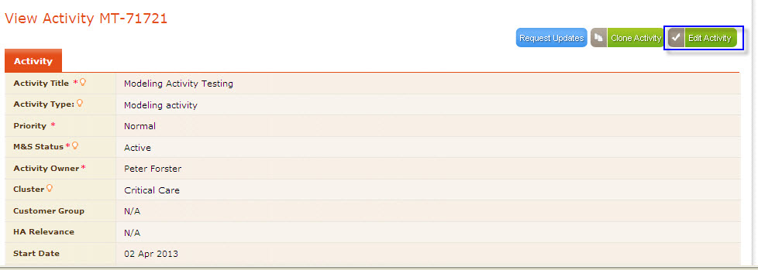

Screen

1. The activity information appears in editable mode thereby allowing user to update the data.
2. When user enters/updated the data in any of the update activity fields, ‘Activity has unsaved Data’ alert message displayed at top of the page as shown in below screen.

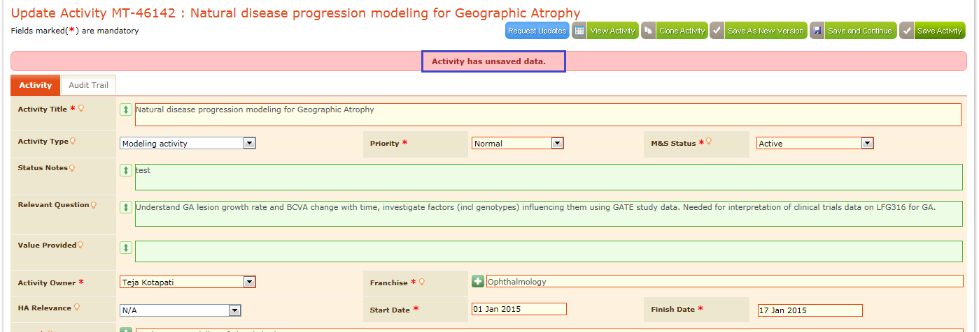

Screen

1. After updating dataif user navigates out of activity page without saving the data, then an popup message is displayed, informing user about unsaved data as shown in below screen

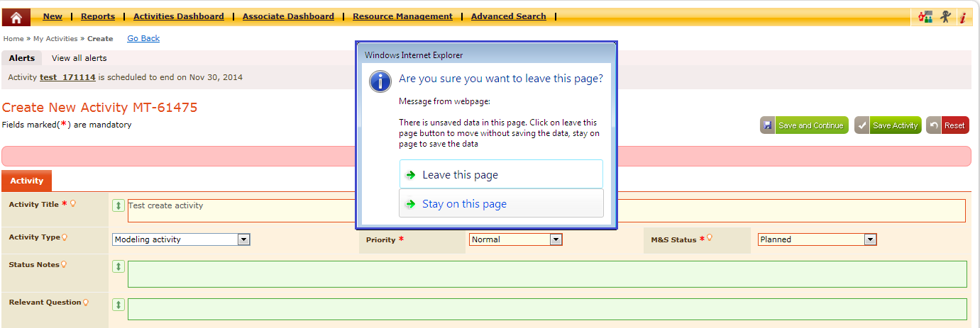

Screen

* When user clicks on the ‘Leave this page’ button in pop up window, then user navigates to the desired page without saving the data.
* When user clicks on ‘Stay on this page’ button in pop up window then user stays in the page to save the activity details

For saving the updated data, click any button among “//Save Activity/Save And Continue/ /Save As New Version buttons based on the requirement. The functionality of the each button mentioned belowshown in below screen

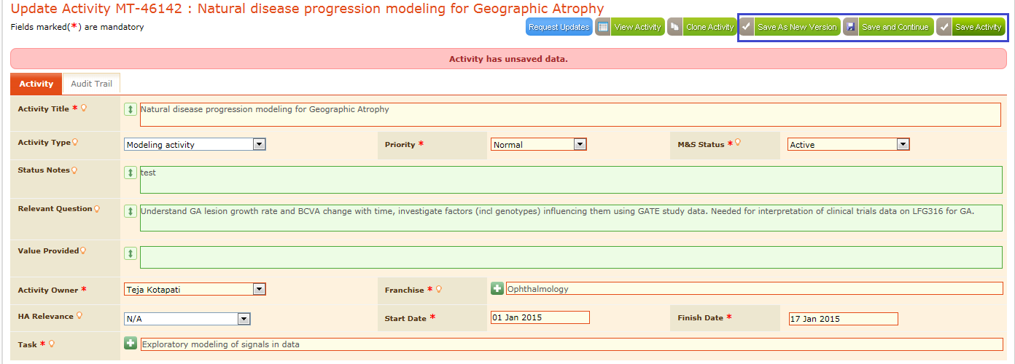

Screen

* When user clicks on ‘Save Activity’ button , activity details gets saved and displayed the success message in ‘My Activities’ page
* When user clicks on ‘Save And continue’ button, activity details gets saved and success message displayed in same tab of the activity where user clicks the button with updated details
* When user clicks on ‘Save As New Version’ button, version comments pop up window is displayed for entering reason and upon submit activity details saved and success message displayed in same tab of the activity where user clicks the button with updated details

**Eg:** If user updates the data in Source data and clicks ‘Save And Continue’/’Save As New version’ button, activity details gets saved and success message displayed in ‘Source Data’ tab with updated details as shown in below screen

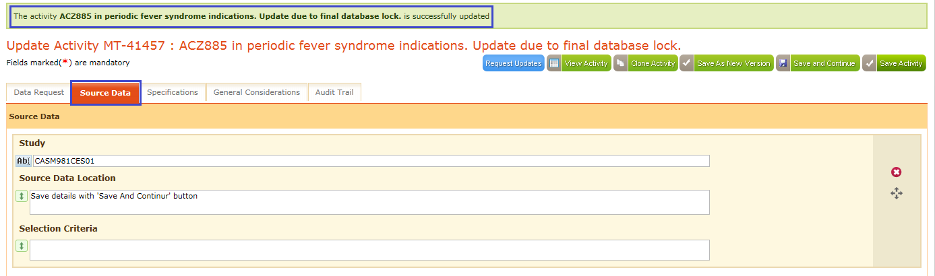

Screen

* Once activity is updated, ‘Audit Trail’ tab is displayed with the audit entries of that updated activity.
* Click on Audit Trail tab and check the audit records of the updated activity as shown in below screen

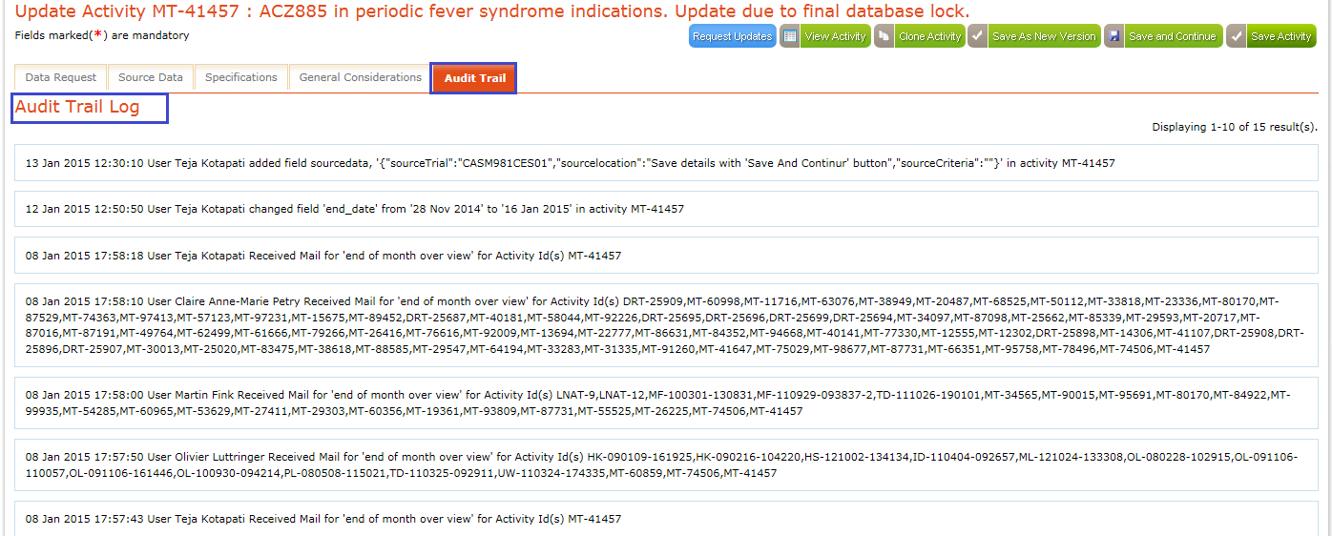

Screen

### Updating Completed Activity

If completed activity data need to be updated then the following users have the permission to the edit the completed activity

* Activity Owner
* Activity team members
* Franchise Leader of the Activity associated franchise
* Line function Head of the activity owner associated group

For the above users “Unlock Activity” button is displayed in the “View Activity” page of completed activity

***Eg:***  Here the activity owner and logged in user both are “Teja Kotapati” so that application allows “Teja Kotapati” to edit the completed activity and the “Unlock Activity” button appears in the “View Activity” page as shown in below screen***.***

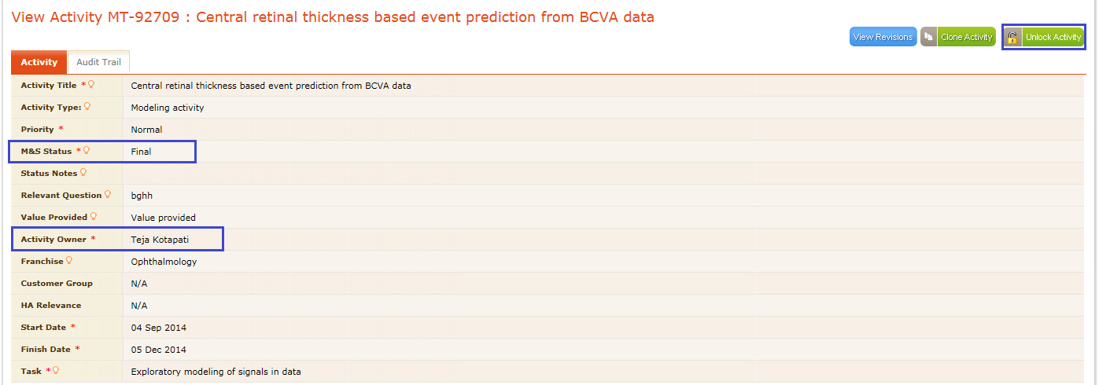

Screen

* Click on the ‘Unlock Activity’ button in the ‘View activity’ page
* Update activity page is displayed with disable fields
* Complete check box is displayed in enable mode at bottom of the page as shown in below screen

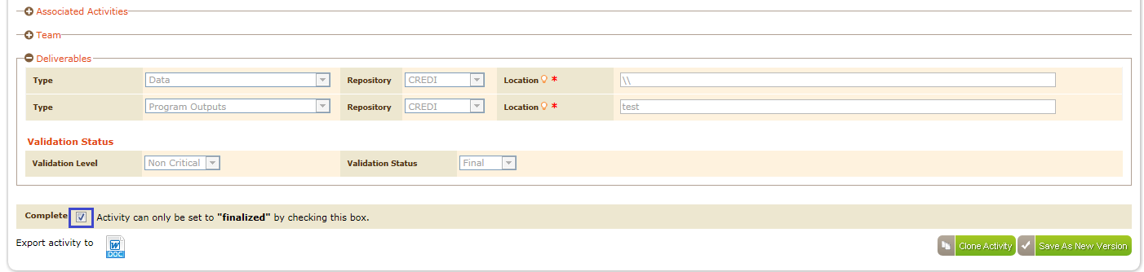

Screen

* Uncheck the complete check box at bottom of the update activity page, M&S status changes to previous status and fields are displayed in editable mode for updation
* Un-checked complete activity page displays only ‘Save As New version’ button to save the activity as new version as shown in below screen

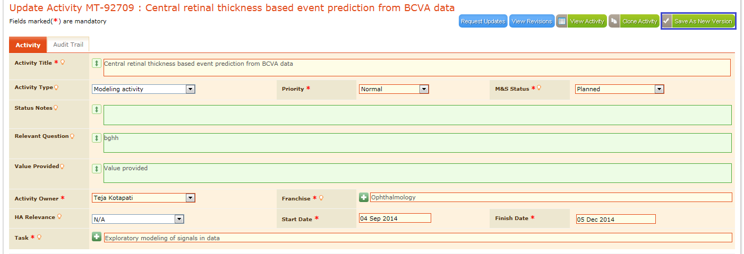

Screen

* User can now update the data in the activity page
* Click on the ‘Complete’ check box, then Acknowledgement prompt appears.
* Click on ‘OK’ button in the pop up window, ‘Add Revision comments’ pop up window is displayed with ‘Submit’ and ‘Close’ buttons as shown in below screen

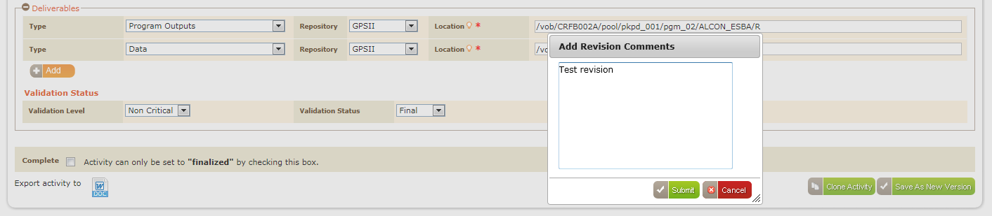

Screen

* Enter revision comments and click on ‘Submit’ button, updated activity details gets saved and displayed in Update activity page with disable fields.

If the logged in user do not have the privilege to edit the completed activity then “Unlock Activity” button doesn’t appears for that completed activity as shown in below screen

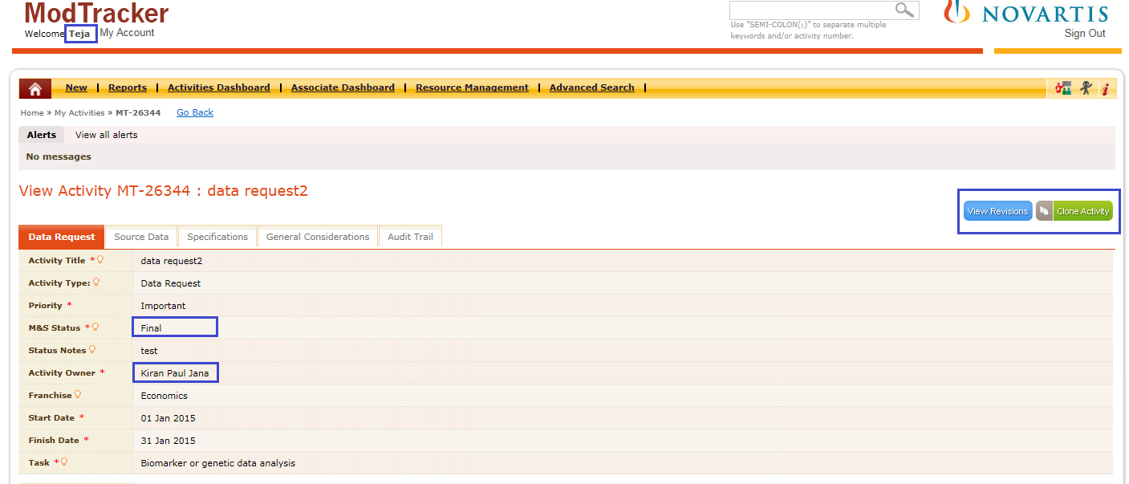

Screen

### Request Updates

If user needs update of any activity, user can click on “Request Updates” button from the “View/Update Activity” page. Request update sends an email to ‘Primary Modeler’ of an activity. If the activity do not have primary modeler then ‘Activity Owner’will receive an email notification requesting update for the corresponding activity. User clicks “Request Updates” button from the “Update Activity” page as shown in below screen.

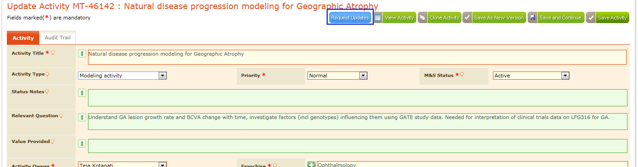

Screen

On click of “Request Update” button, anconfirmation message appears as shown in below screen.

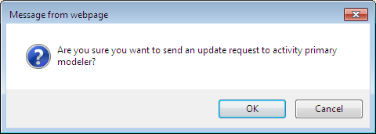

Screen

Click “Ok” button on the message box, then ‘Request Update Reason’ pop up window is displayed with ‘Submit’ and ‘Cancel’ buttons.

Enter reason and click on ‘Submit’ button as shown in below screen

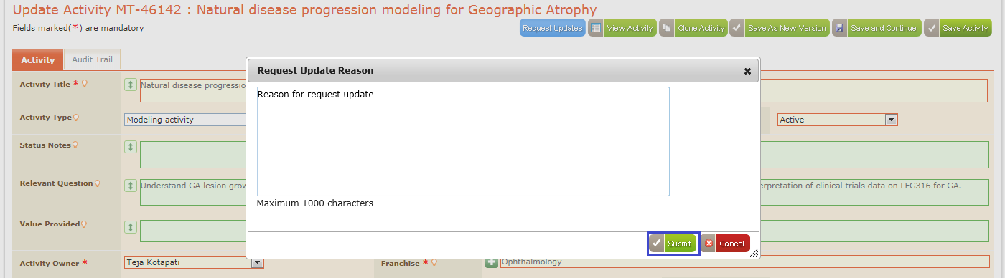

Screen

Corresponding Primary modeler of that activity will receive an email notification requesting update for the corresponding activity as shown in the below sample Email format. Activity Title is hyperlinked, click “Activity Title” to access the activity.

Dear Mahesh Vedurupaka,   
  
An update has been requested for the activity [**pool_ldk378x_tum**](http://localhost:88/modtracker-phase2-it2-svn/index.php/activities/view/11125) by **admin**.   
  
Please review this activity and make sure all the information is up-to-date.   
  
Request Update Comment :  
  
test request update reason   
  
Thank you,  
ModTracker application

**Note:** For completed activities ‘Request Updates’ button is not displayed in view activity/Update activity pages

### Clone Activity

Clone Activity enables users to maintain another copy of the activity information, by reducing the burden of filling the complete activity information. User clicks “Clone Activity” button from the “View Activity” page as shown in below screen.

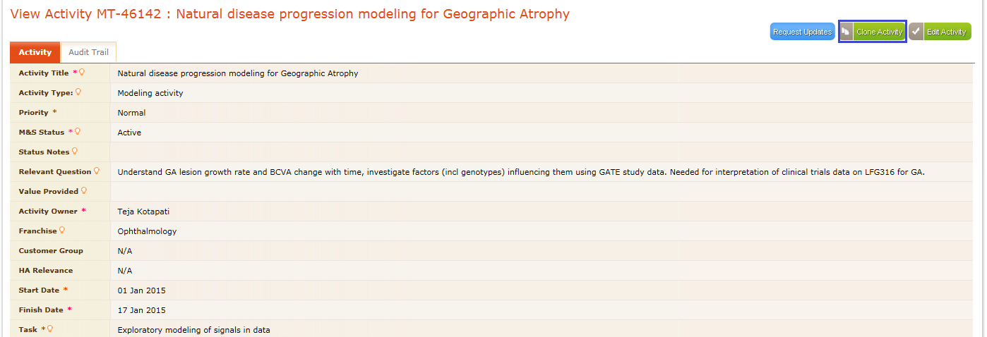

Screen

* On click on “Clone Activity” button in view activity page, clone activity page appears with activity information in the editable mode as shown in below screen.

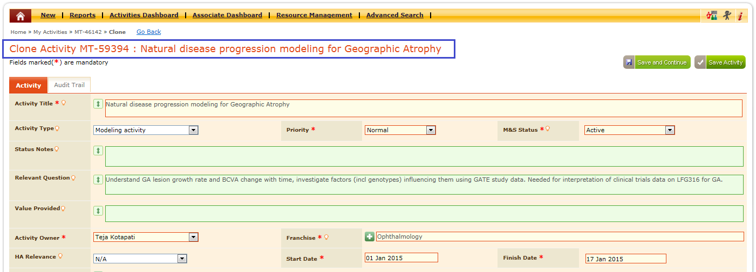

Screen

* User can modify the data if required and click ‘Save Activity’/’’Save And Continue’ button to save the modifications.
* If user clicks on ‘Save Activity’ button then activity gets cloned and an acknowledgement appears indicating the cloning is successfu in ‘My Activities’ page.
* If user clicks on ‘Save And Continue’ button, activity details gets saved and displayed in same tab of the activity with audit trail tab showing the record of clone activity as shown in below screen

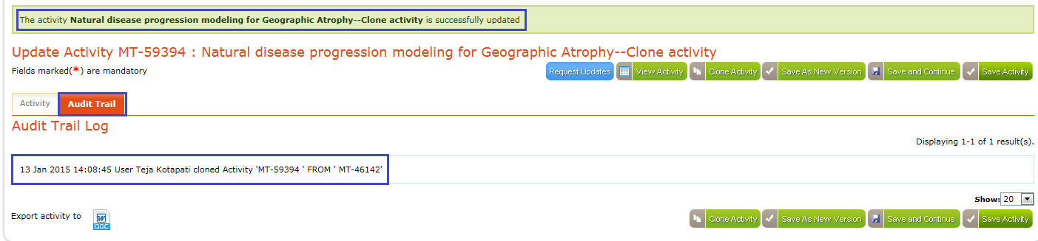

Screen

### Save As New Version

“Save as new version” allows user to maintain multiple versions for same activity. In general if user saves any activity, then for those activities there will be oneversions. But when user saves any activity using “Save As New Version” option then new versions is created and maintained, and at any point of time user can view those versions using “View Revisions” button.

* Click “Save As New Version” button from the “Update Activity” page as shown in below screen.

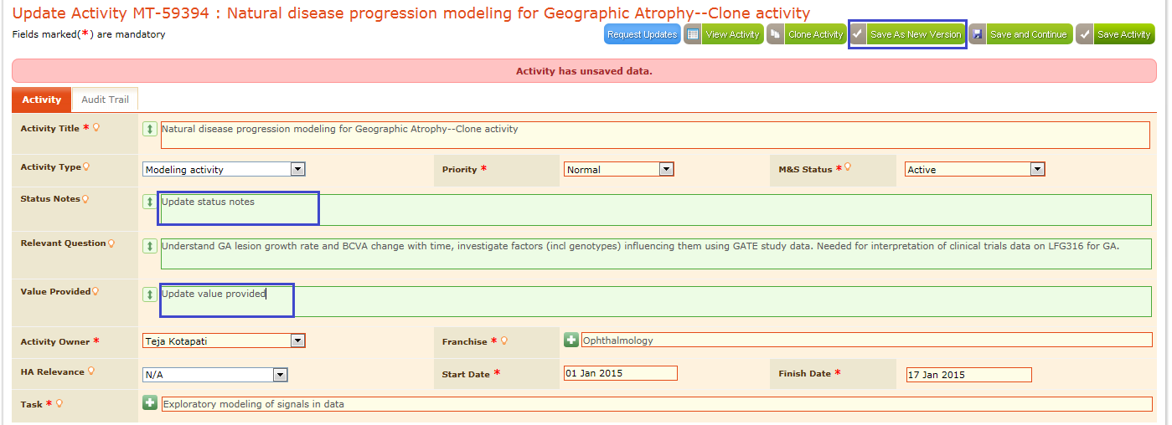

Screen

* Add Revision Comments” message box appears as shown in below screen.

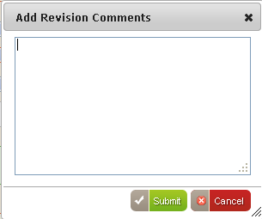

Screen

* Enter comments in that message box and then click “Submit” button as shown in below screen.

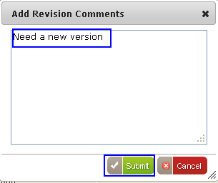

Screen

* Activity gets updated and acknowledgement message appears in the update activity page
* Click on Audit trail tab display the log for updated fields and version information as shown in below screenshown in below screen

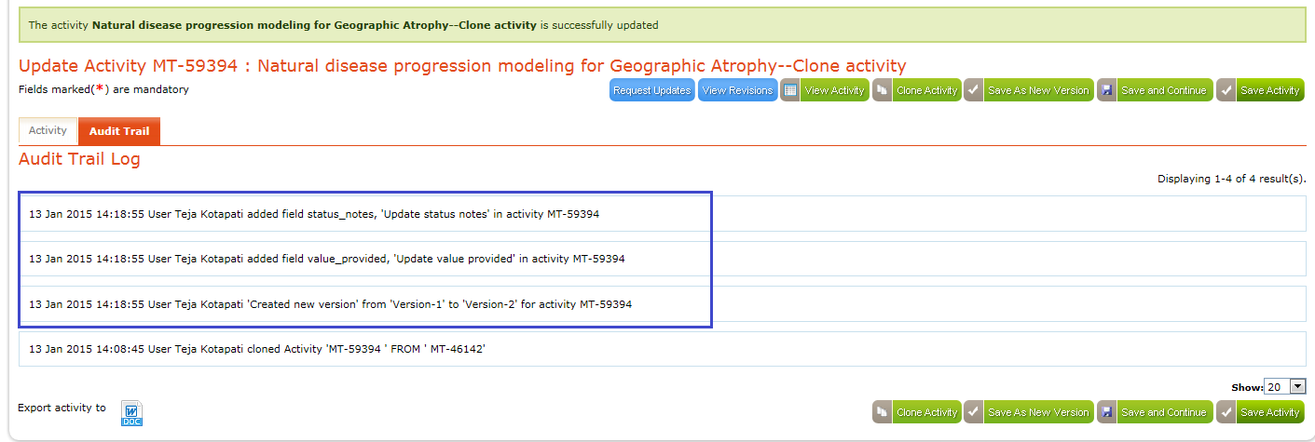

Screen

### View Revisions

“View Revisions” button appears for all the activities that are saved as new versions, in their corresponding “Update activity/View Activity” page as shown in below screen.

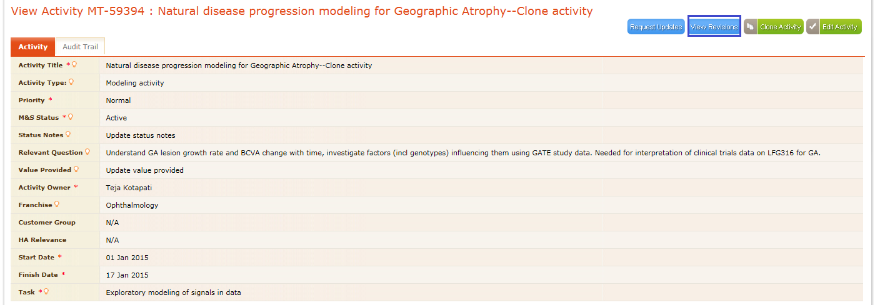

Screen

* Click “View Revisions” button, “Revisions of Activity” appears as shown in below screen.

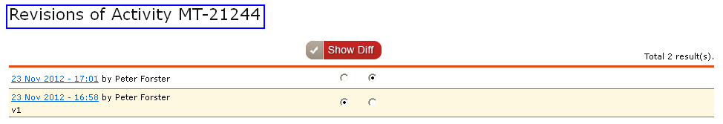

Screen

* Select the option buttons and then click “Show Diff” button to View the revisions as shown in below screen.

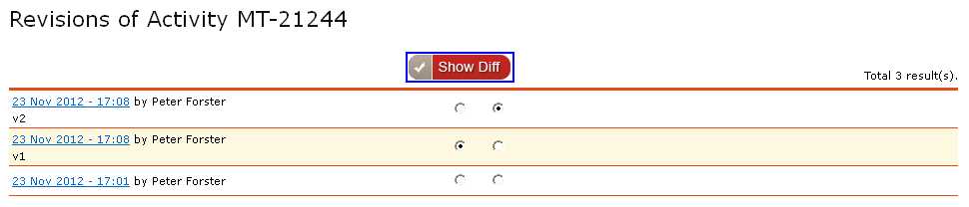

Screen

* “Difference View of the Activity” appears and all the differences between the versions of the activity appear in highlighted mode as shown in below screen.

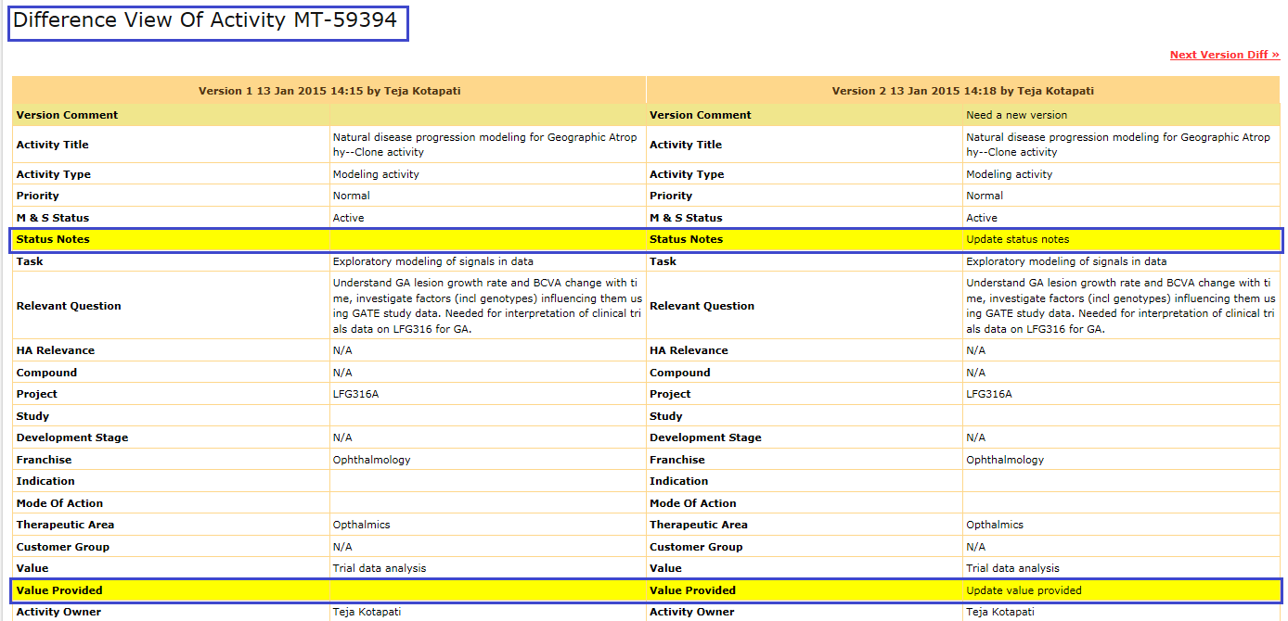

Screen

* In the “Difference View of Activity”, view the previous version differences using “Previous Version Diff” link.
* Click the “Previous Version Diff” link then the previous version diff appears and if activity has next version, then to view next version diff “Next Version Diff” link appears as shown in below screen.

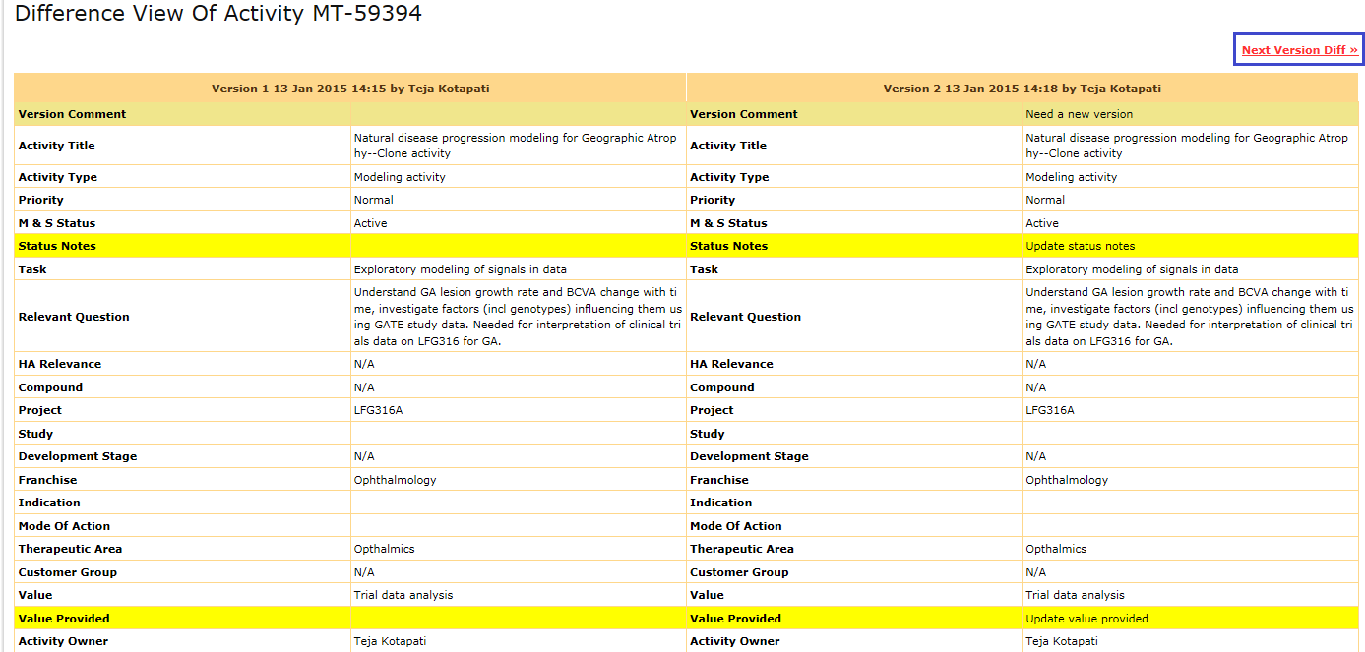

Screen

* Click “Export this Version of the Activity to” icon to export the diff as shown in below screen.



Screen

* Then “Save Activity” pop up appears in that enter the activity name and then click “Download” button as shown in below screen.

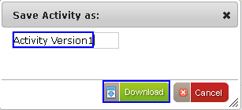

Screen

* Version difference information gets downloaded and opening activity version window appears.
* Click “Save File” option to save the file as shown in below screen.

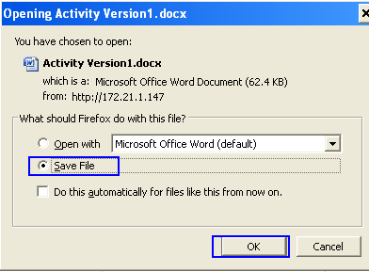

Screen

### Save Activity - Alerts

When user enters value in any field, activity page display’s an alert message indicating about unsaved data in the page as shown in below screen

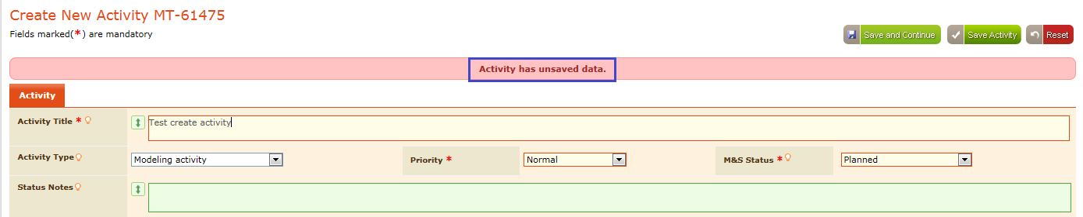

Screen

When user tries to navigates out of activity page without saving the data, then an alert message is displayed, informing user about unsaved data as shown in below screen



Screen

* When user clicks on the ‘Leave this page’ button in pop up window, then user navigates to the desired page without saving the data.
* When user clicks on ‘Stay on this page’ button in pop up window then user stays in the page to save the activity details

In New/Edit activity page, after entering/selecting the required data,user has two options to save the activity details

* **Save Activity:** On clicking this button, activity gets saved and navigates to landing page. Saved activity appears in “My Activities and All Activities” pages under the corresponding “M&S Status” selected while creating the activity.
* **Save And Continue:** On clicking this button the activity gets saved and stays in same tab of Update activity page with updated details of activity for further updation.

Once activity is saved, activity page is displayed with Activity title beside the activity ID and ‘Audit Trail’ tab is displayed with the audit entries of that activity.

If the saved activity is related to Franchise or My Line function team then it appears in the “My Franchise(s) or My Line Function Team” pages, under the corresponding M&S Status selected while creating the activity.

User can export any activity to word document using “Export activity to” option in the “View Activity” page as shown in below screen.

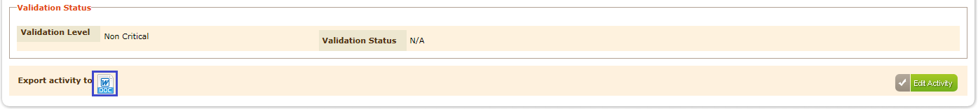

Screen

Pop up appears in that enterfilename and click “Download” button as shown in below screen

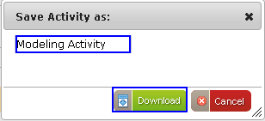

Screen

Activity file gets downloaded,select “Save File or Open with” options as shown in below screen.

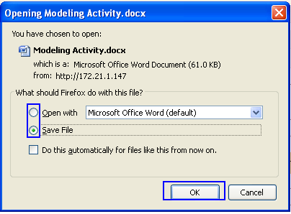

Screen

Click “Ok” button then the exported activity file document is downloaded and opened as shown in below screen.

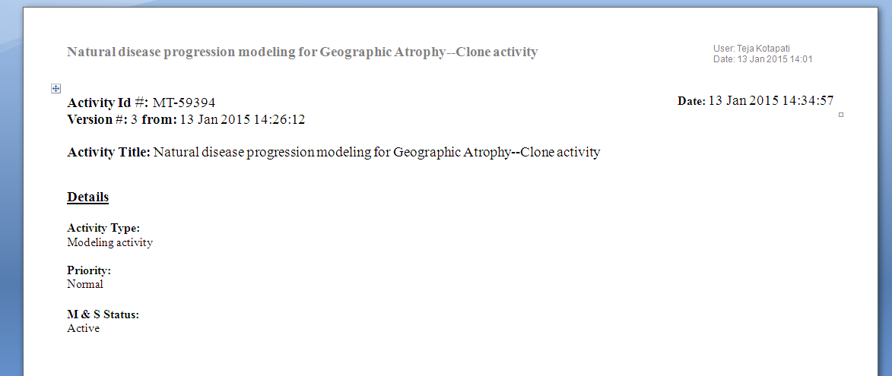

Screen

## My Franchise(s)

My Franchise(s) holds the activities list that is related to the particular “Franchise”, selected while creating the user in “Manage Users” page. Initially while creating a new user account Franchisename need to be assigned for the user. Activities which have the assigned franchiseappear in “My Franchise(s)” list as shown in below screen.

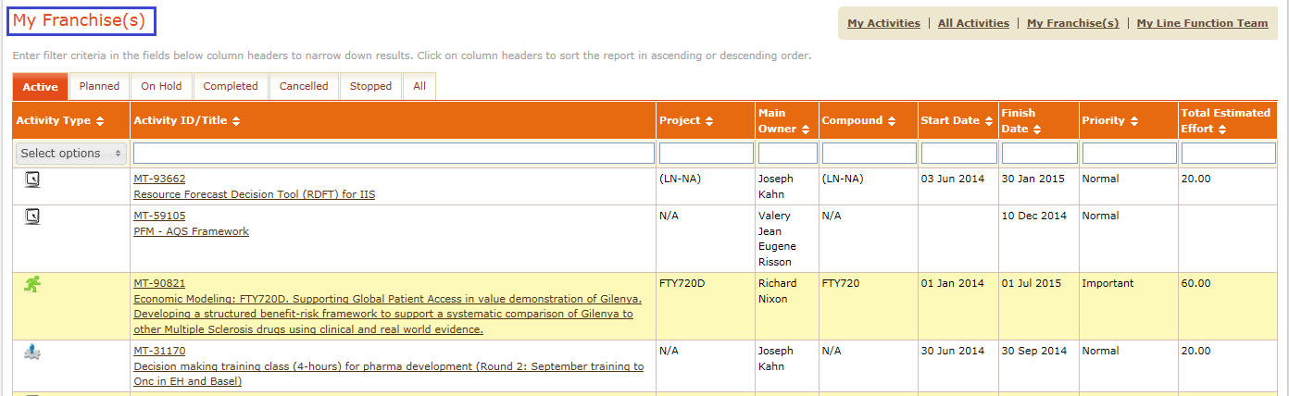

Screen

## My Line Function Team

My Line Function Team facilitates the Activities information that is relevant to the selected “Group” for the users. If any other users also consists the activities that are related to the same group then those appear under “My Line Function Team” under corresponding “M&S Status” tabs.

### My team

Click “My Line Function Team” from the home page, “My Team” page appears with activities list as shown in below screen.

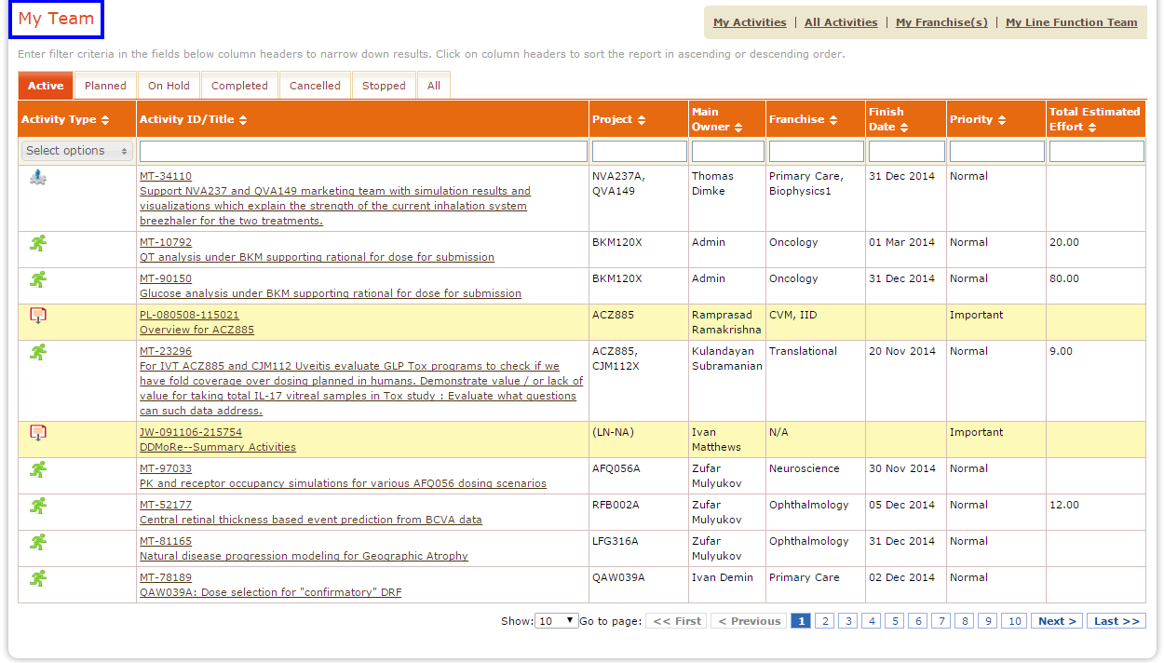

Screen

### Go Back functionality

Click “Go Back” link from any page in the application then the application navigates to the previous page similar to the functionality of browser back button.

Click “My Activities” link then the “My Activities” page appears as shown in below screen.

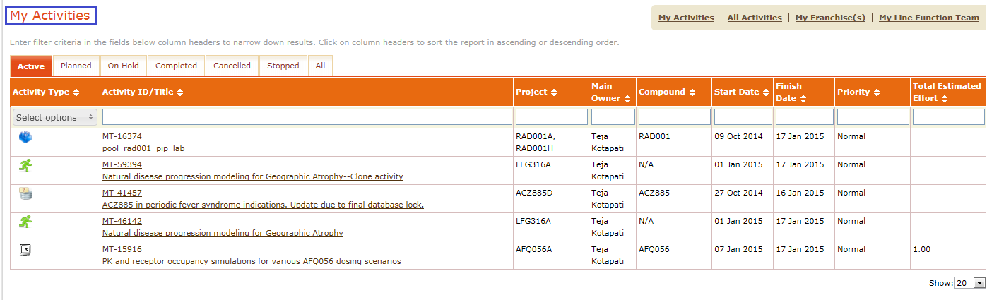

Screen

Click any Activity Title/ Activity ID as shown in below screen.

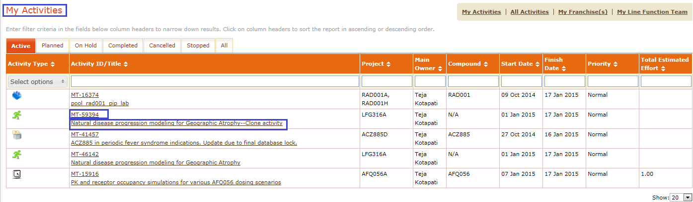

Screen

“View Activity” page appears, in that click “Go Back” link as shown in below screen.

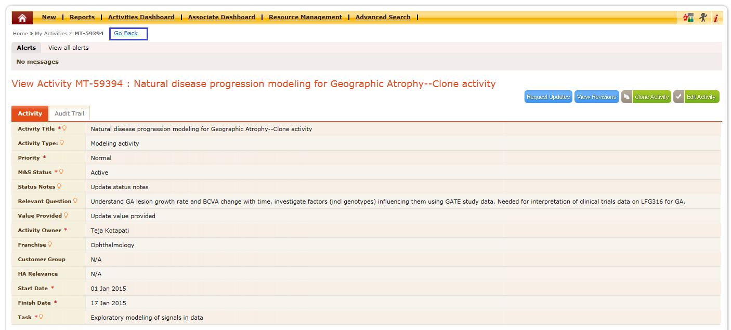

Screen

Then the application navigates to previous page as shown in below screen.



Screen

# Search

ModTracker enables search functionality for the users to attain required data using “Search” option. Here Search functionality is divided into two types

1. Global Search
2. Advanced Search

## Global Search

For the global search, search field is available in all the pages of the application as shown in below screen***.***



Screen

Enter the required search criteria and click “” button then the page will be displayed with progress bar as shown in below screen.

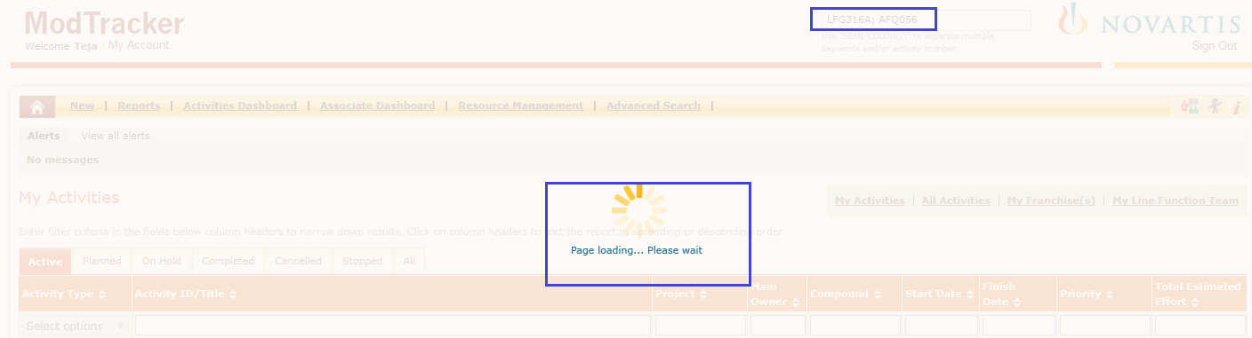

Screen

After search completes, corresponding Search Results appears considering the search criteria as shown in below screen.

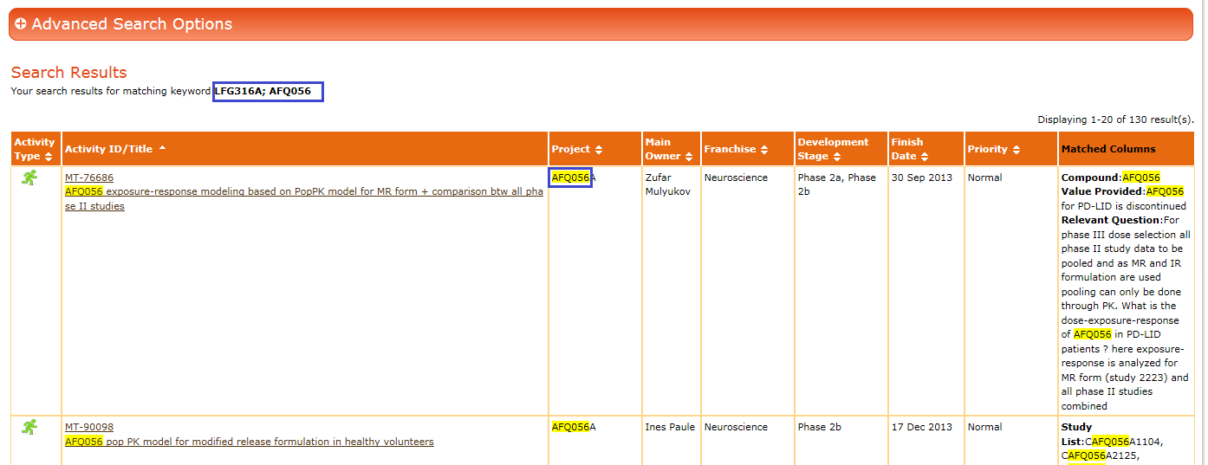

Screen

This feature enables user to attain the search results in an effortless manner. Search is performed and results are displayed, If the given keyword exists in internal reports or specifications or in any part of the activity and its related information.

# Advanced Search

Advanced Search page is intended to provide the resultant information based on the user selected search criteria using the search fields provided in the advanced search page. This Advanced Search page fields are categorized as sections to make the search easy for the user

1. Click “Search” link from the “My Activities” page “Advanced Search” page appears as shown in below screen***.***
2. Enter the required search criteria and click “Search” button to obtain the results.

.

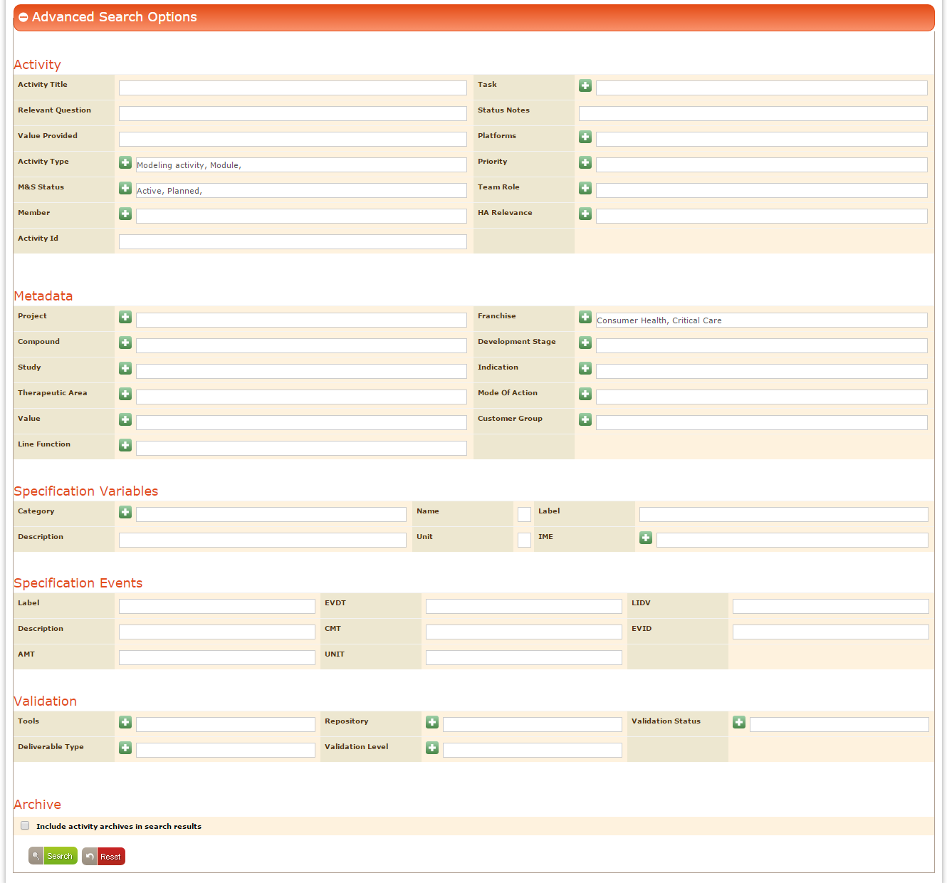

Screen

1. Click “Search” button, based on the given search criteria relevant search results appears below the “Search” button as“Search Results” and all the search criteria’s appears in highlighted mode as shown in below screen.

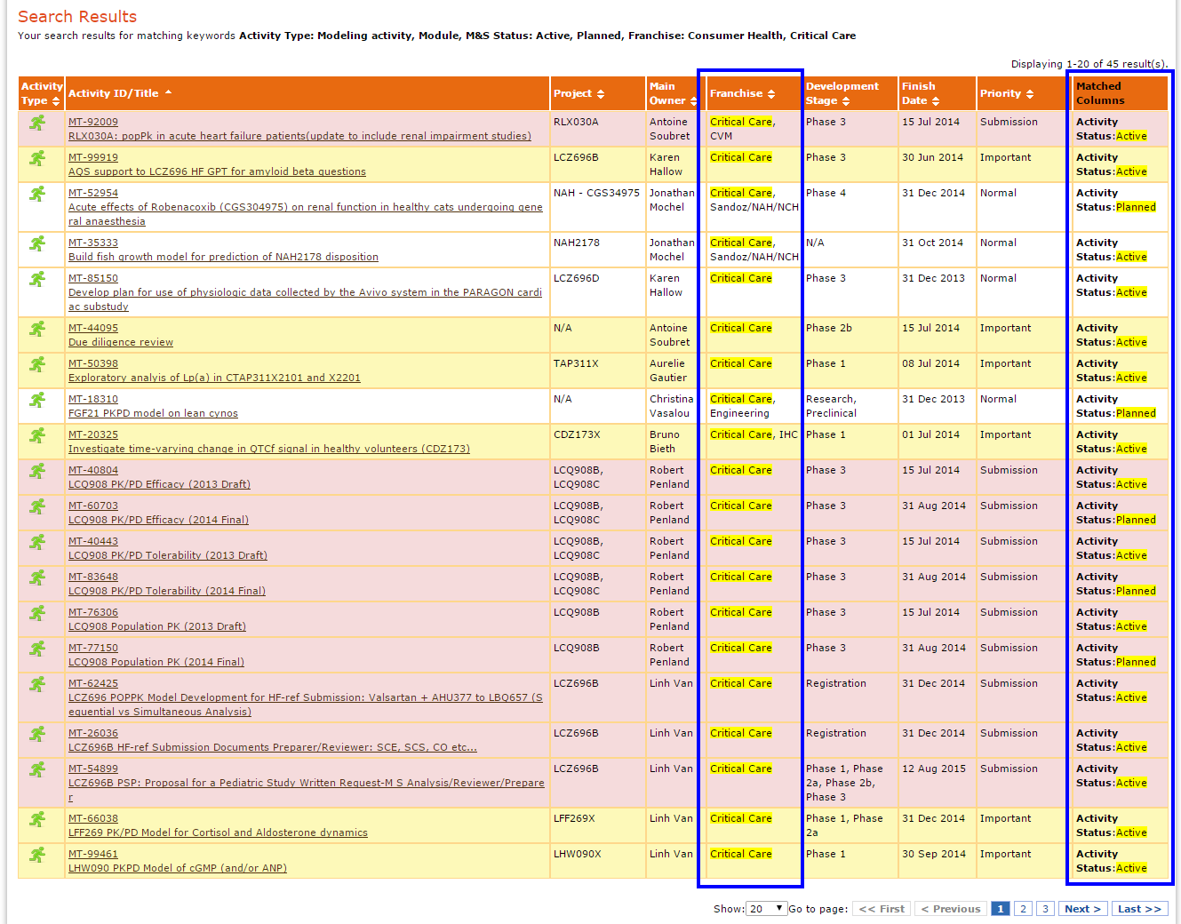

Screen

If there are no results available for the given search criteria then “No results found” message appears as shown in below screen.

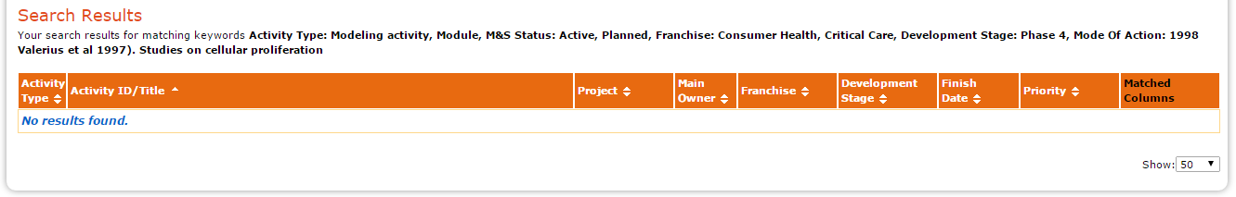

Screen

# Resource Management

Resource Management facilitates to view the complete resource allocation information of all the activities with “M&S Status” as “Active” in the Gantt chart format. It includes the “Resource View, Activity View” along with detailed information of the activities that are under allocated and over allocated.

To view the resource management, the following criteria should be satisfied

1. Active activities should have valid percent allocations for the resources. For this activity owner need to allocate resources with the below specified fields data in the “Create New Activity” under the “Team” pane as shown in below screen.

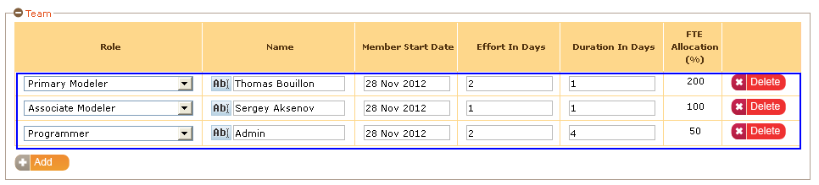

Screen

1. Activities M&S Status should be “Active.”
2. Start and End data should be in between the specified “Start and End” dates in the “Resource Management” page.
3. As per resource allocation in Activity data, the allocated data appears under “Resource Management” link as shown in below screen.

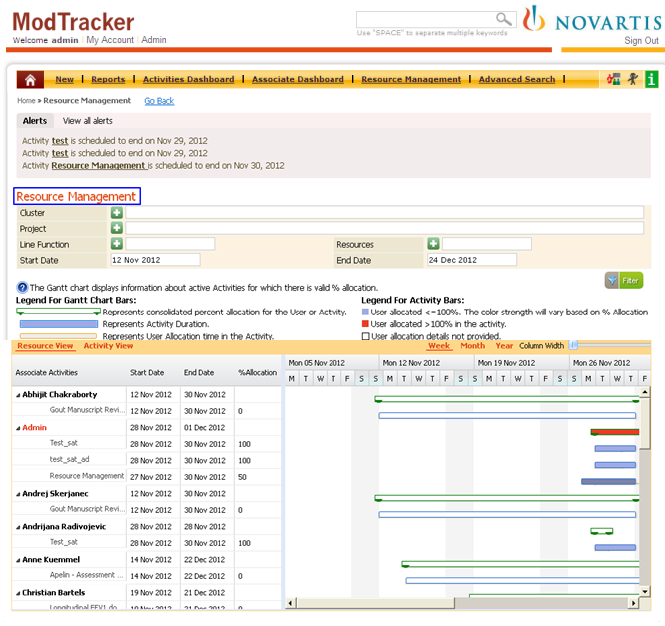

Screen

1. In the “Resource Management”, user can filter the data using the “Franchise, Project, Line Function, Resources, Start and End Dates” as shown in below screen.

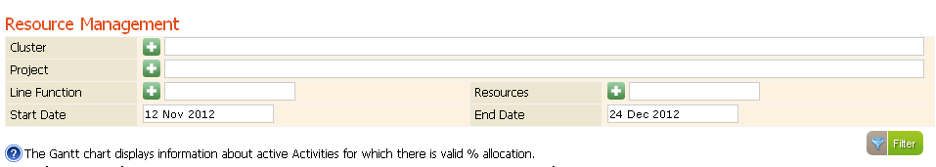

Screen

Specify the required data in the “Franchise, Project, Line Function, Resources, Start and End Dates” fields and click on “Filter” button, the corresponding data appears in the Gantt chart as shown in below screen.

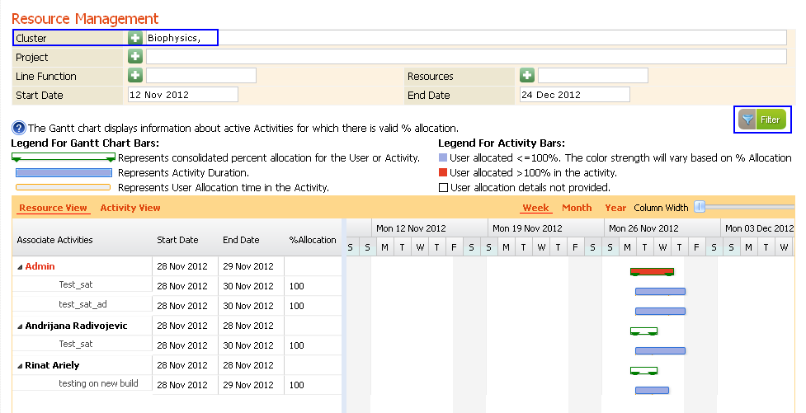

Screen

## Resource View

In the “Resource Management” page by default “Resource View” appears with the “Associate Activities, Start Date, End Date and %Allocation information with the corresponding allocation, Gantt chart appears as shown as shown in below screen.

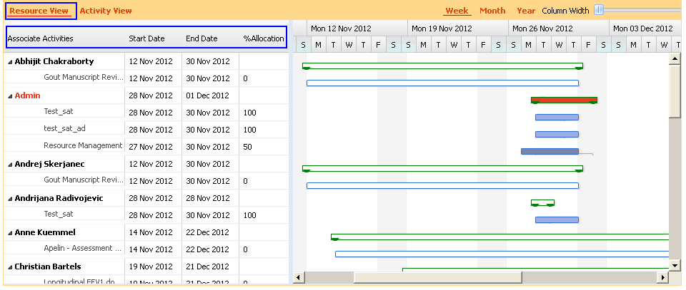

Screen

In the Gantt chart on placing mouse hover on the bars the allocation details appears as tool tip. Here in the below screen“Start Date and End Date” of the resource allocation appears along with the activity overlap information.

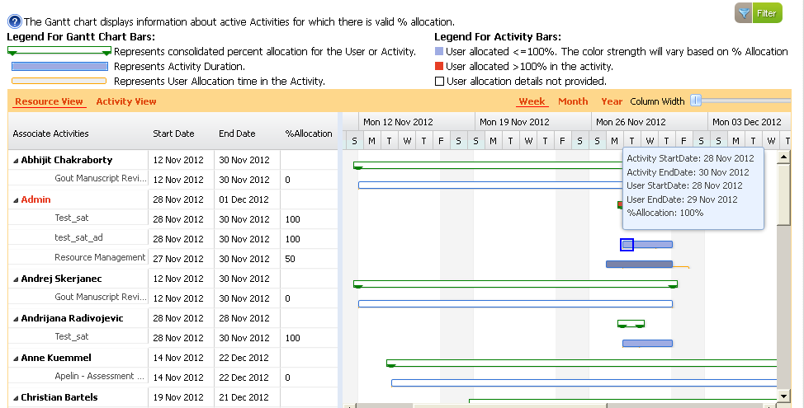

Screen

### Overlap information

The overlap information in the Gantt chart appears when the user is allocated for multiple activities within the same period.

**Example:** For an activity if the users are allocated in multiple activities as shown in below screen.

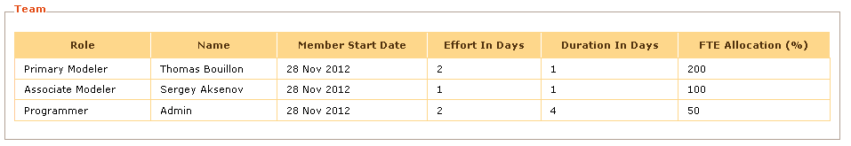

Screen

For another activity if the same users are allocated within the same time period as shown in below screen.

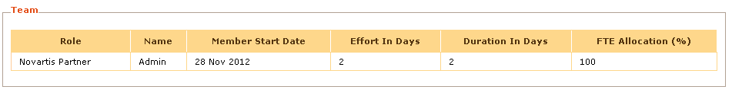

Screen

And For another activity if the same users are allocated within the same time period as shown in below screen.

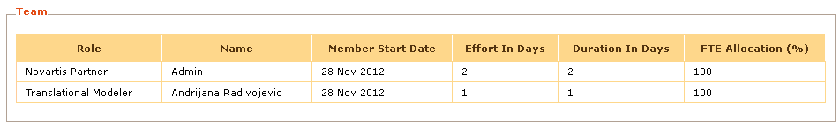

Screen

In the “Resource Management” Gantt chart the overlapping period appears considering the resource allocation with the same time period in both the activities as shown in below screen.

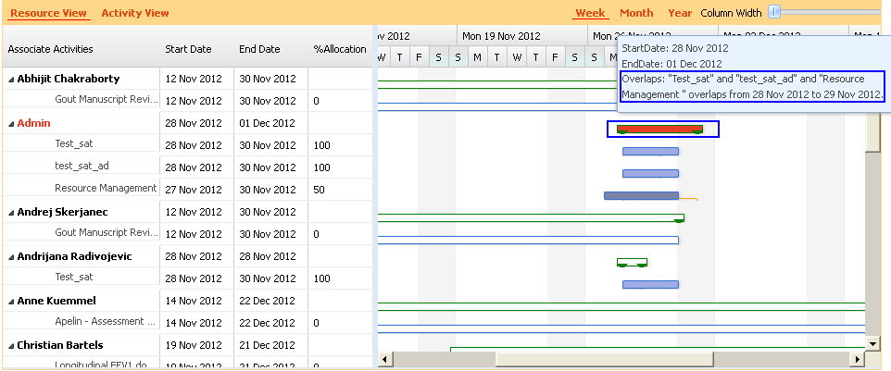

Screen

## Activity View

When admin clicks “Activity View” link , the activity view appears with “Associate Activities, Start Date, End Date and % Allocation” with the corresponding Gantt chart asshown in below screen.

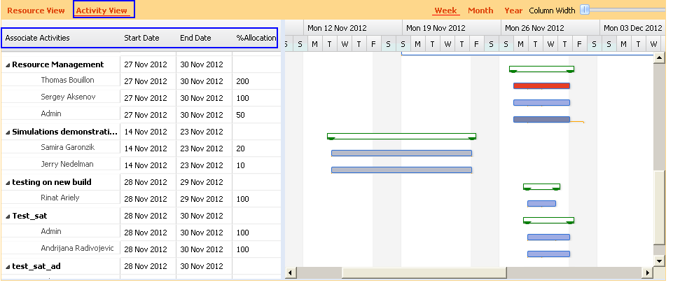

Screen

In the Activity View the bar represents the consolidated percent allocation for the activity along with “Start Date, End Date of the activity and “Most Happening” Time period information of the activity as shown in below screen.

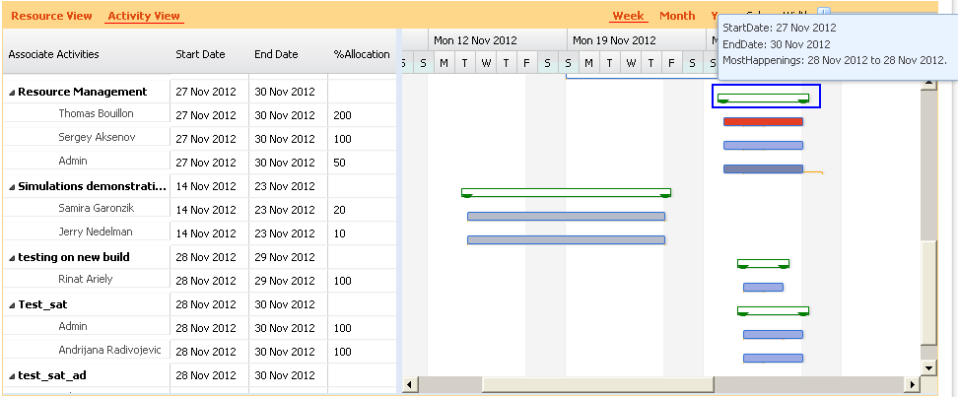

Screen

In the Activity view “Most Happenings” period indicates the period in which resources are overlapped in the “Resource View.”

# Reports

Refer “**Quick Reference Guide 1.6”** for details

# Dashboard

Refer “**Quick Reference Guide 1.6”**for details